**Description:**

In this lab we were tasked with creating a game of “Bee Keeper” on the Basys3 board and a VGA monitor in which a bee hive released its bees and was then able to move around and catch them. The beehive started out holding its bees, but when a button was pressed the hive froze for a certain amount of time and the bees started moving around the screen. The hive was then able to move around by itself or be controlled towards bees and catch them, and won if all bees were caught under a certain amount of time, or lost if otherwise. In this lab, we put together everything we learned throughout the quarter, including state machines and sequential circuits, as well as how to display images onto a VGA monitor. The lab consisted of the following parts:

**Part One: The VGA Controller**

In the first part of the lab, we had to learn how to interact with the VGA monitor in order to display images and have them moving. To do so, we had to generate two control signals, Hsync and Vsync, as well as vgaRed, vgaBlue, and vgaGreen for each of the 640 x 480 pixels of the screen. Our grid of pixels was actually 800 x 525, but we needed to make sure that the active region was only within the 640 x 480 bounds of the monitor. To do so, I created two counters, one for the x-coordinate pixel on the screen, and another for the y-coordinate. My x-coordinate counter counted up to 800 pixels, reset, and incremented the y-coordinate counter, which counted up to 525 pixels and then reset. Hsync was kept high except for the 655th-750th pixels in the grid, and Vsync high except for the 489th-490th pixels. The code and schematic for the Controller are the following:

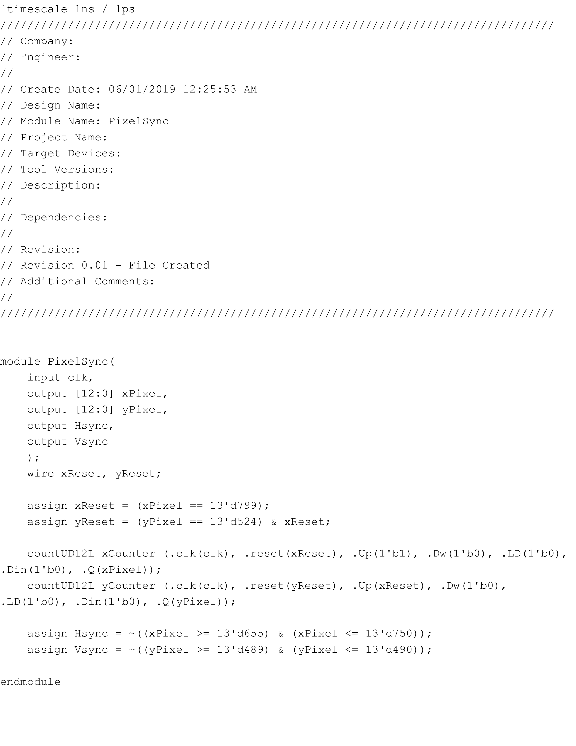

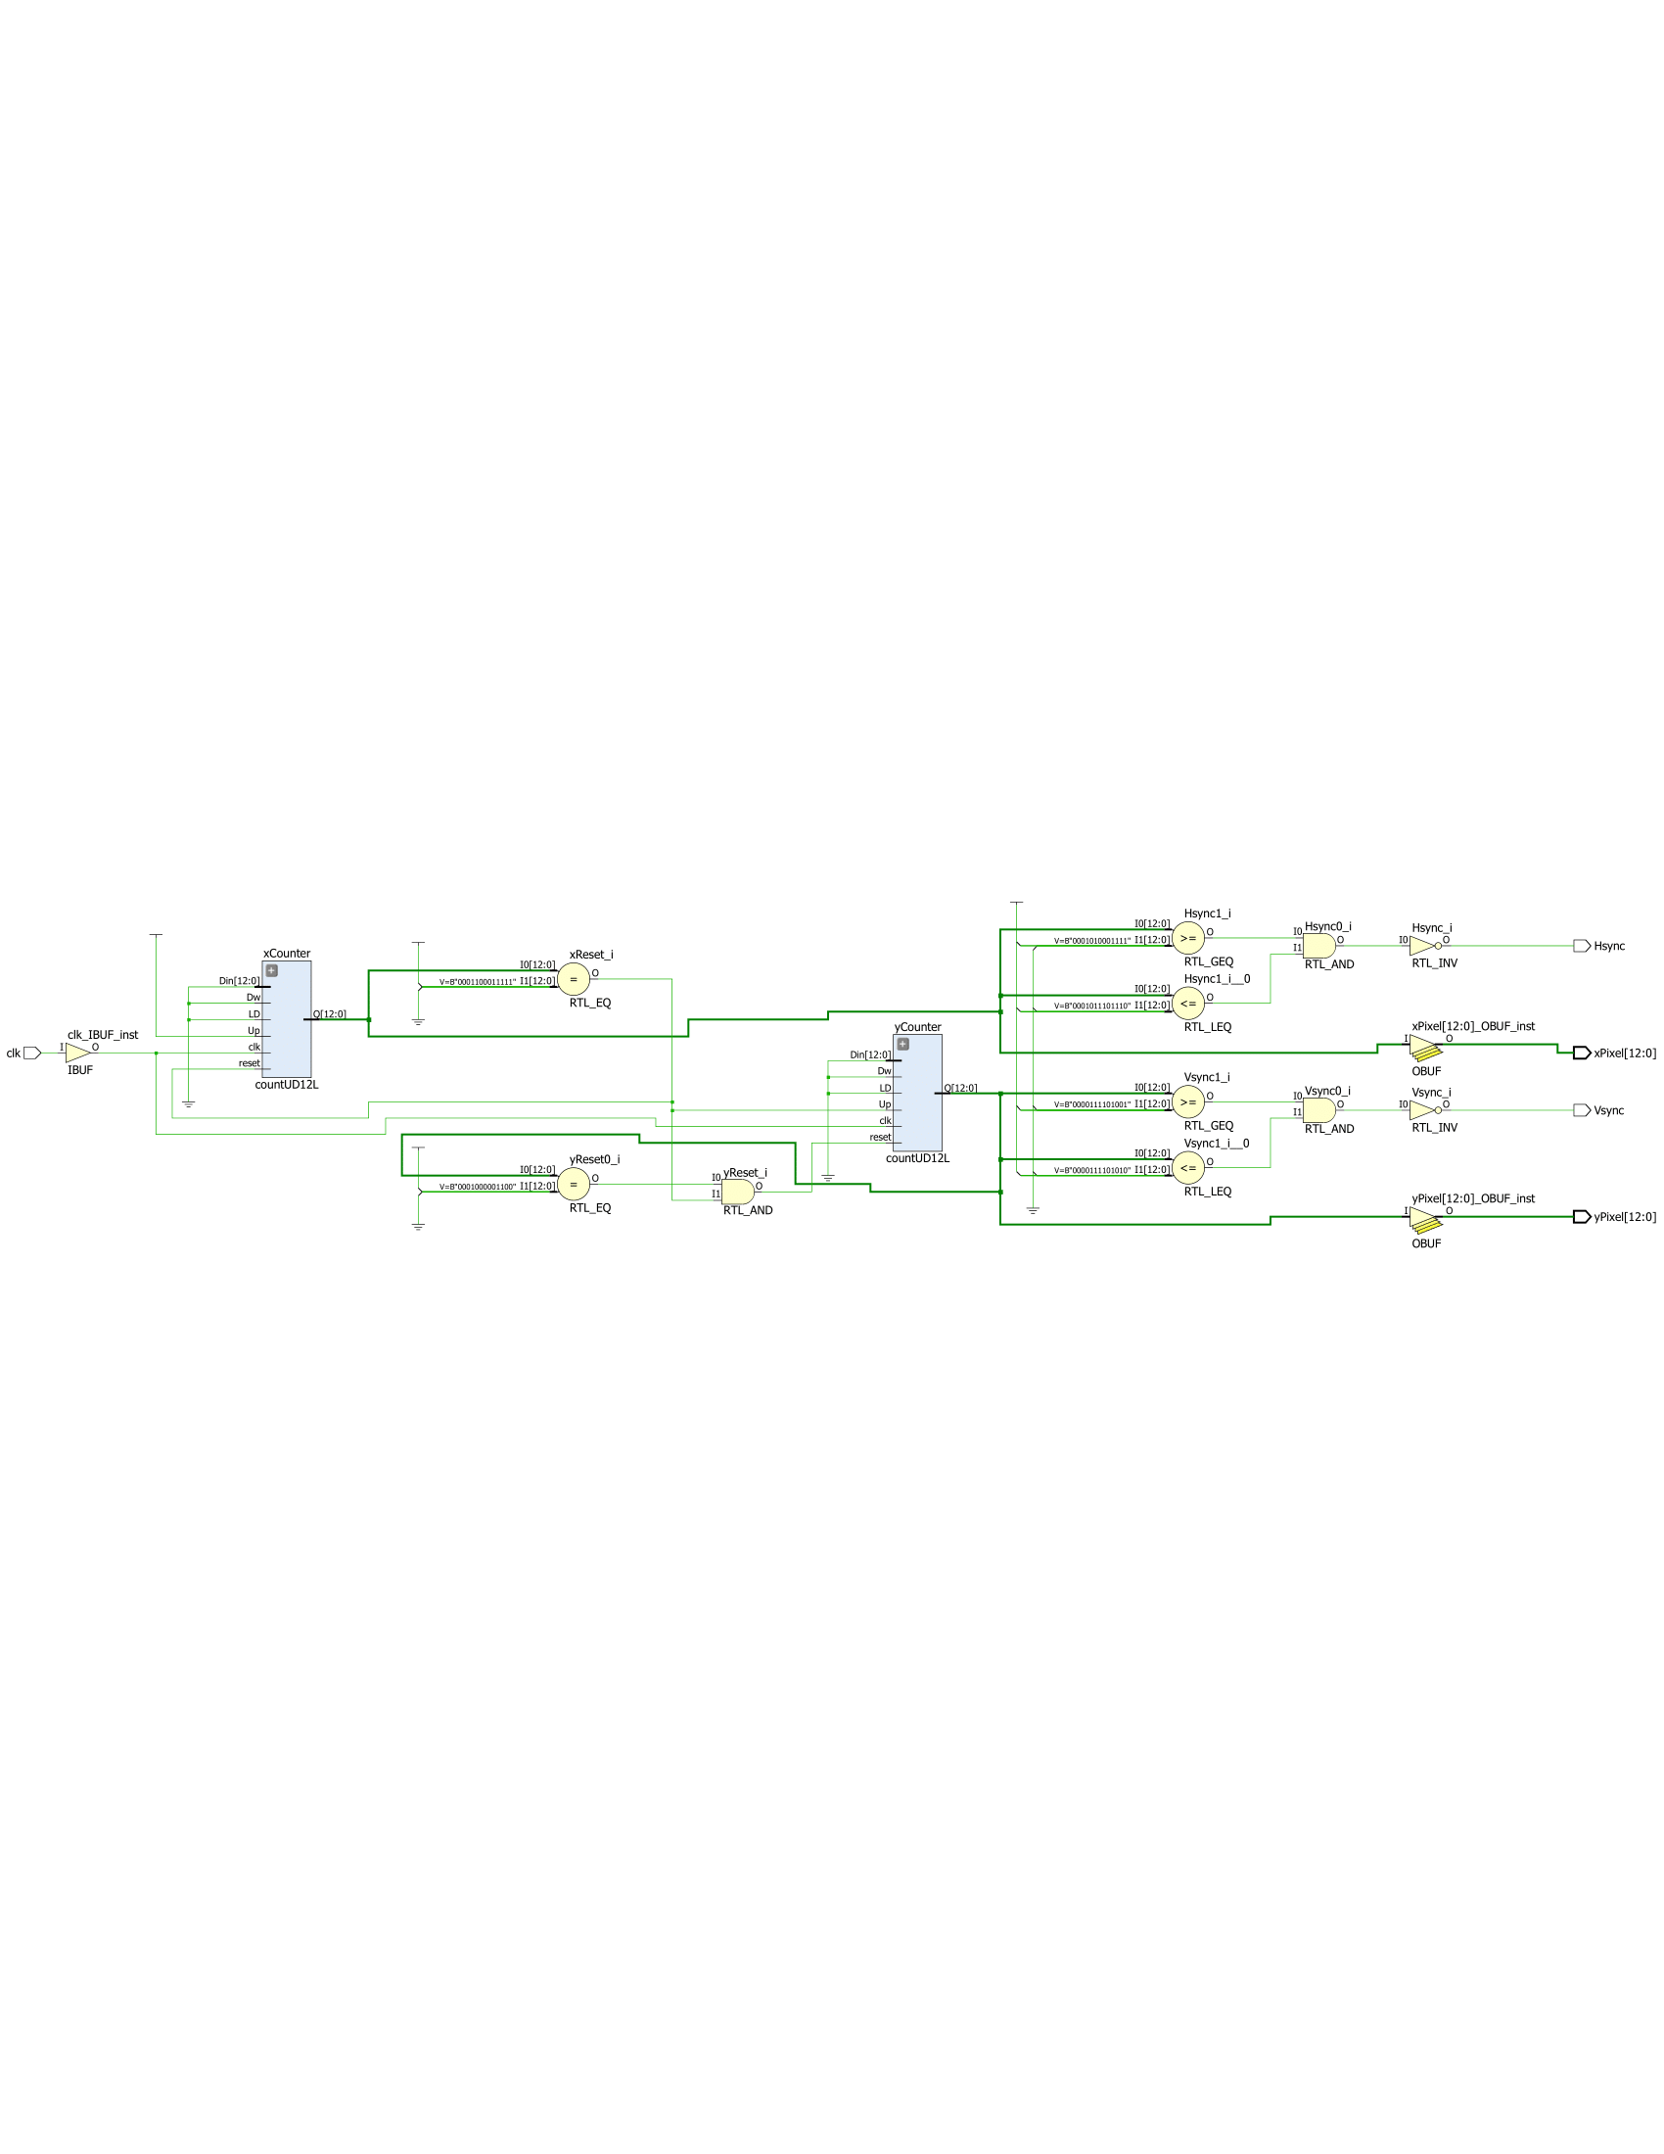

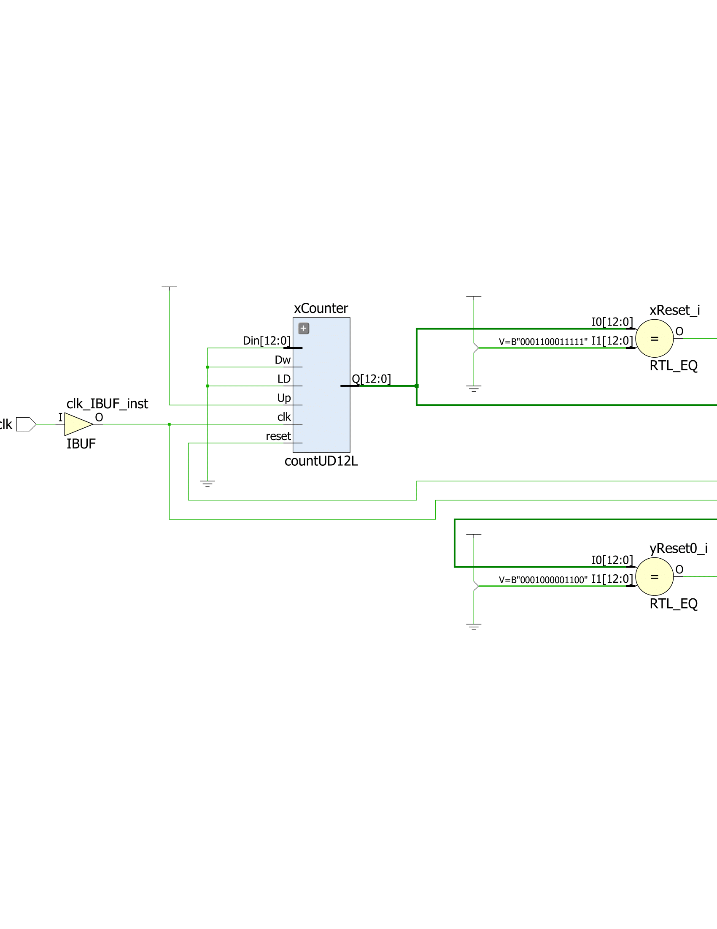

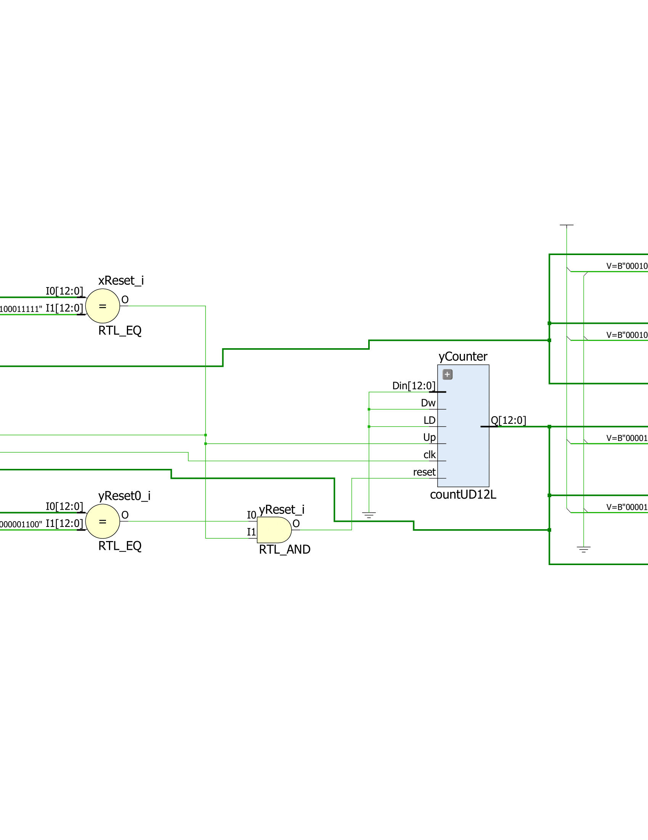

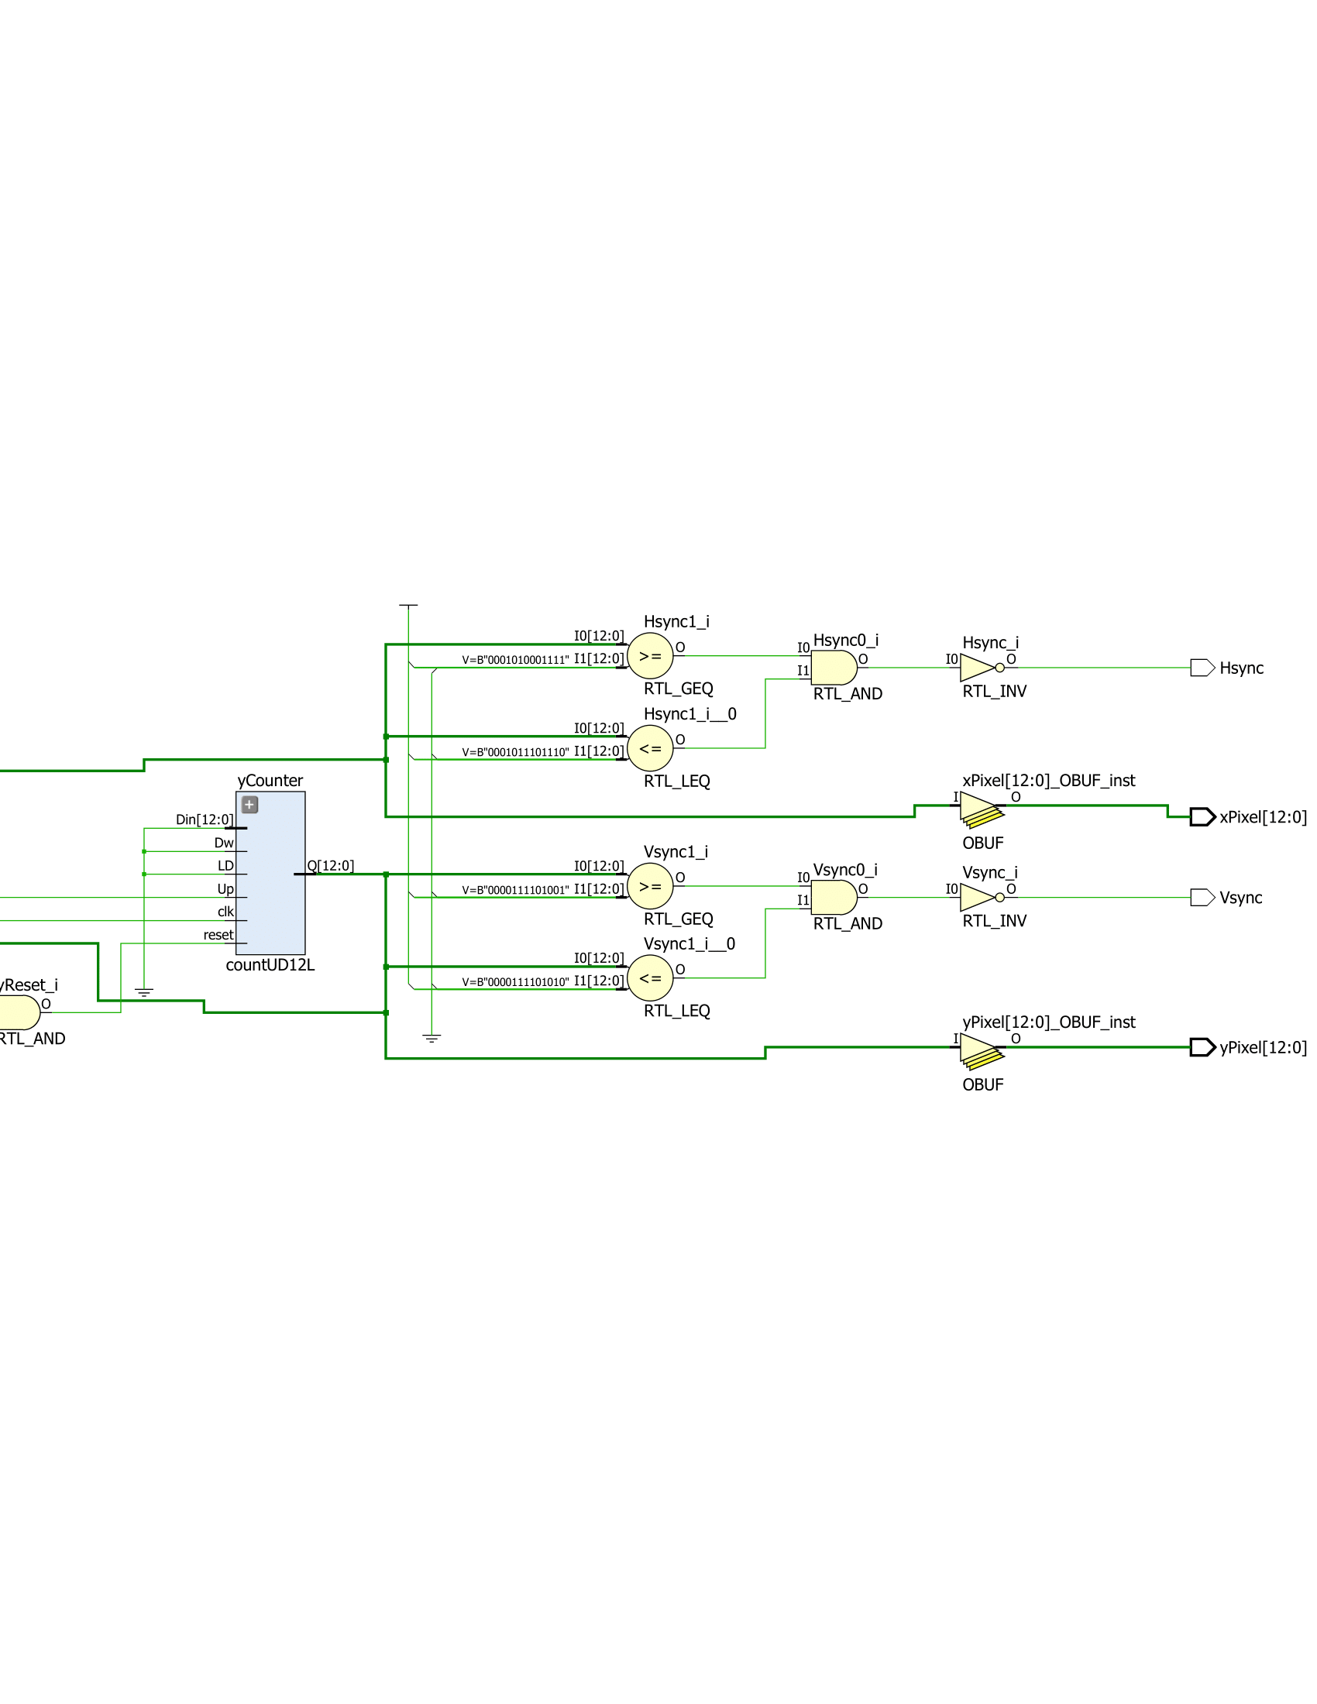

**Part Two: Time Counter**

In this lab, we weren’t given a measure of time with qsec, so we had to create our own time counter. The refresh rate of the monitor was 60 frames a second, so by having a frame counter that counted every frame, counting 60 (or about 64) of these resulted in a second. That frame counter counted up to 16 frames, and incremented another time counter that kept track of quarter seconds. When the time counter reached a value of a quarter second, one second, four seconds, or eight seconds, it produced a value of 1 accordingly. The code and schematic for the time counter are the following:

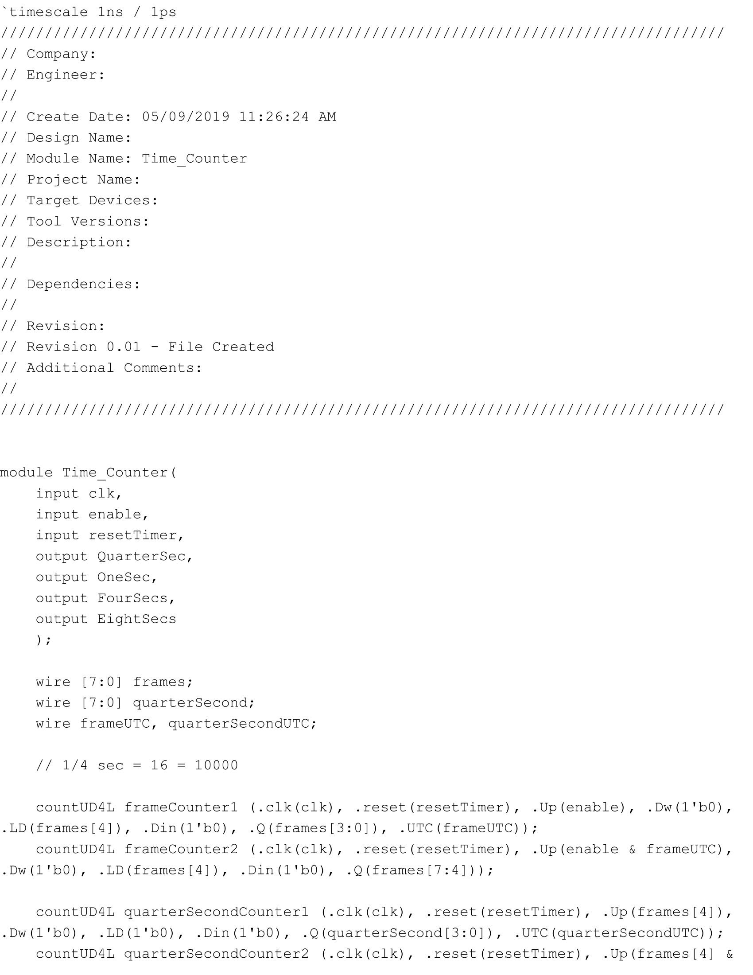

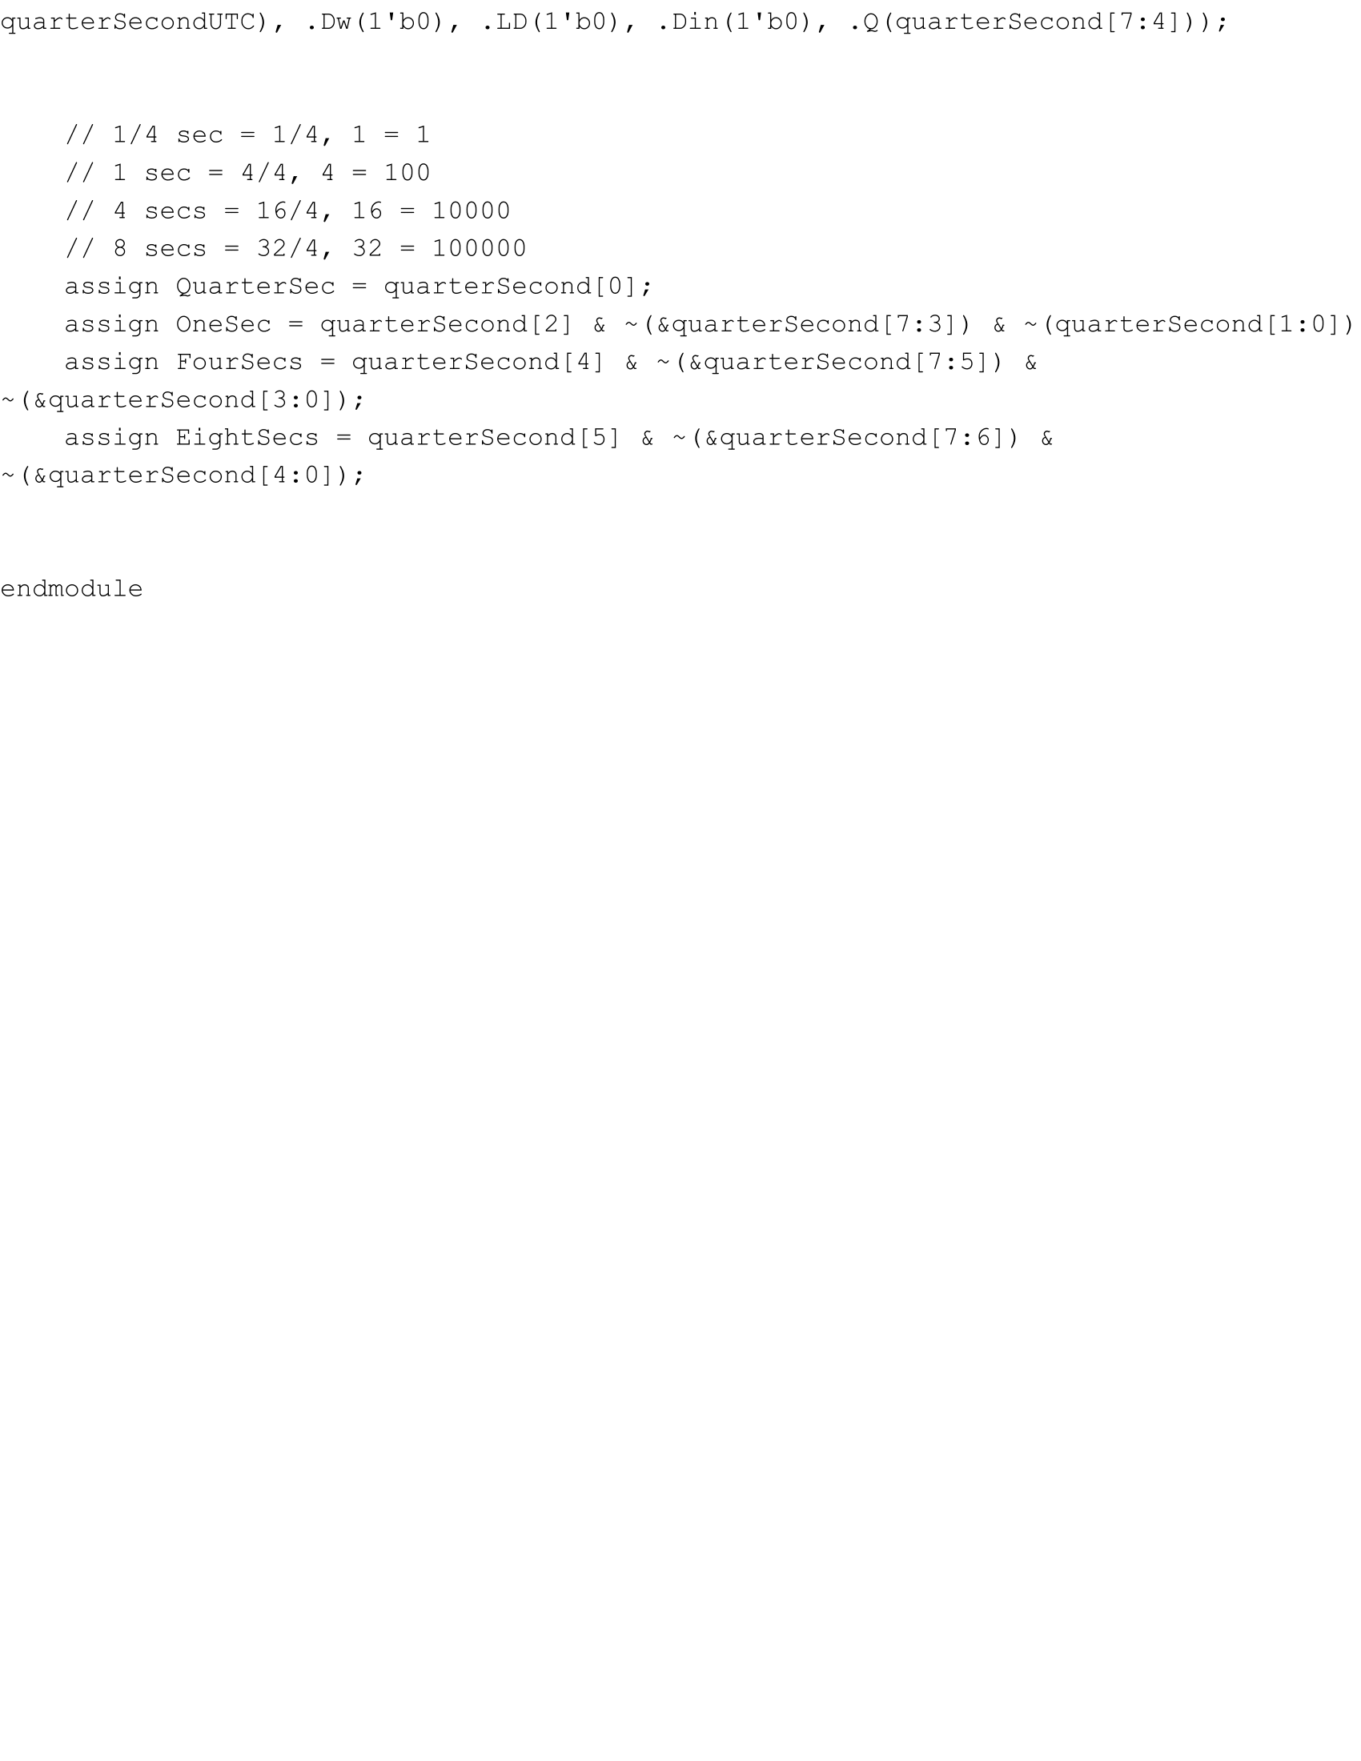

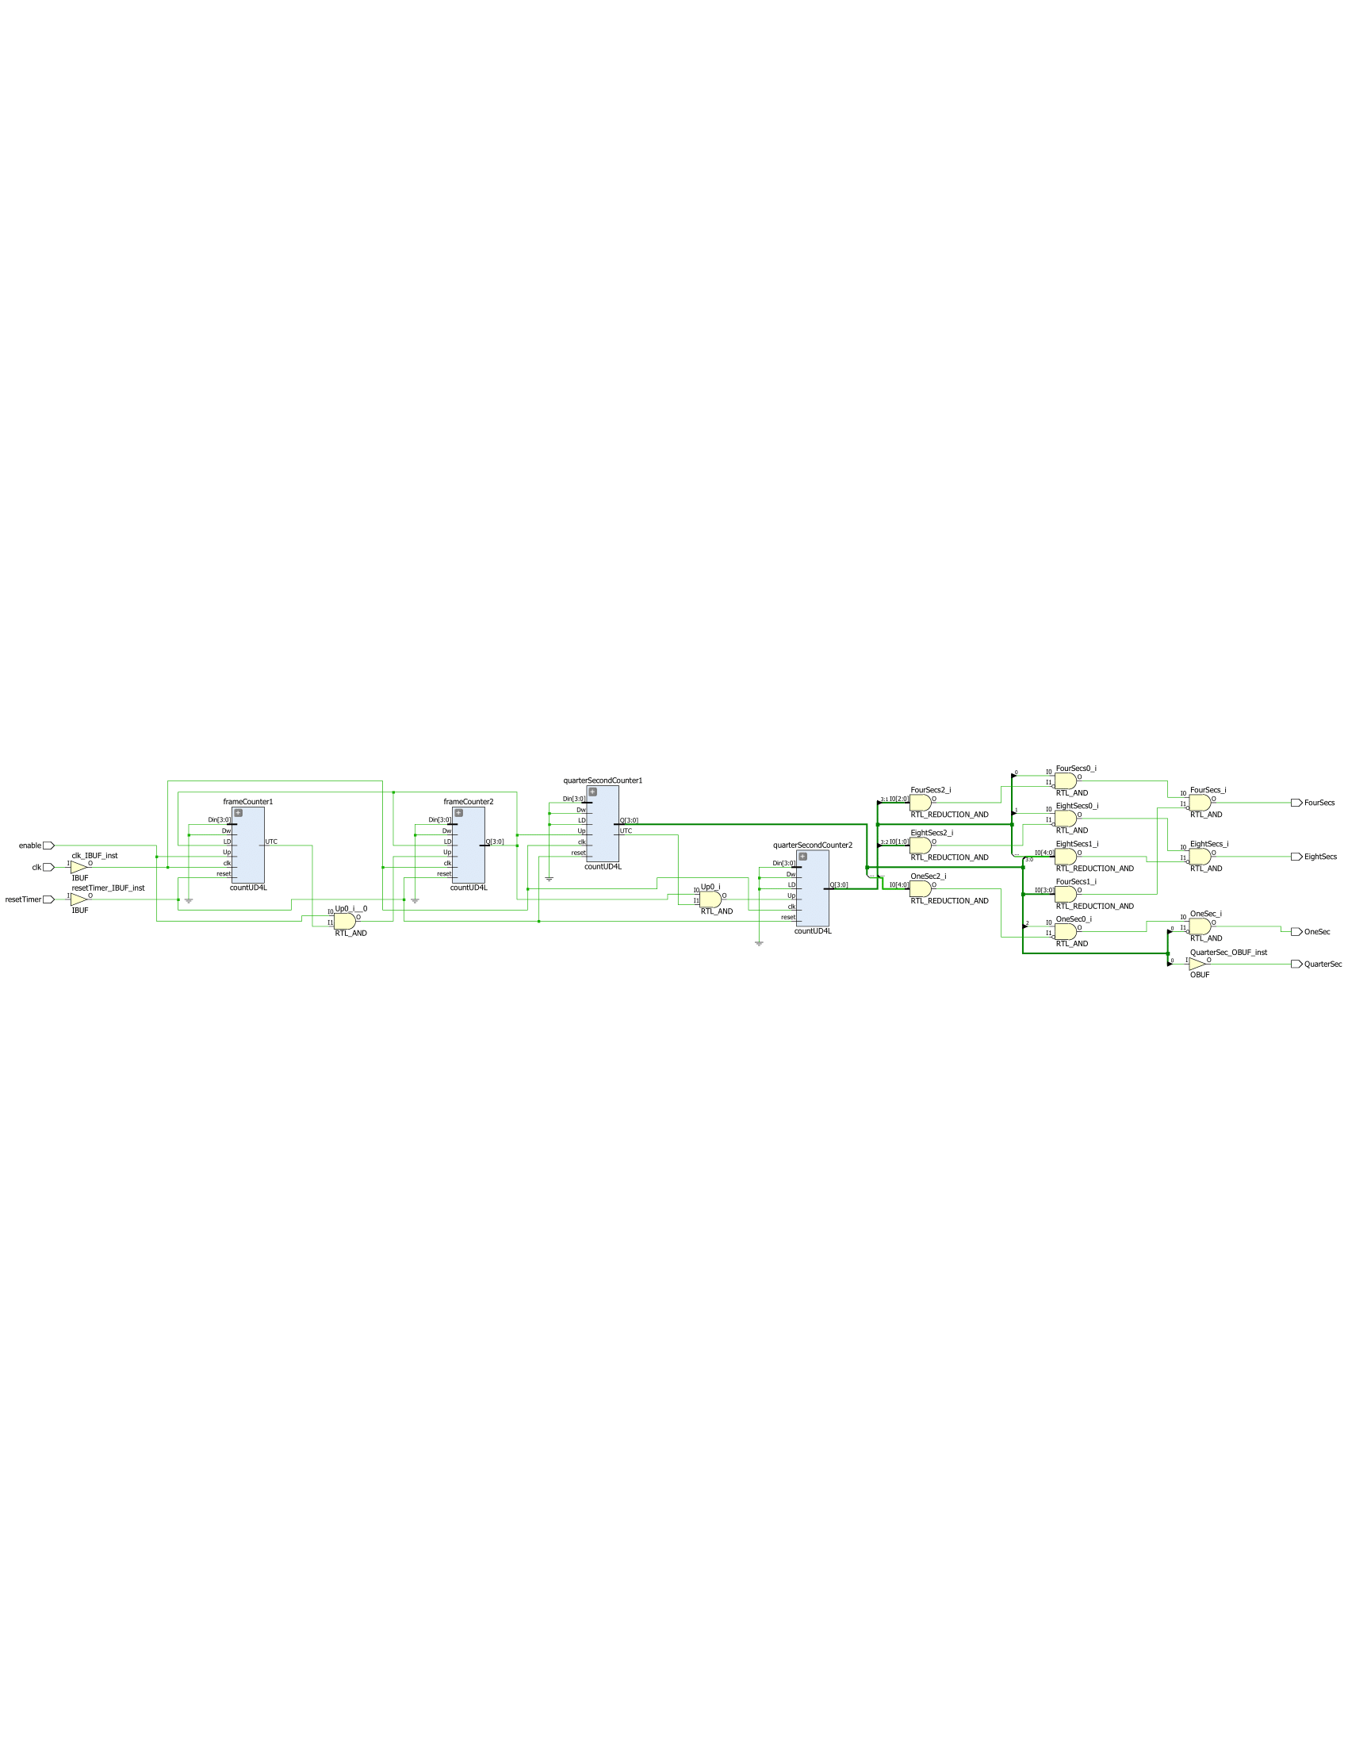

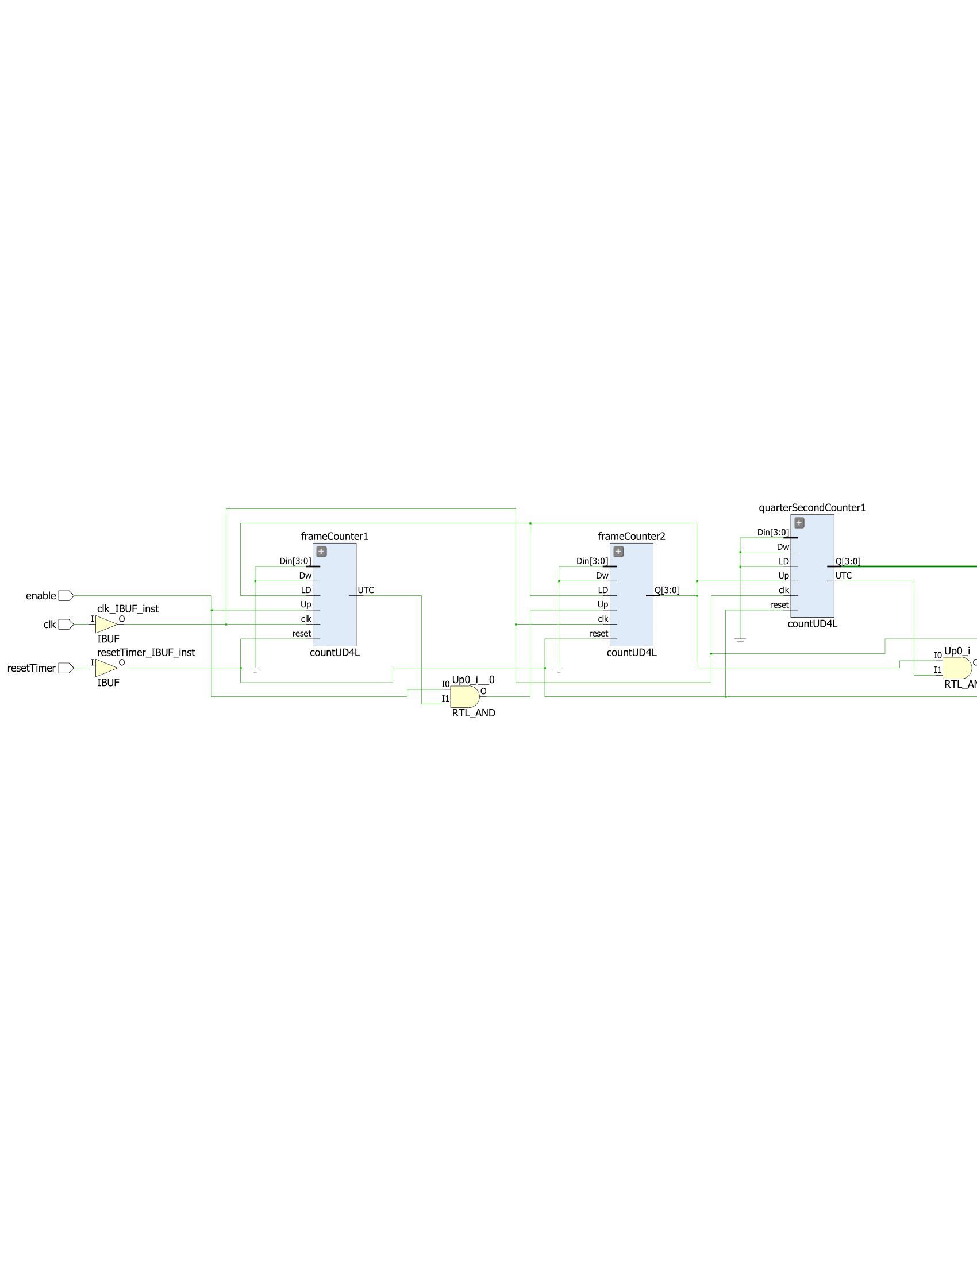

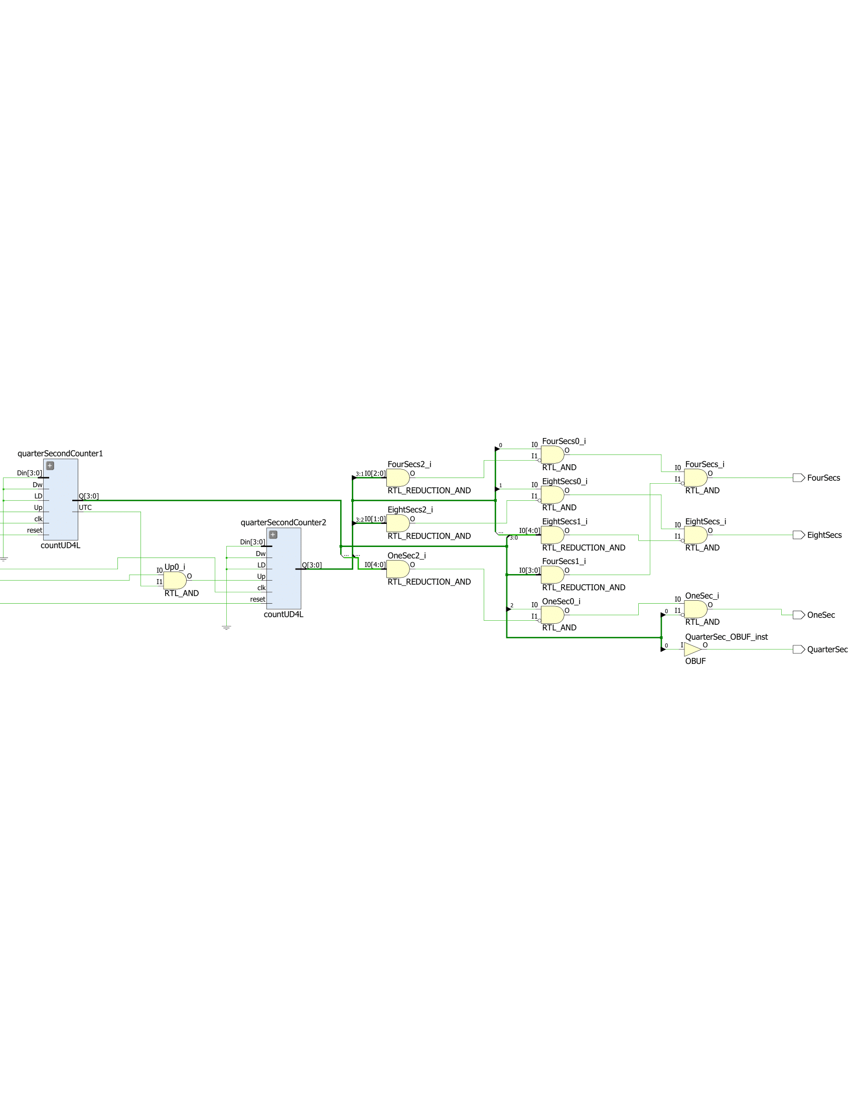

**Part Three: The Game’s State Machine**

In the next part of the lab, I created a state machine that controlled the flow of the game by telling the hive and the bees when to move, as well as keep track of time, reset and start timers, and flash the amount of bees caught, timer, or borders of the hive. The first thing I did was create a state diagram that mapped out every possible scenario and result. The following is the state diagram I created:

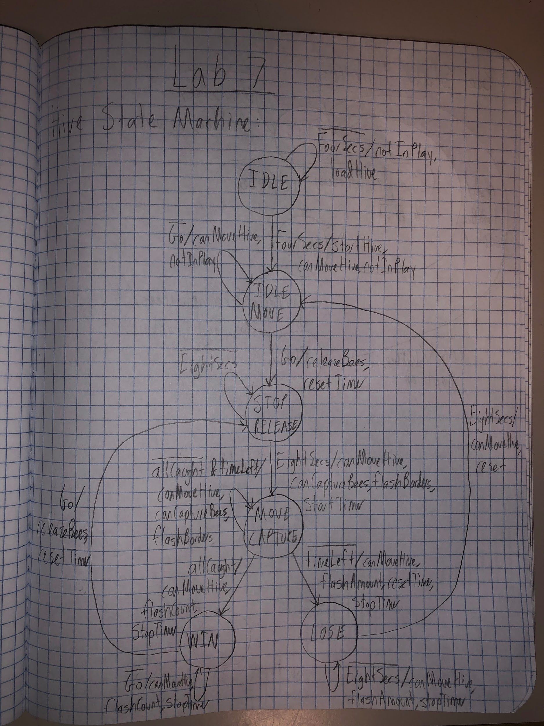

Initially, the system would be in state IDLE. While four seconds have not passed, the game is not in play, and the hive should continuously be loaded into its starting position. When four seconds do pass, the system transitions to state IDLE_MOVE and the hive starts moving, can be controlled by the user, and the game remains not in play. The system remains in state IDLE_MOVE, not in play, and can be moved until the user presses btnC. When the user does press btnC, the system transitions to state STOP_RELEASE, the bees are given the signal to start moving, and the time counter is reset. While eight seconds have not gone by, the system stays in STOP_RELEASE, and the hive cannot move while the bees can, and are not caught if they overlap. After eight seconds have passed by, the system transitions to state MOVE_CAPTURE, the hive moves again with its borders flashing and can capture bees. The timer also starts counting down. Until the bees are all caught or time runs out, the system stays in MOVE_CAPTURE, and the hive keeps moving with its borders flashing and can capture bees. Two possible cases can now happen:

1. If all bees are caught, the system transitions to state WIN where the hive can keep moving, and the timer is stopped and begins flashing. The system stays in this state and continues doing this until the user presses btnC again, and the system goes back to state STOP_RELEASE, the bees are released, and the time counter is reset.
2. If time runs out, the system transitions to state LOSE where the hive can keep moving, the timer counter is reset, and the timer is stopped and the amount of bees caught begins flashing. The system stays in this state doing this until eight seconds have gone by, and the system transitions to state IDLE_MOVE, resets the bees to their original positions, and the hive can be moved.

The code and schematic for the state machine’s logic is shown below.

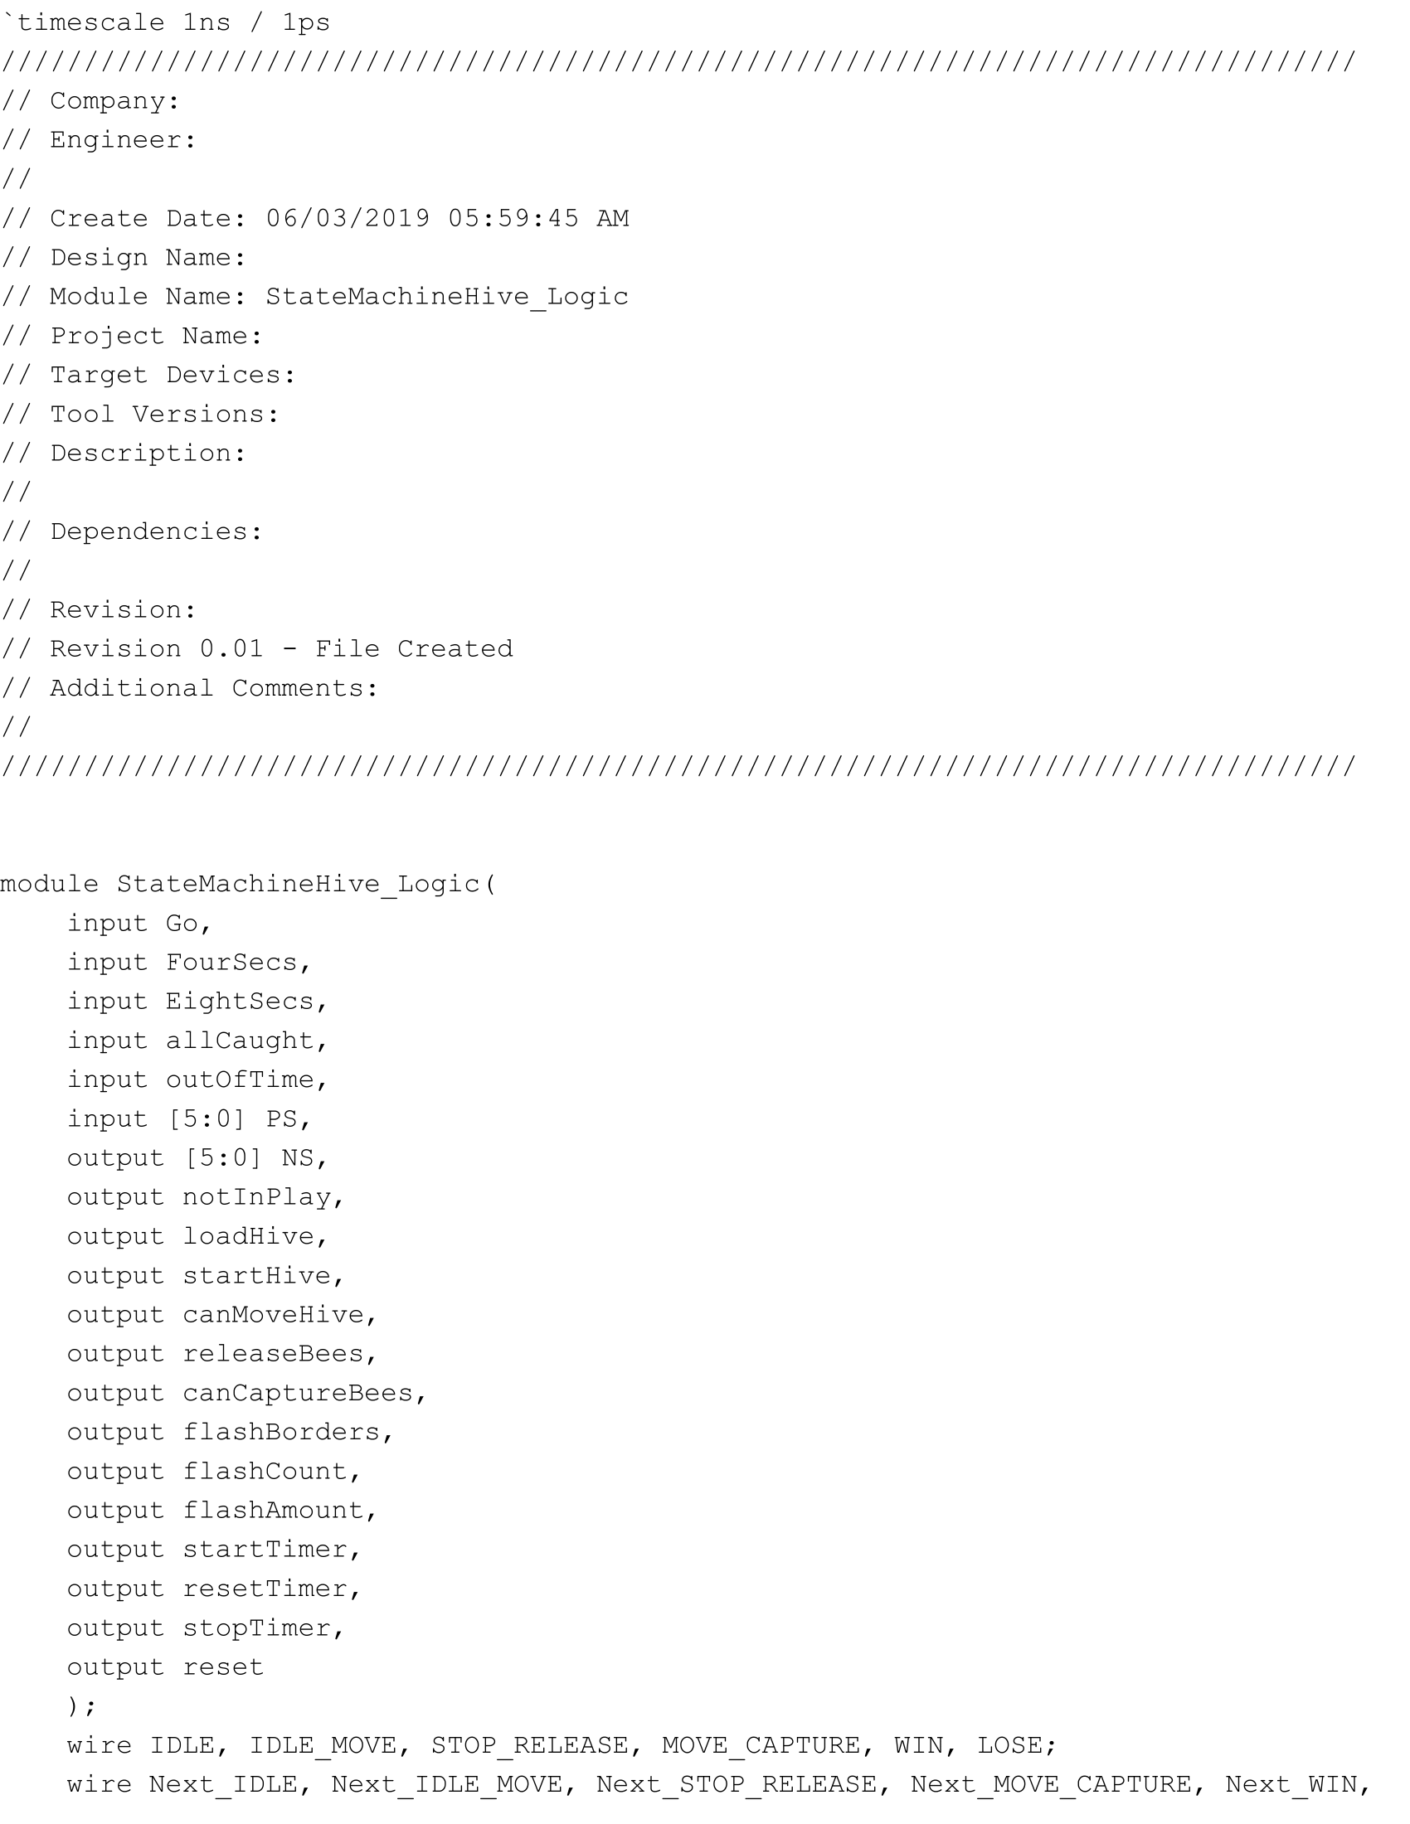

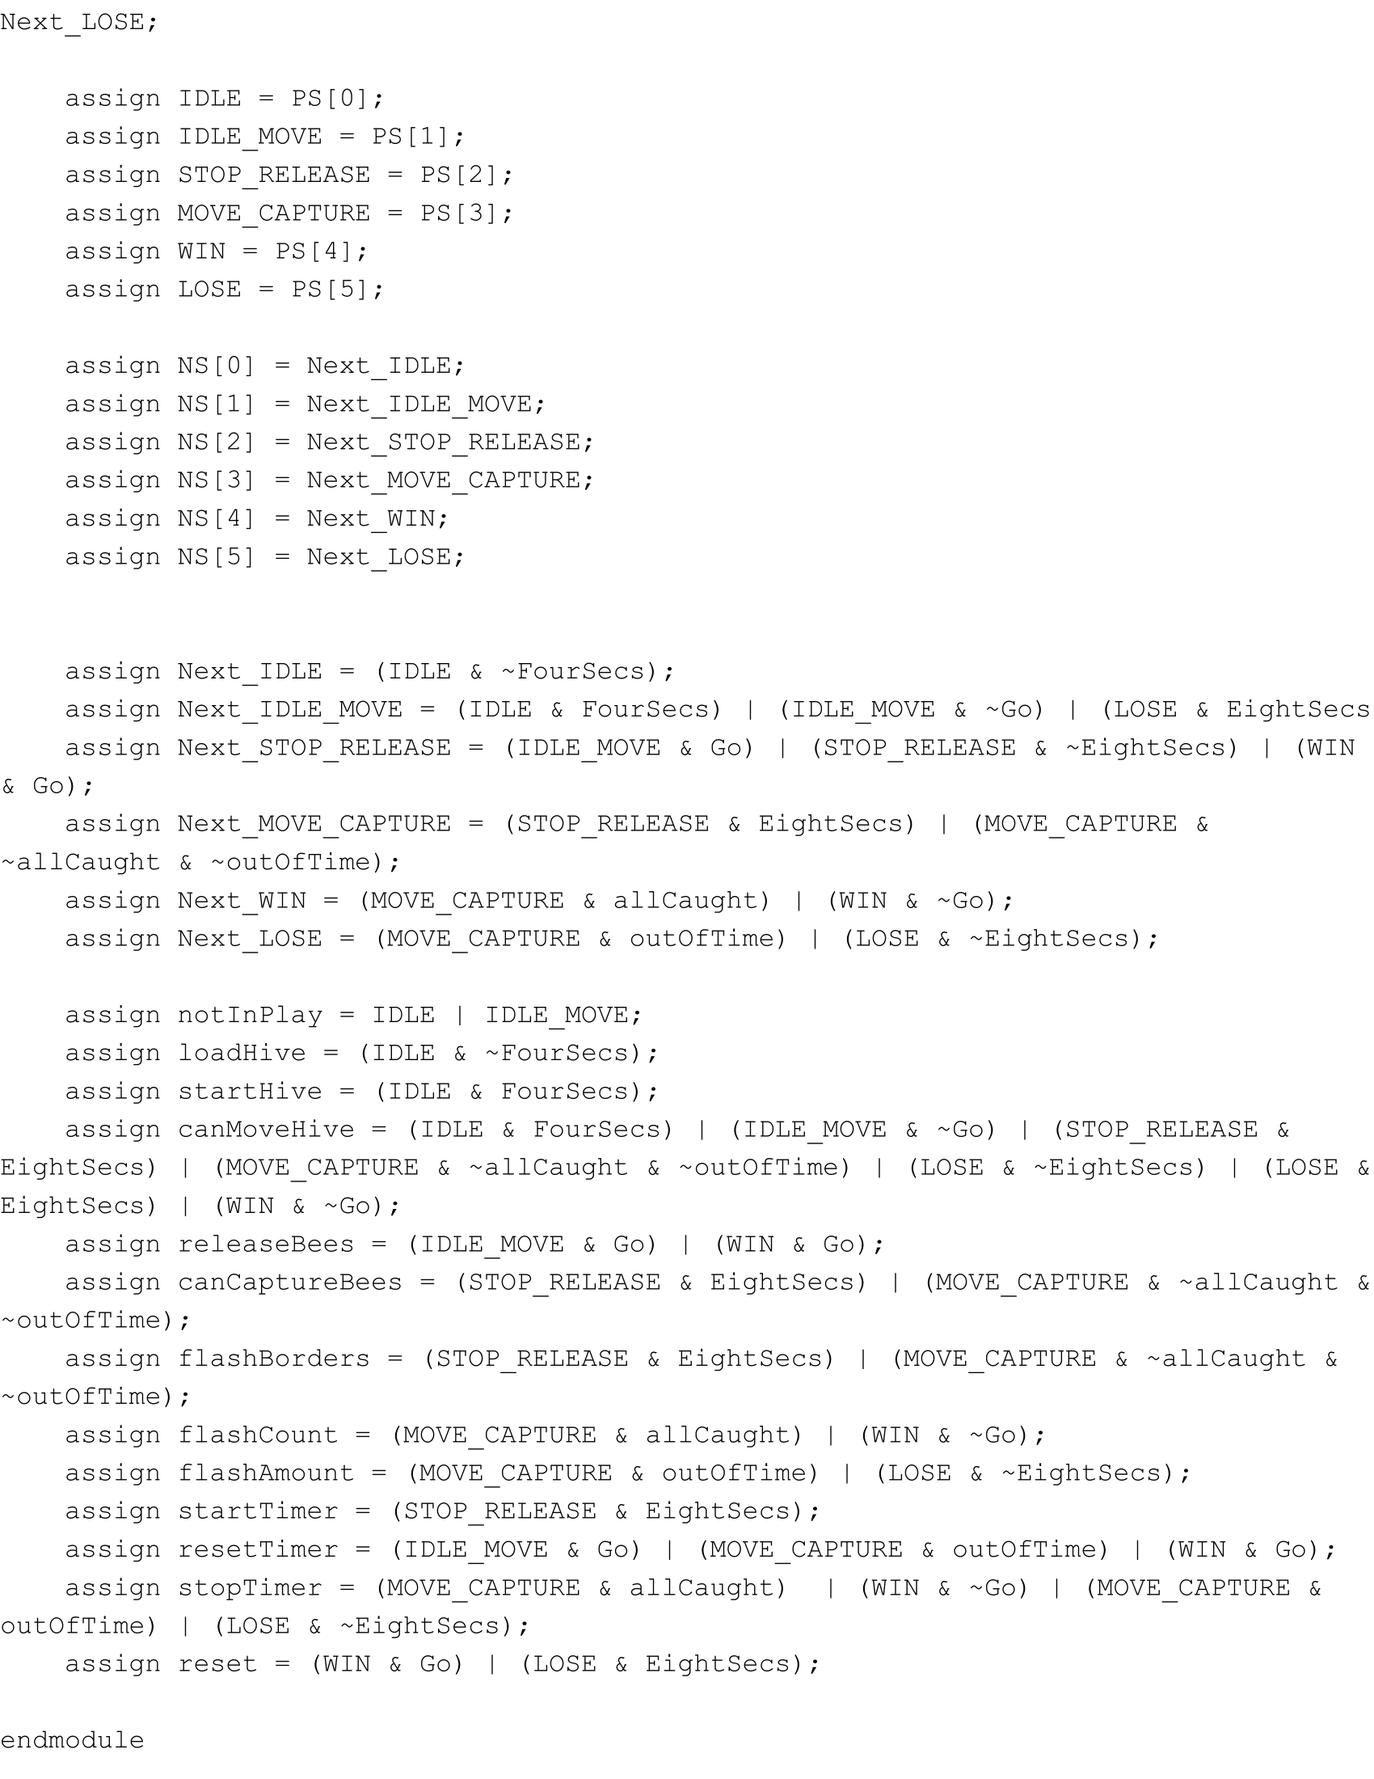

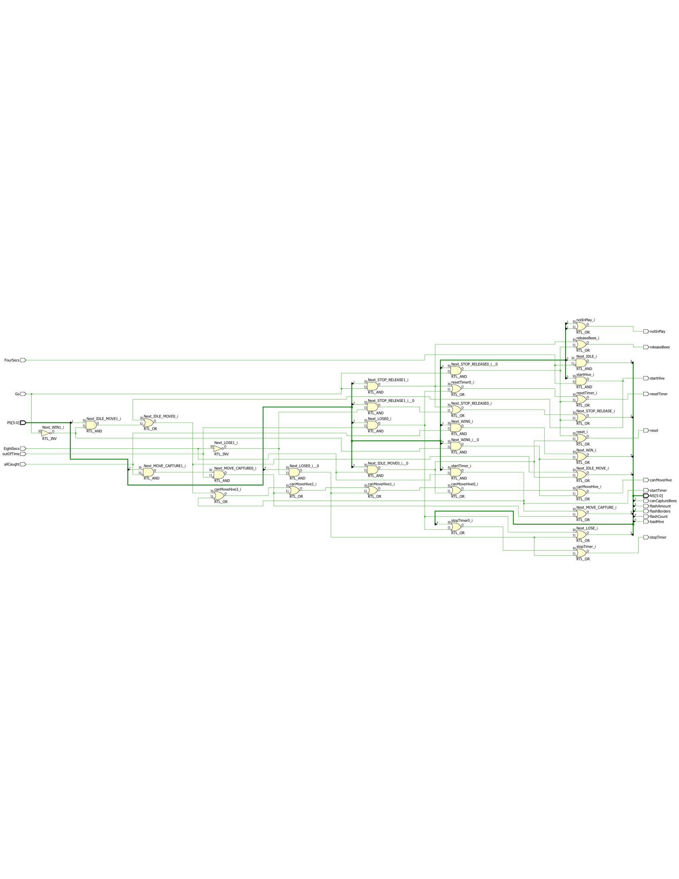

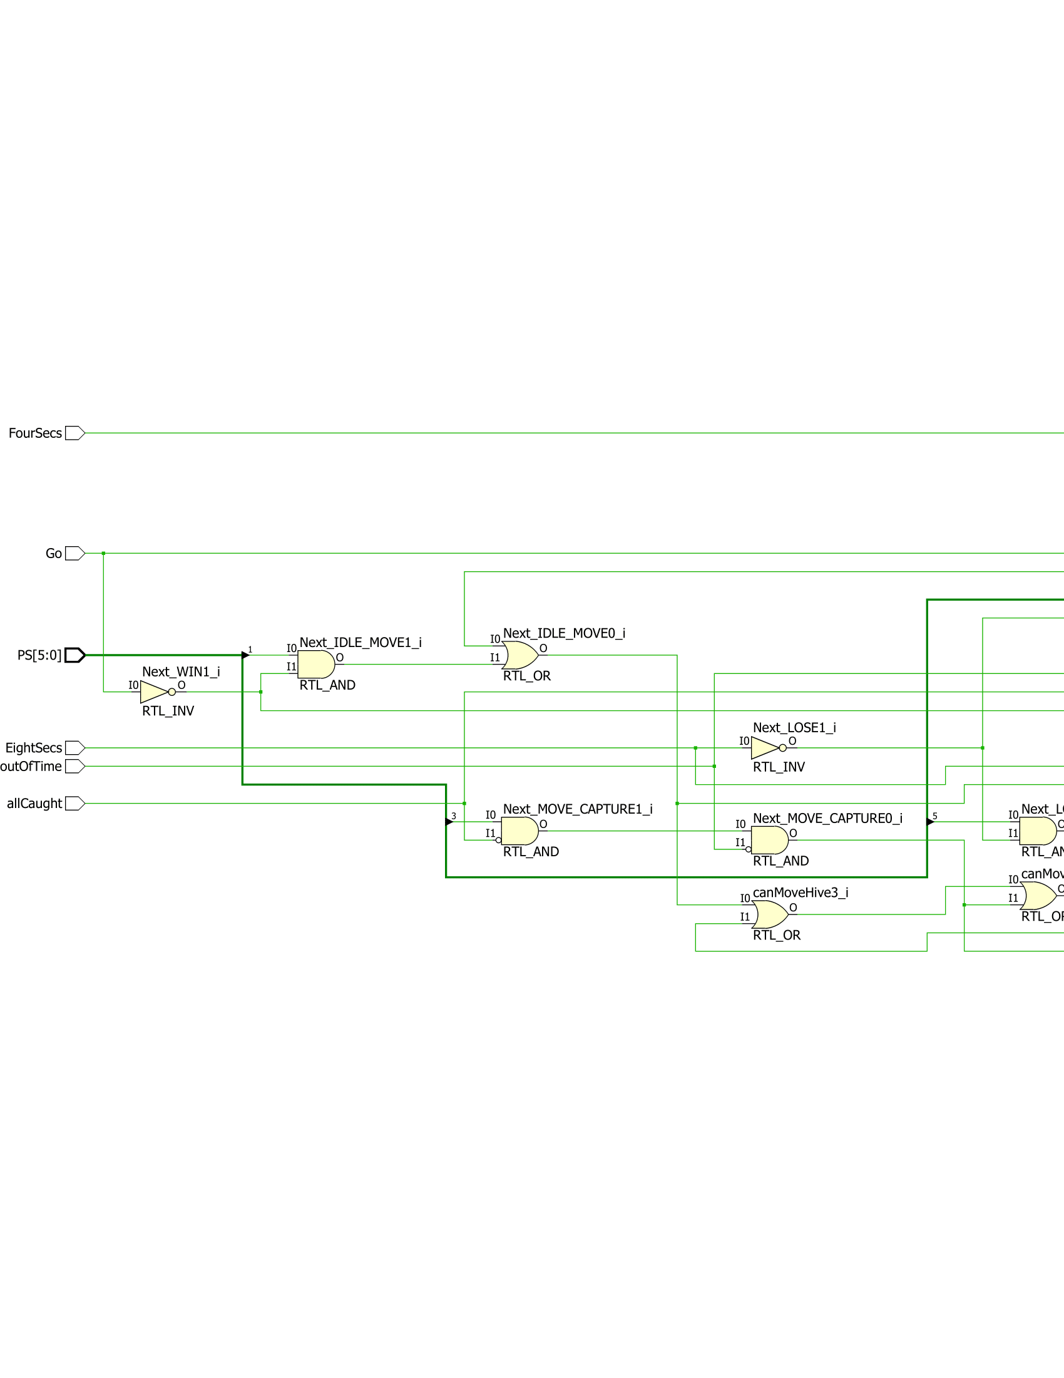

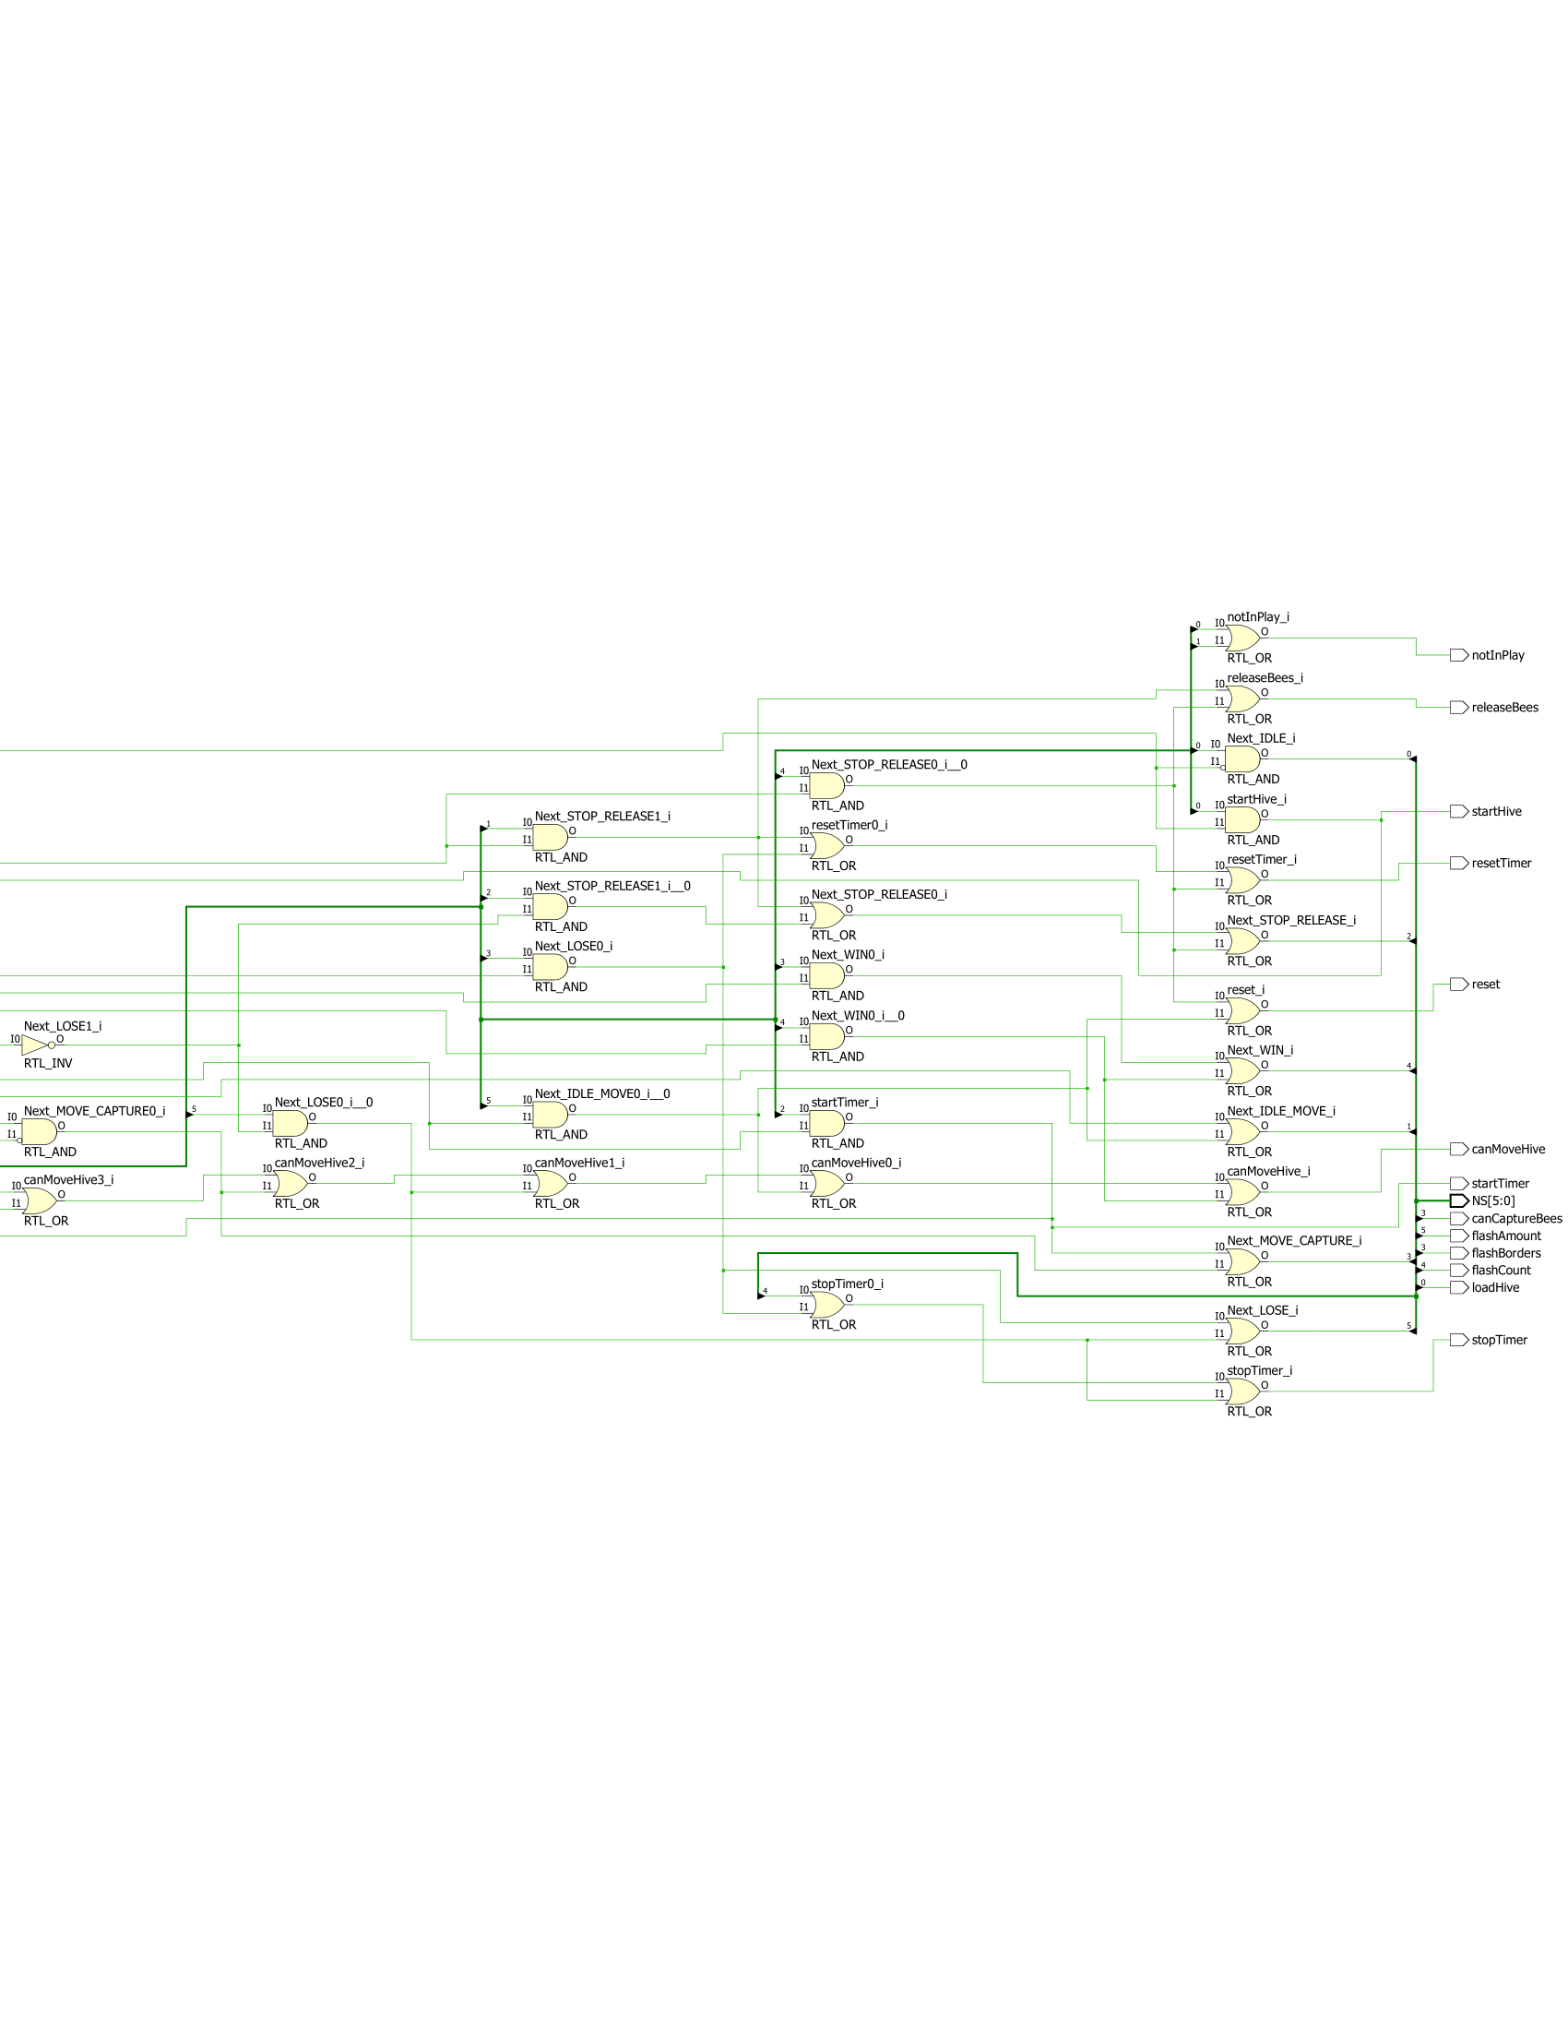

To facilitate the inputs and outputs of the state machine, I created a module that makes use of six flip-flops and one-hot encoding to ensure that only one state happens at a time. The code and schematic are the following:

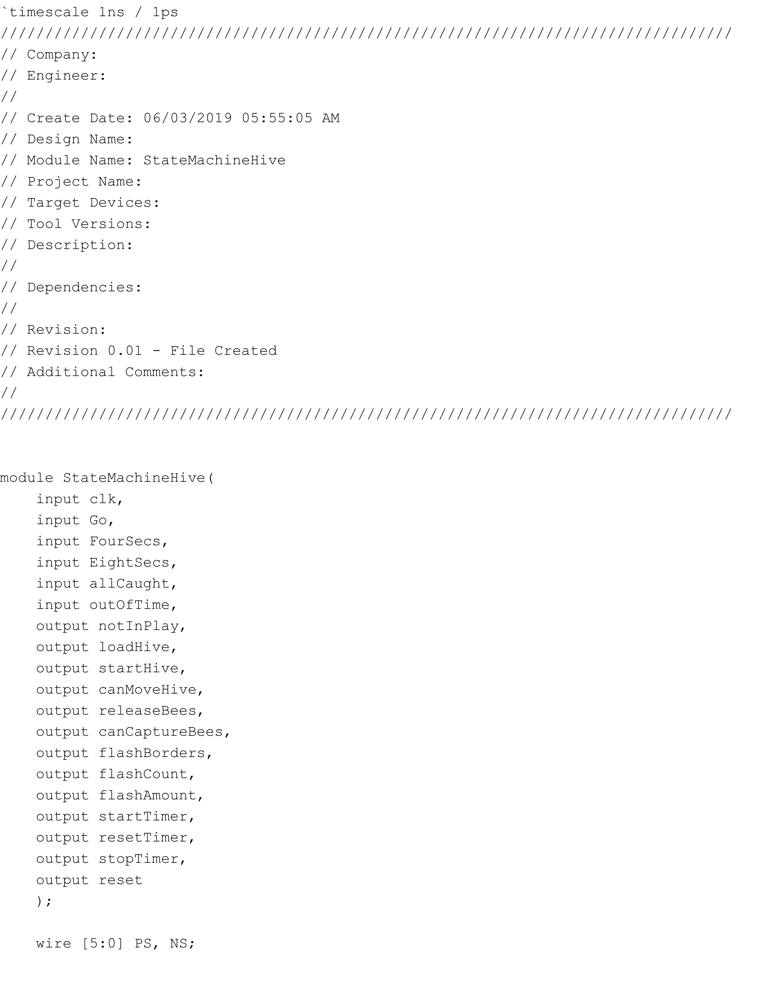

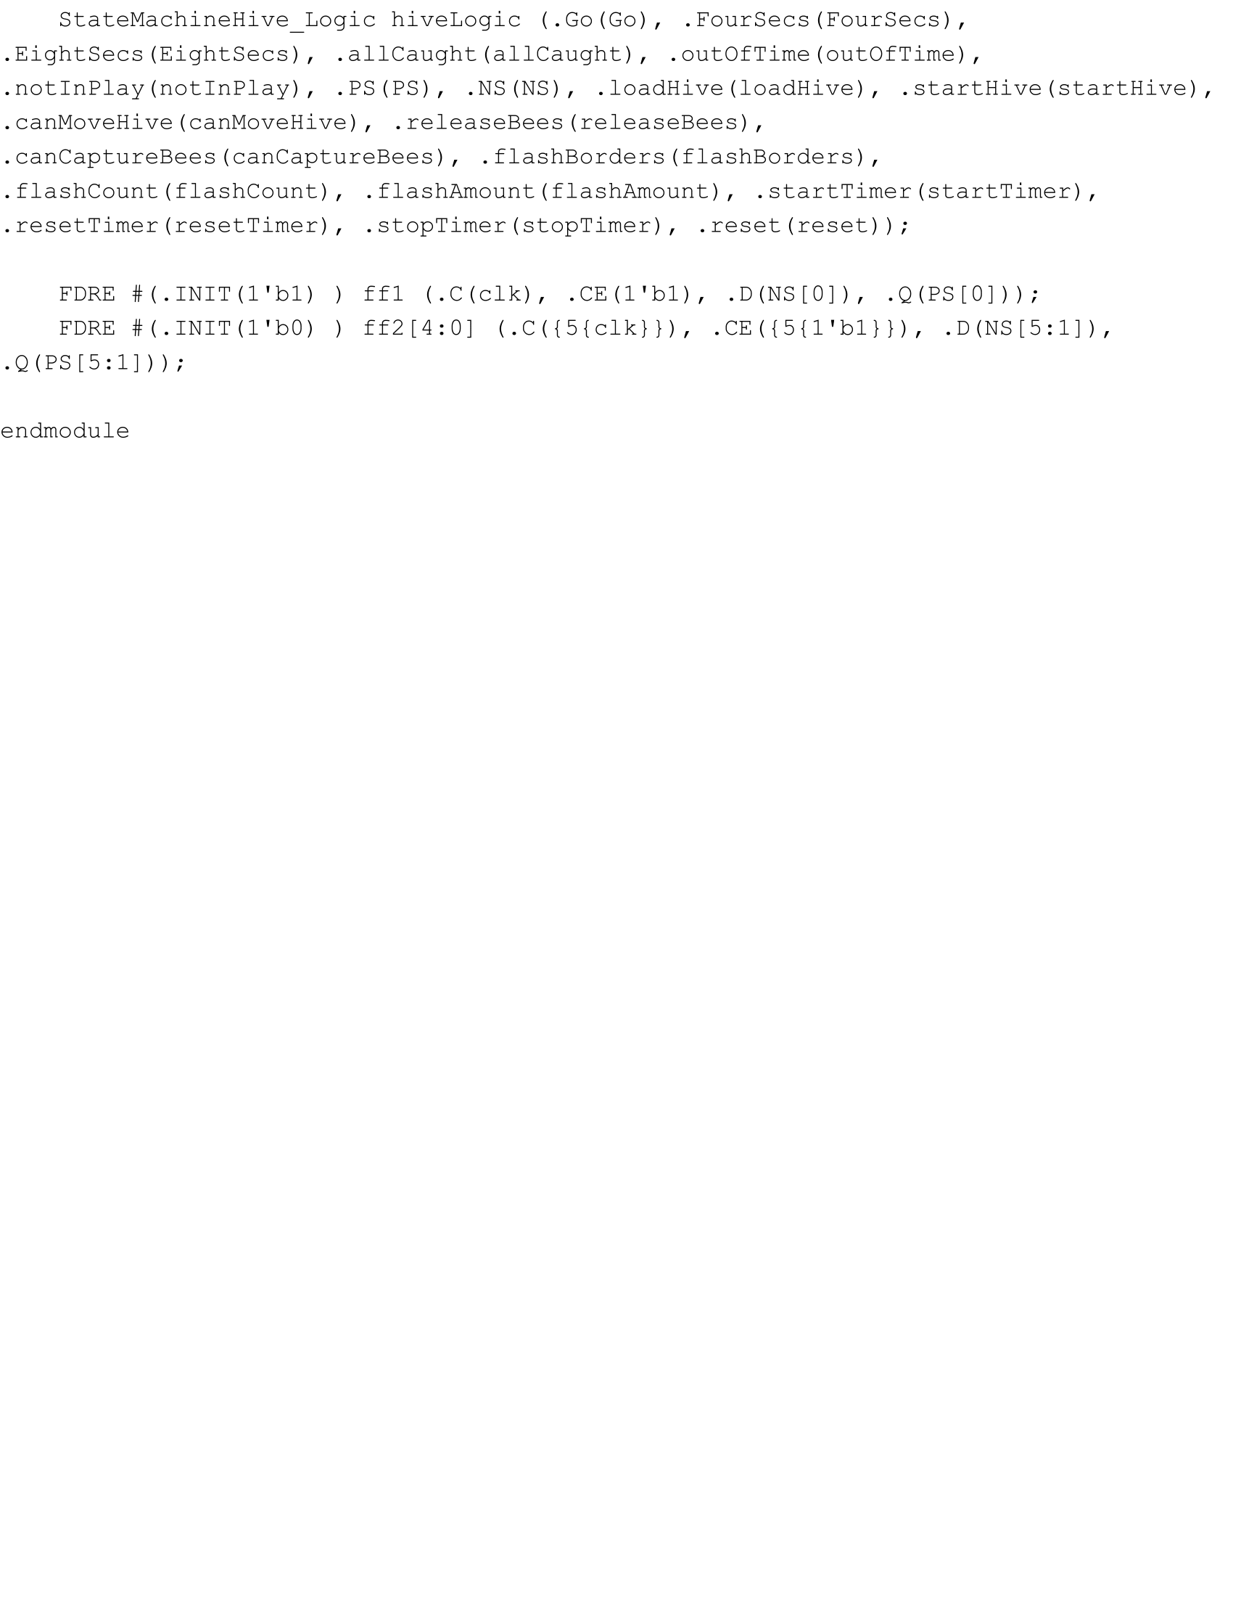

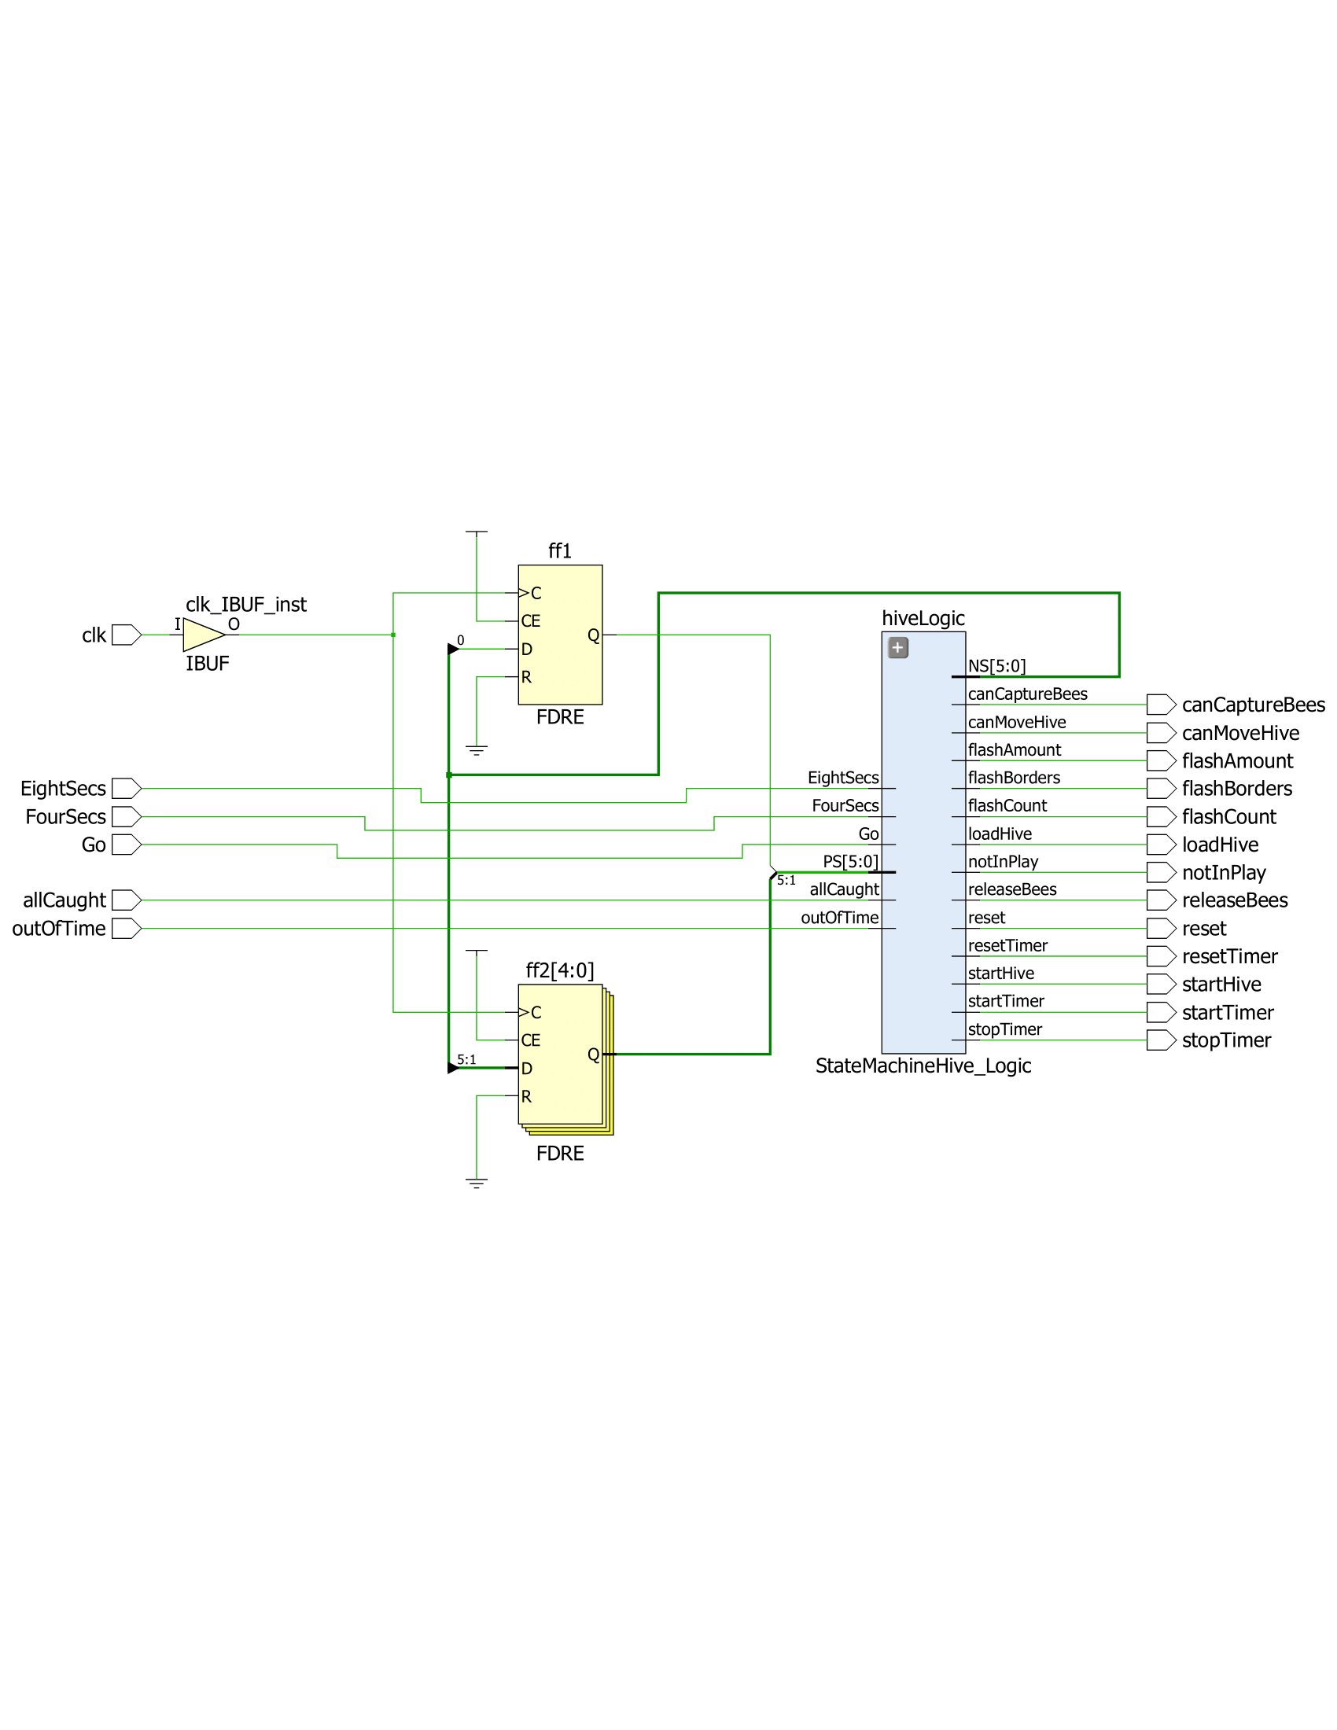

**Part Four: The Hive**

The next part of the lab was to create a functioning hive that could move around on its own or be controlled by button presses from the user and bounce in an opposite direction when coming into contact with the borders on the screen. To do so, I created a 80 x 80 square that began in the middle of the screen, and would move by having two counters that incremented its x-coordinate and y-coordinate. The hive began by moving diagonally down and right after being told to move from the state machine, and kept its direction until it reached a wall, received a certain button input from the user, or until the state machine forced it to stop moving. I implemented this by having four flip-flops that kept a direction high and kept incremented or decrementing the counters accordingly or not at all. The hive also had borders, which I set by just extending the region from the square with a width of 4 pixels. The code and schematic for the hive are the following:

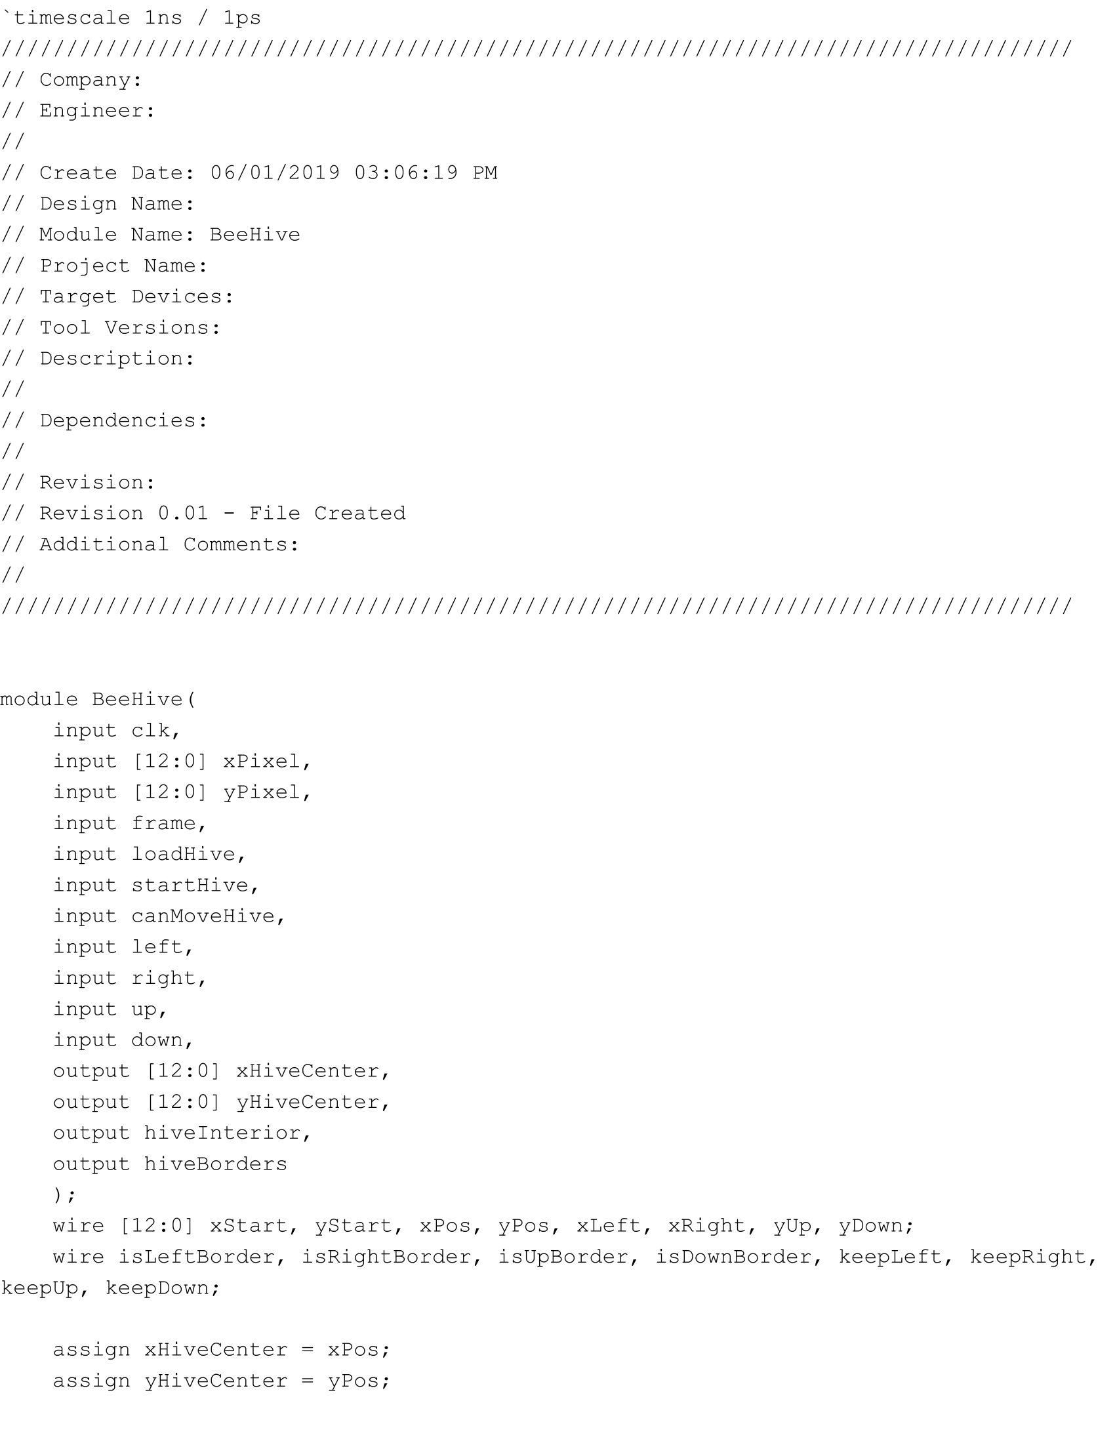

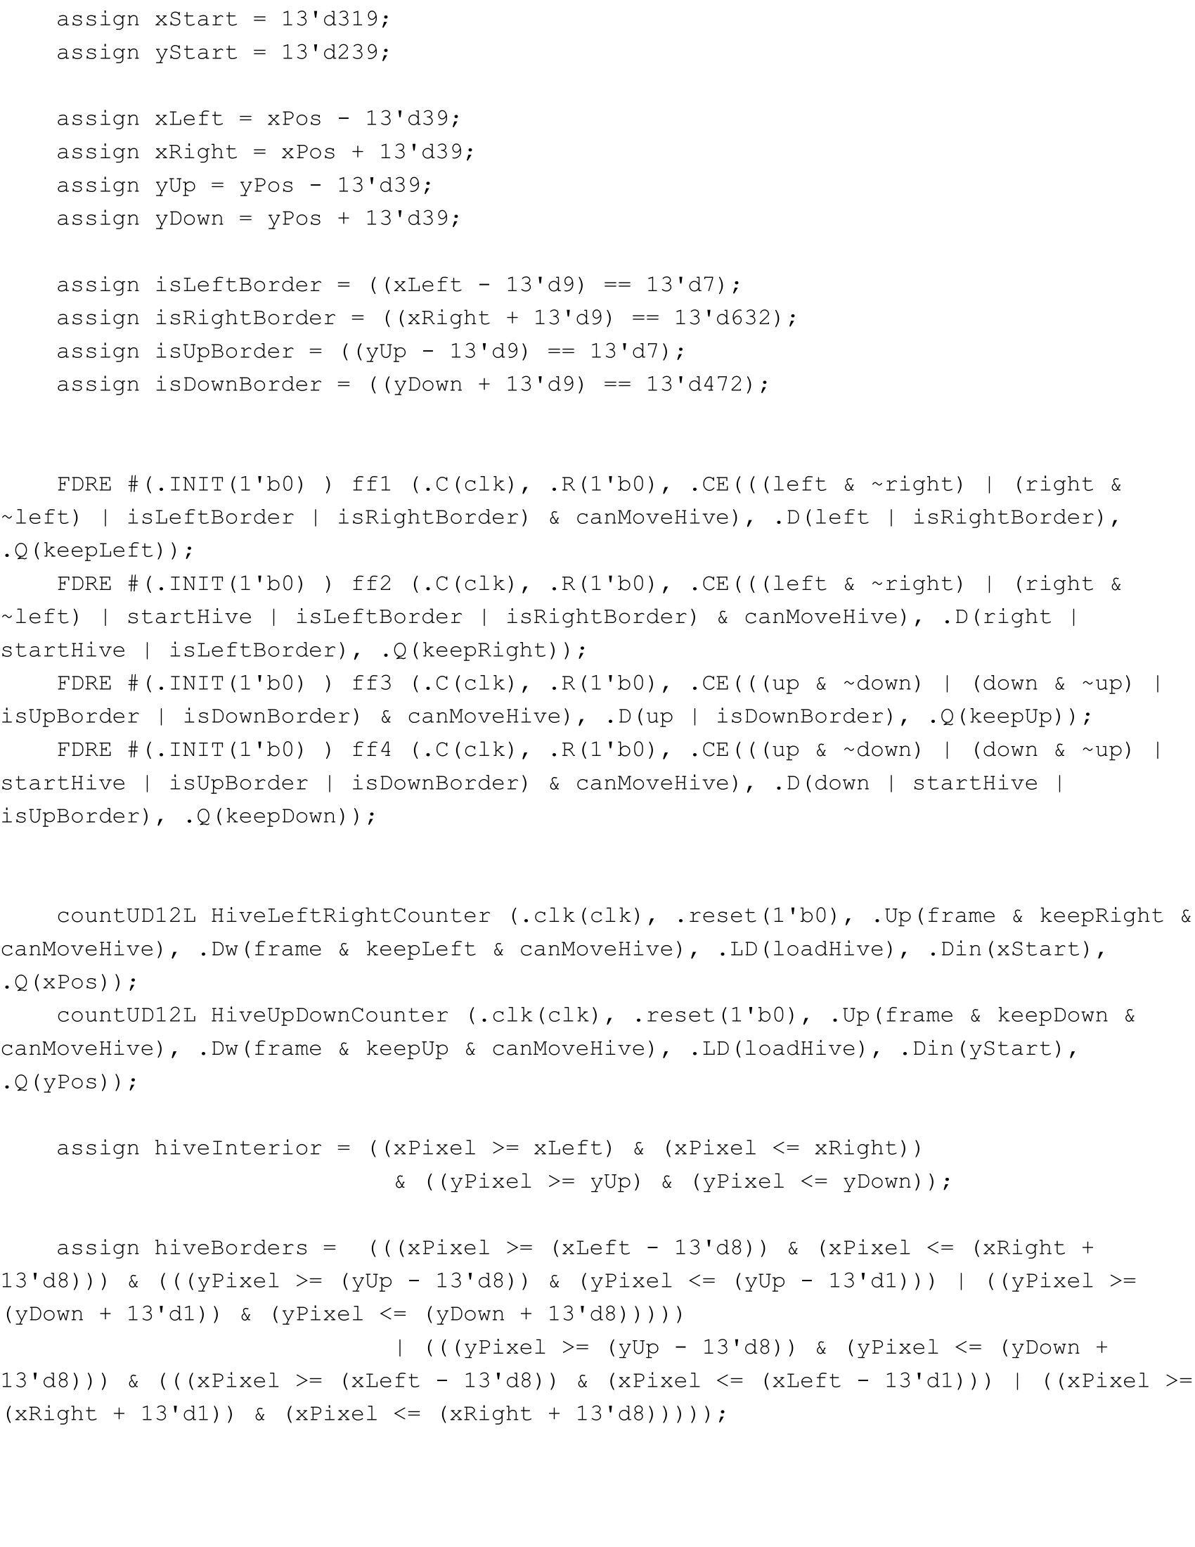

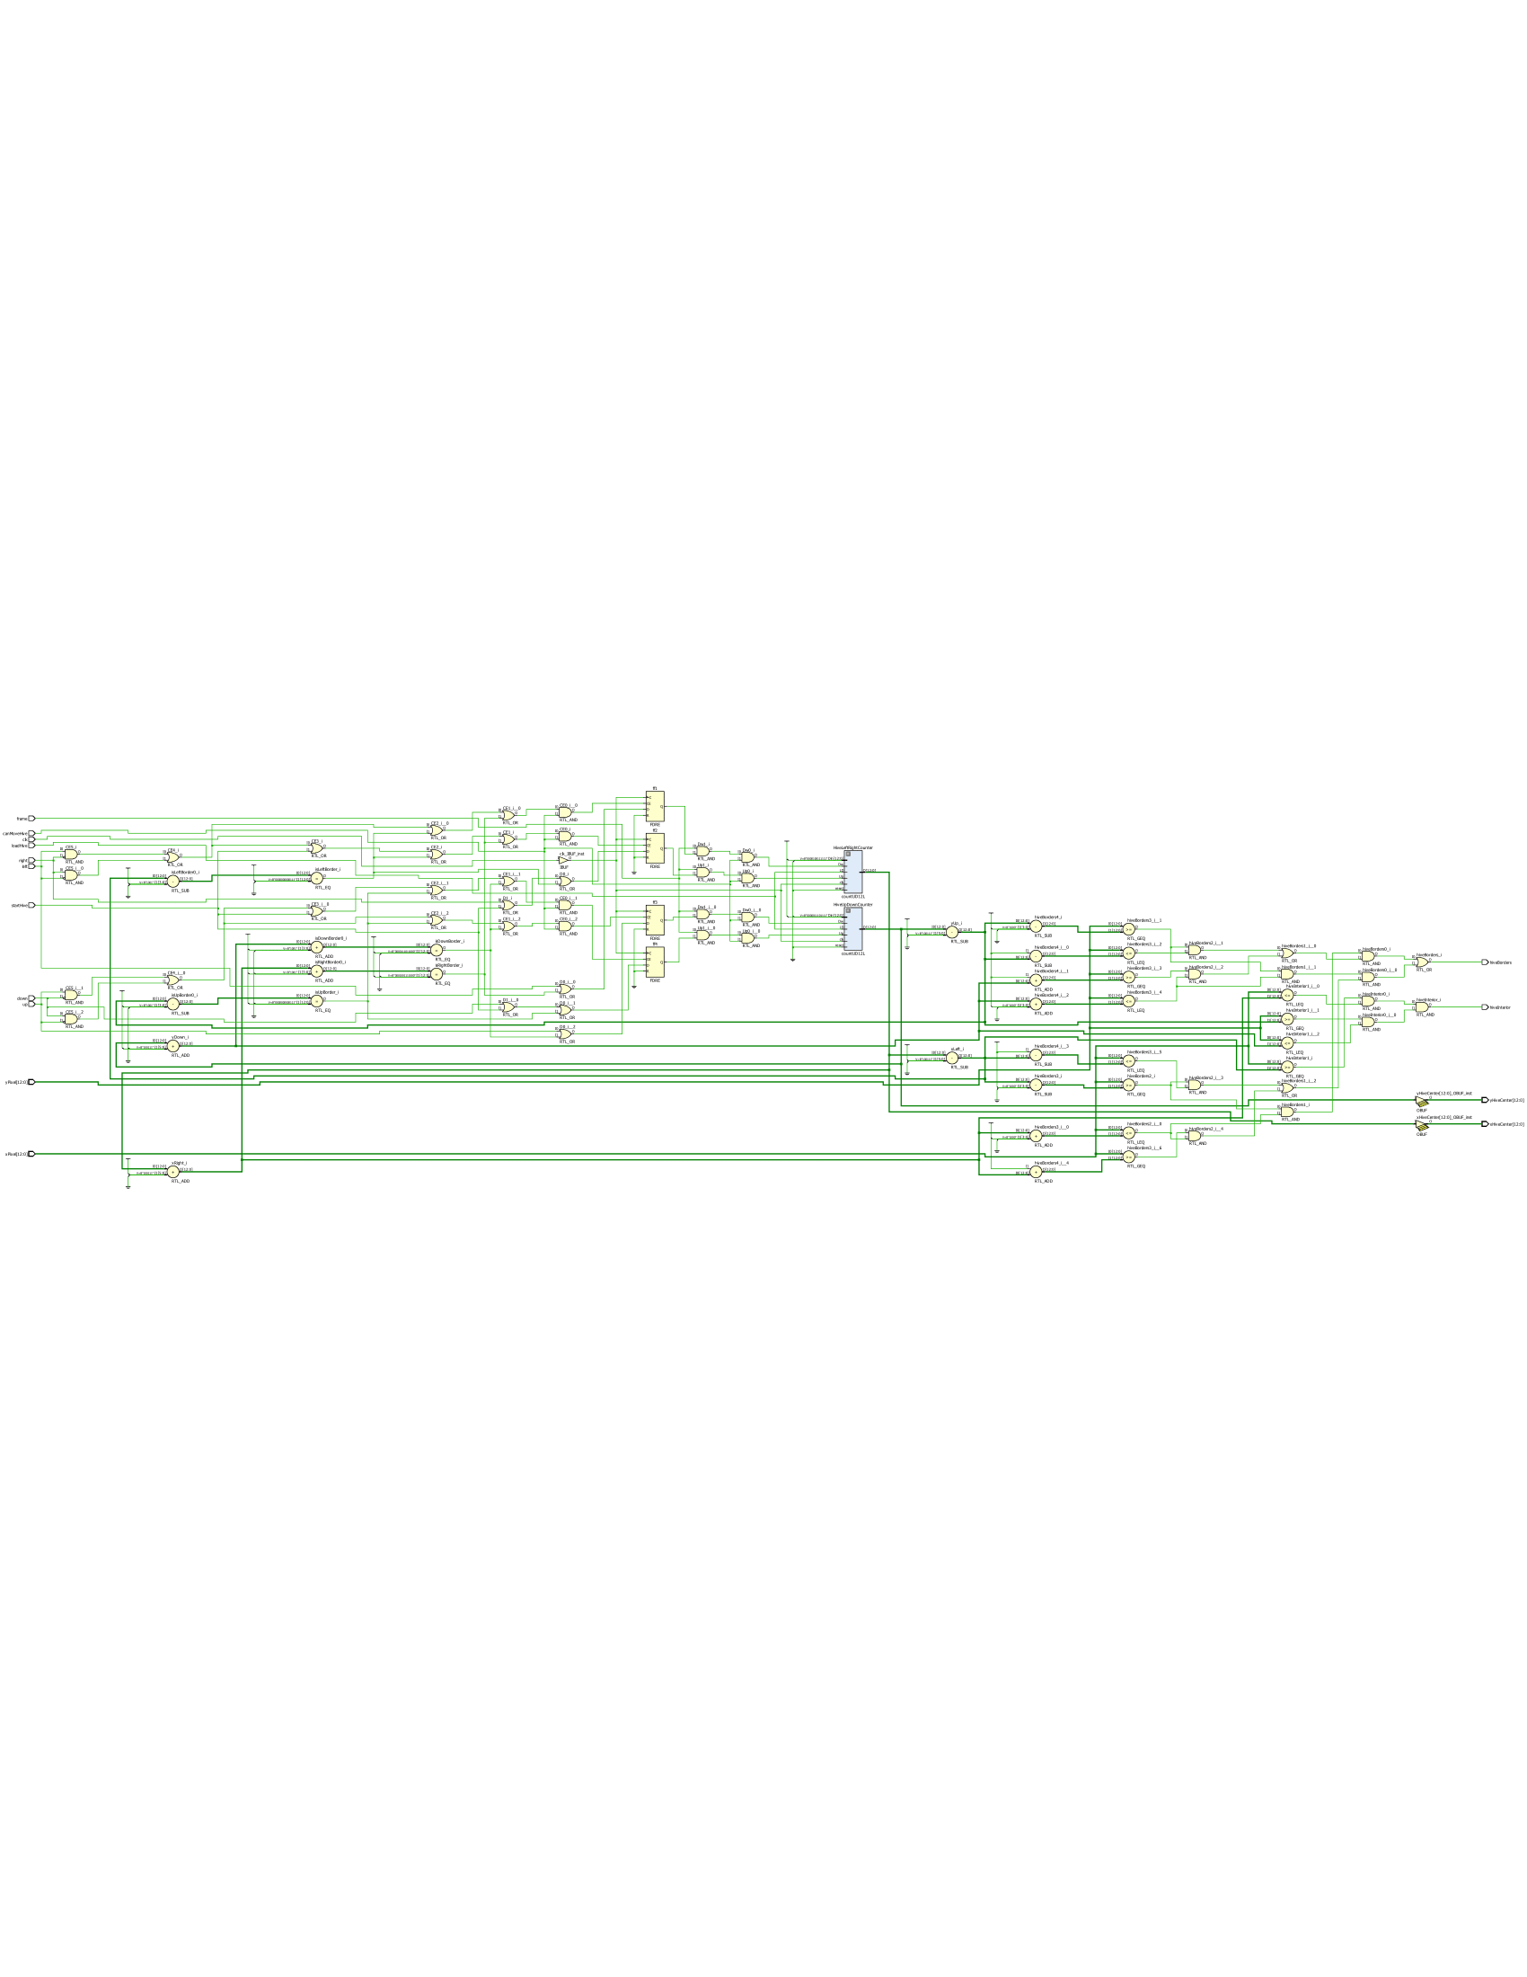

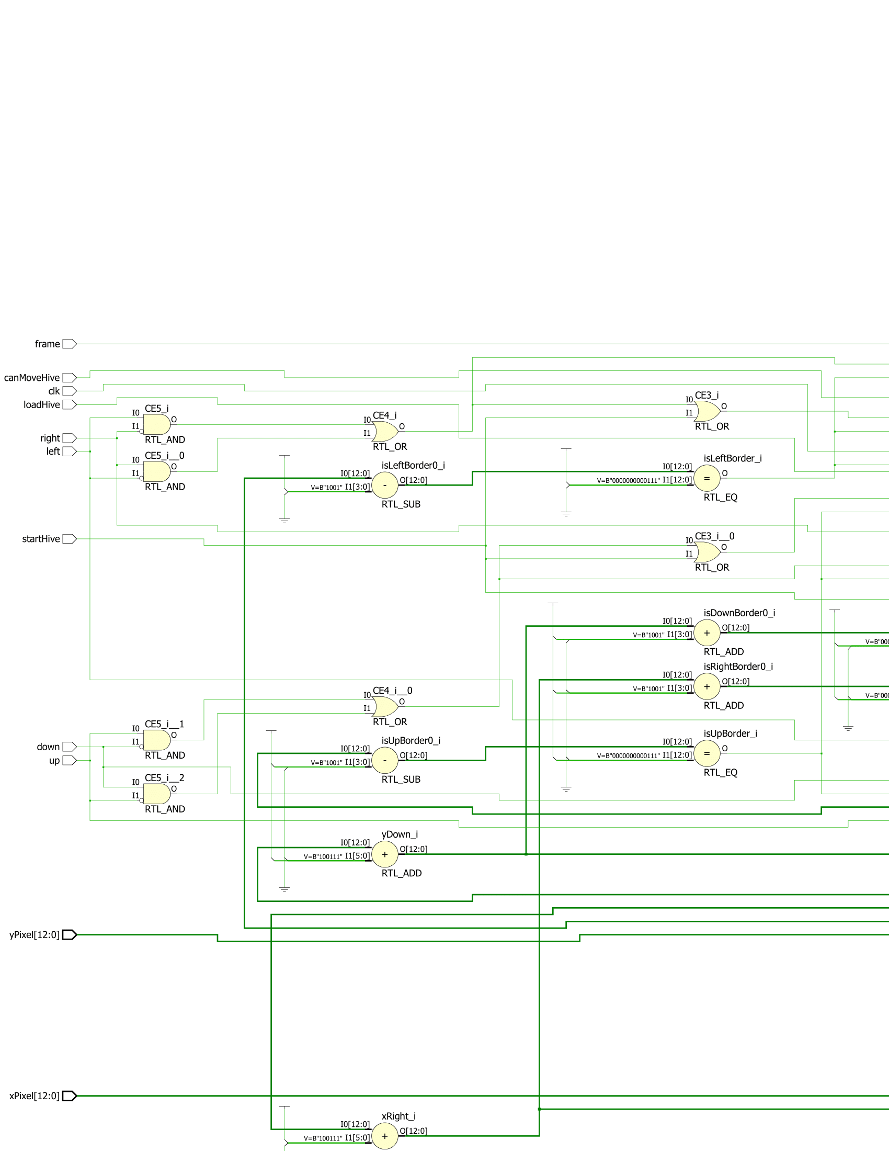

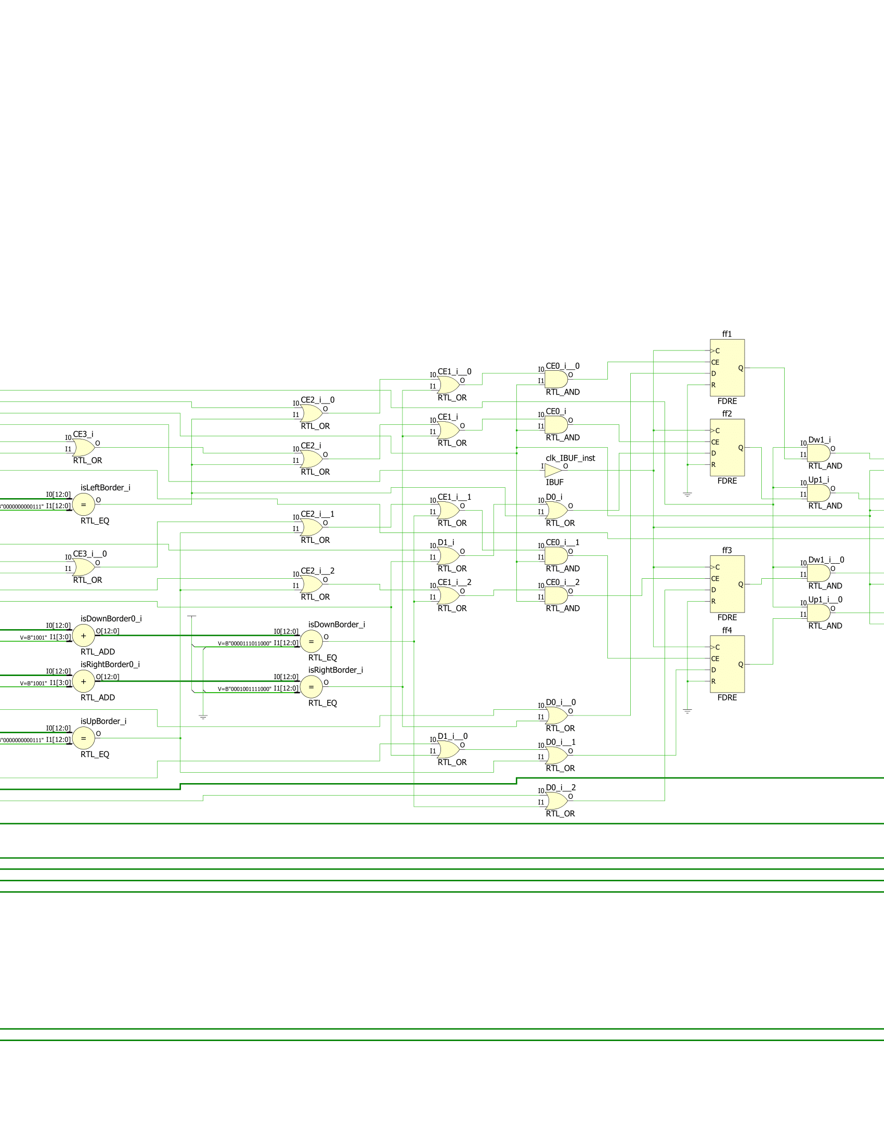

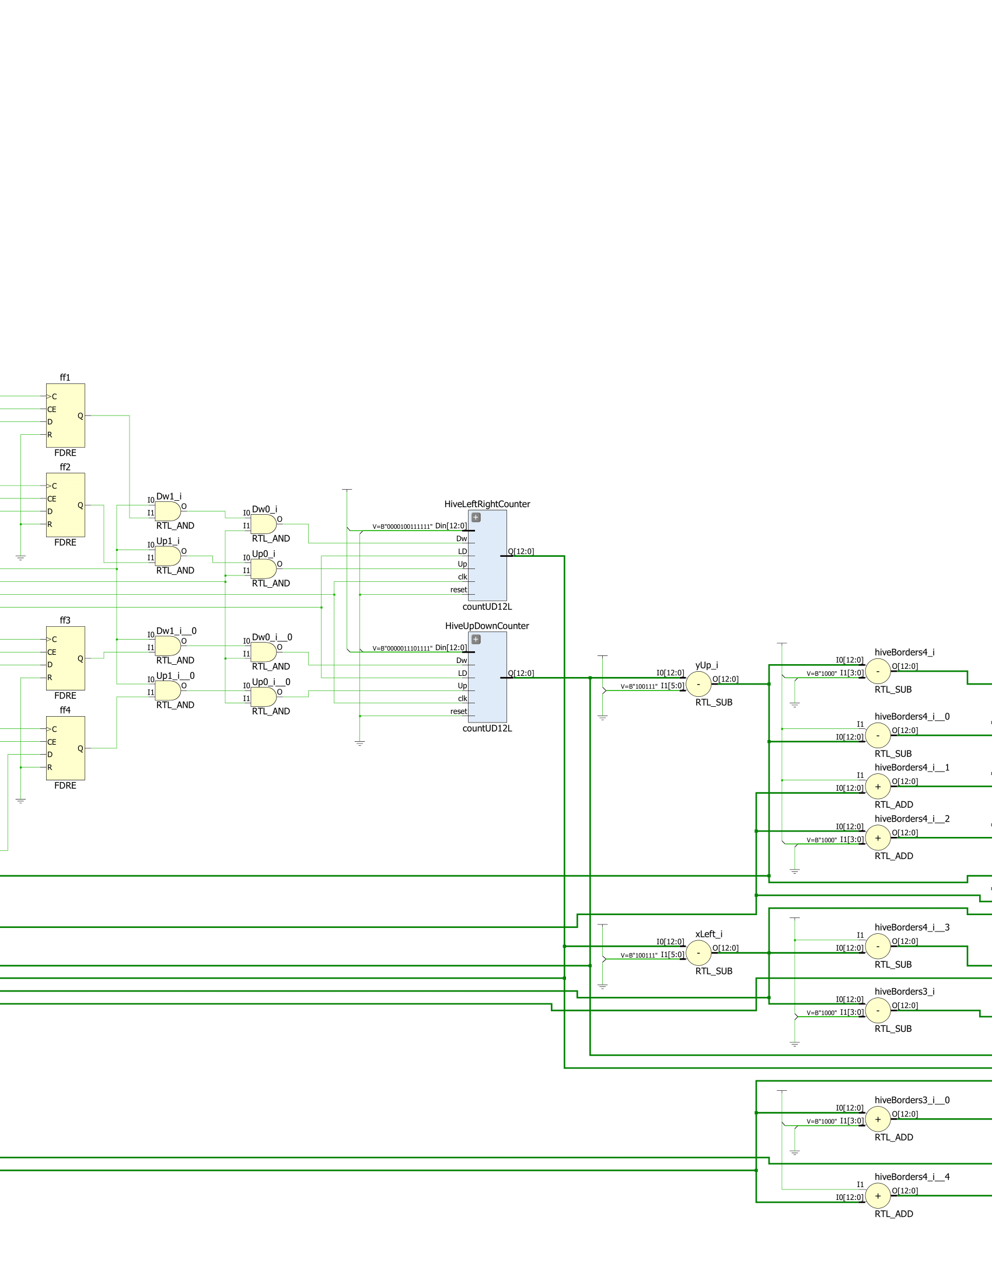

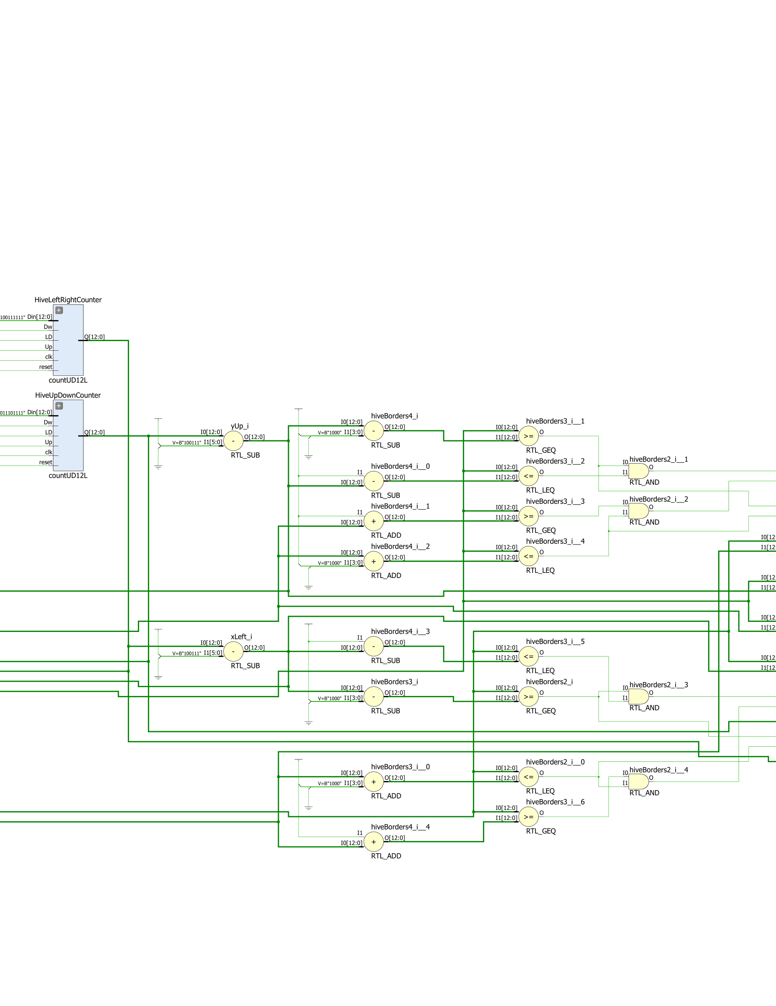

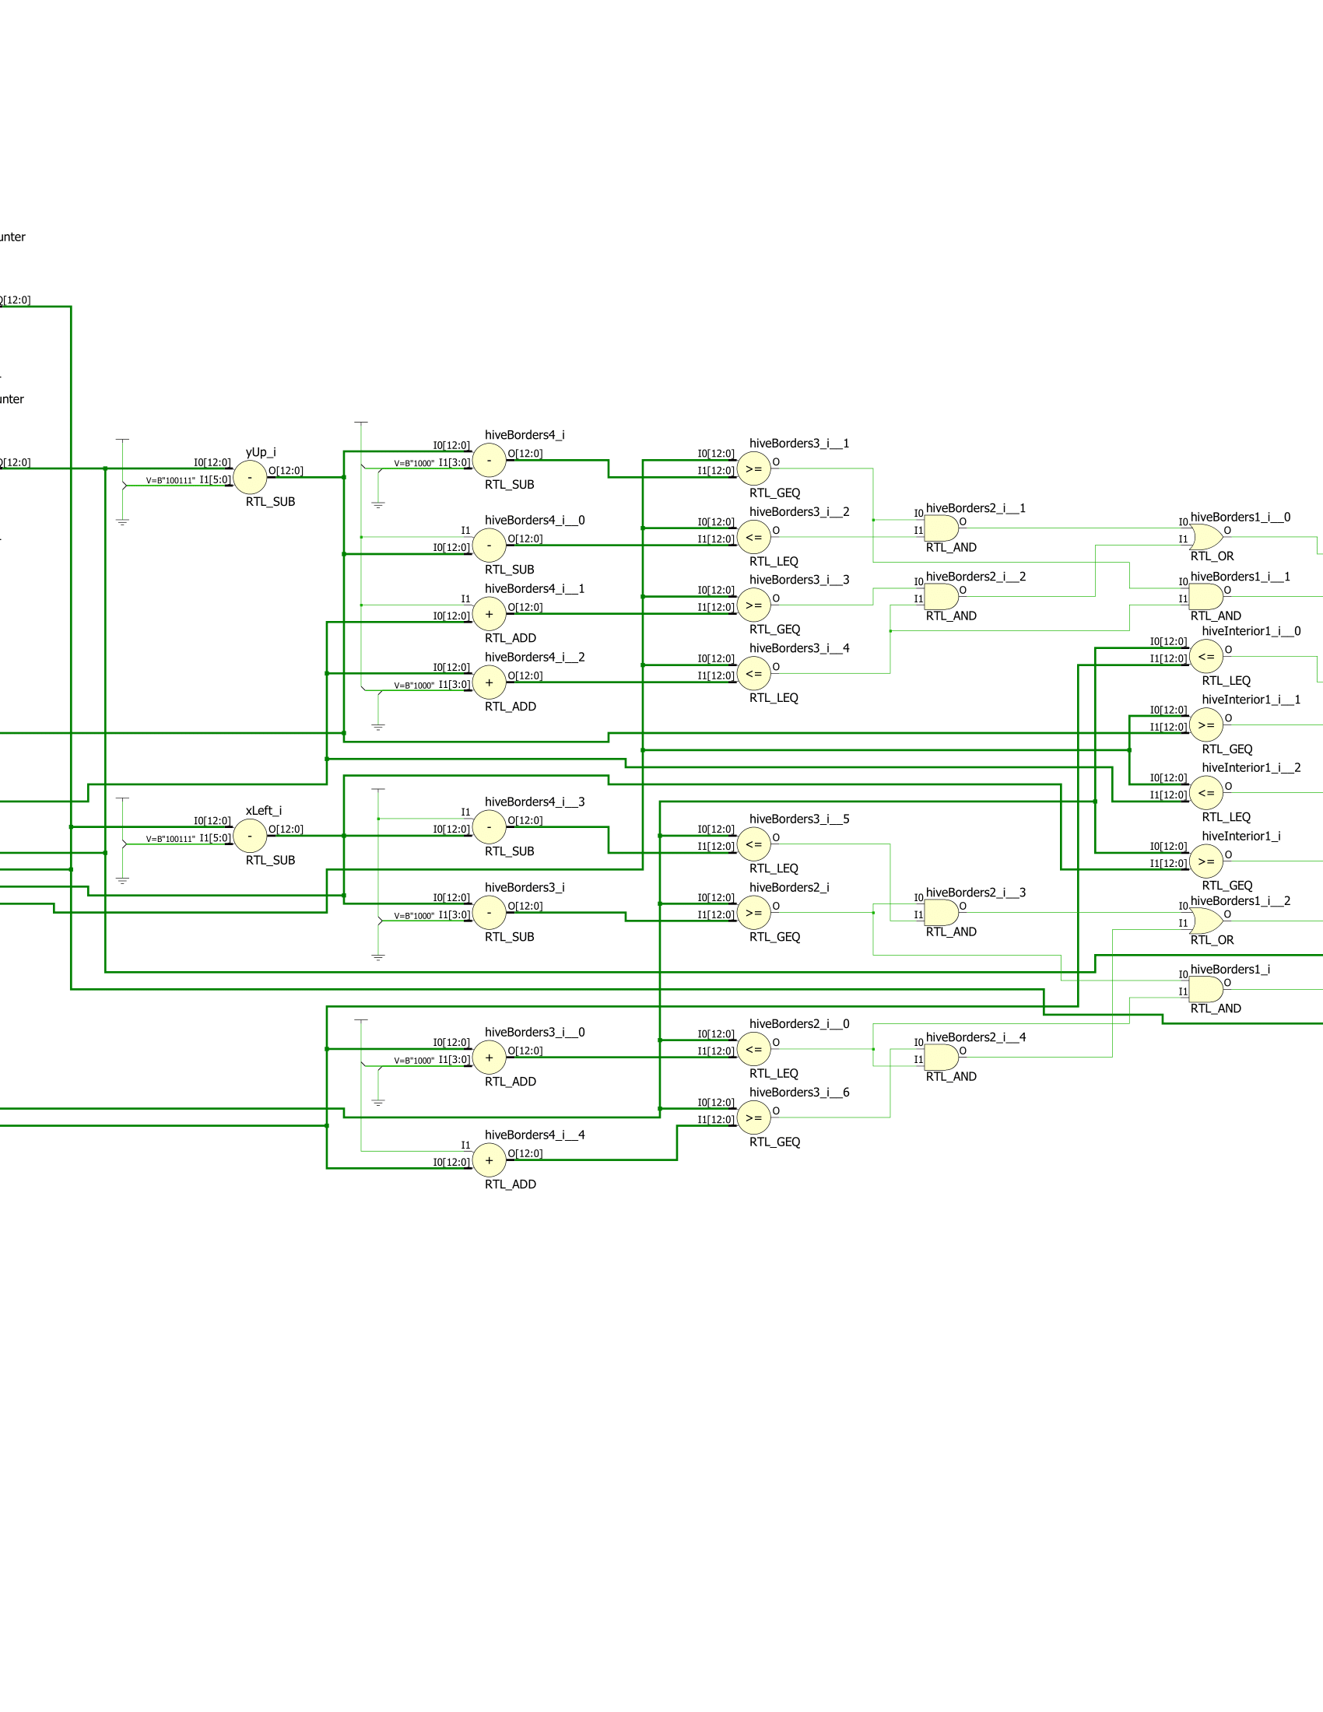

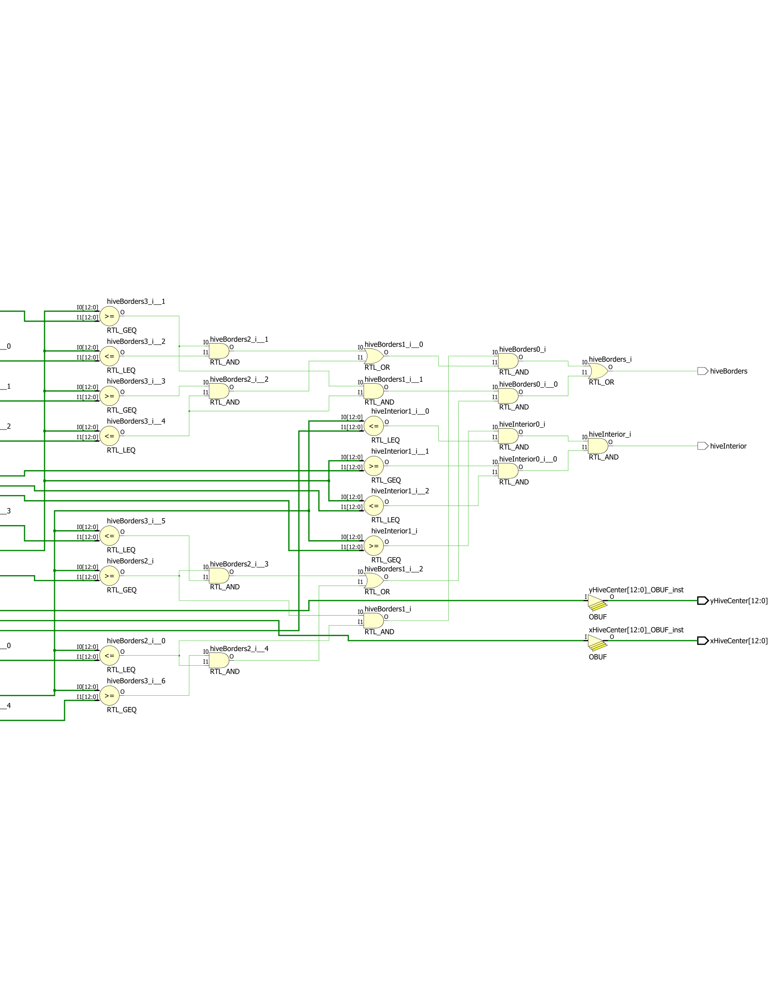

**Part Five: LFSR**

Before moving onto the bees, I had to make a random number generator that dictated which direction the bees would start going in when the hive released them. To do so, I created a LFSR that produced a 16-bit number with 16 flip-flops, with the first one receiving the xor of random bits in the 16-bit number. This 16-bit number would be later used for the bees, which each took in two bits of the number. The code and schematic for the LFSR are the following:

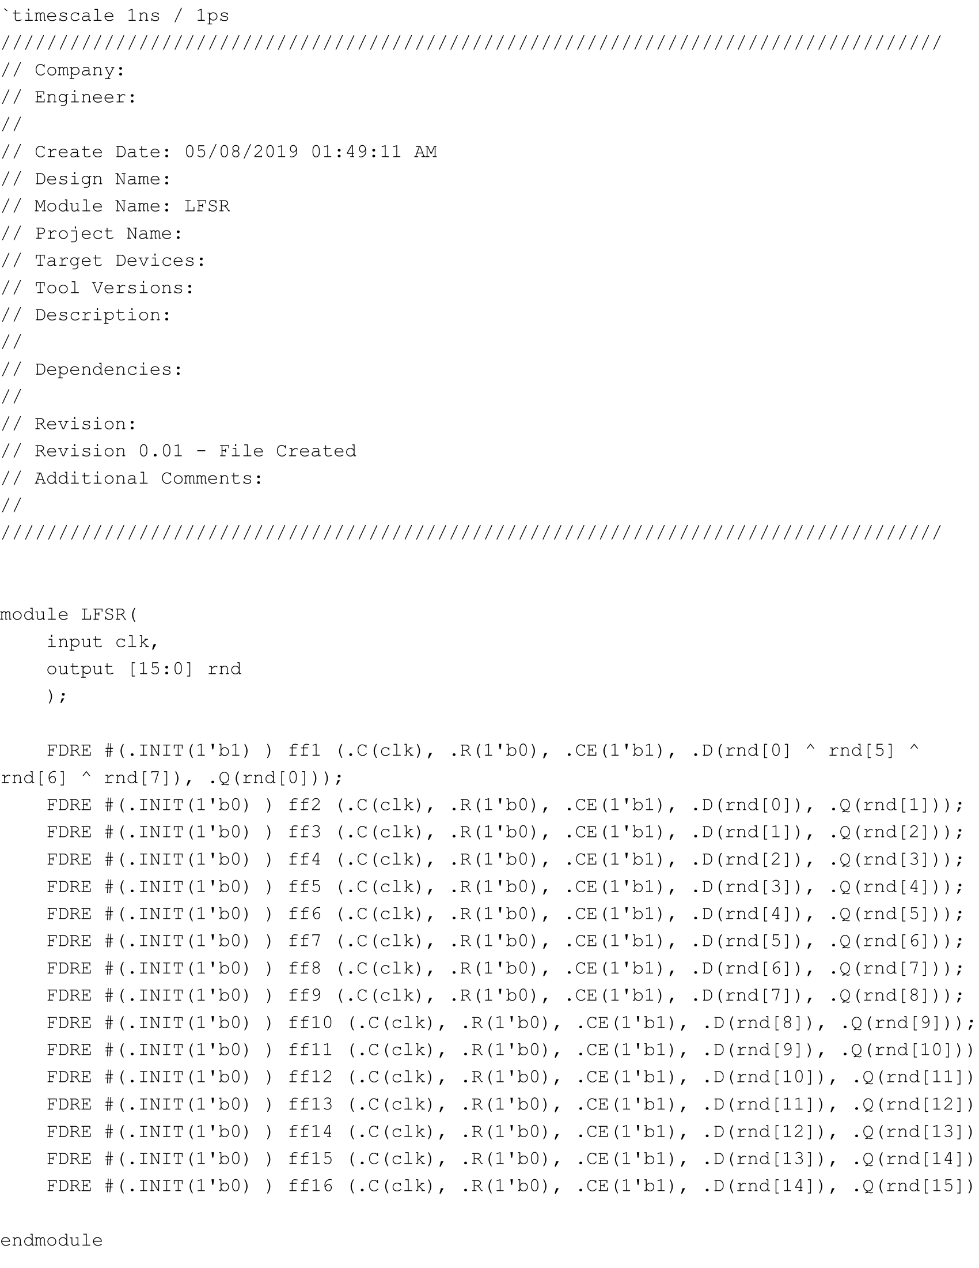

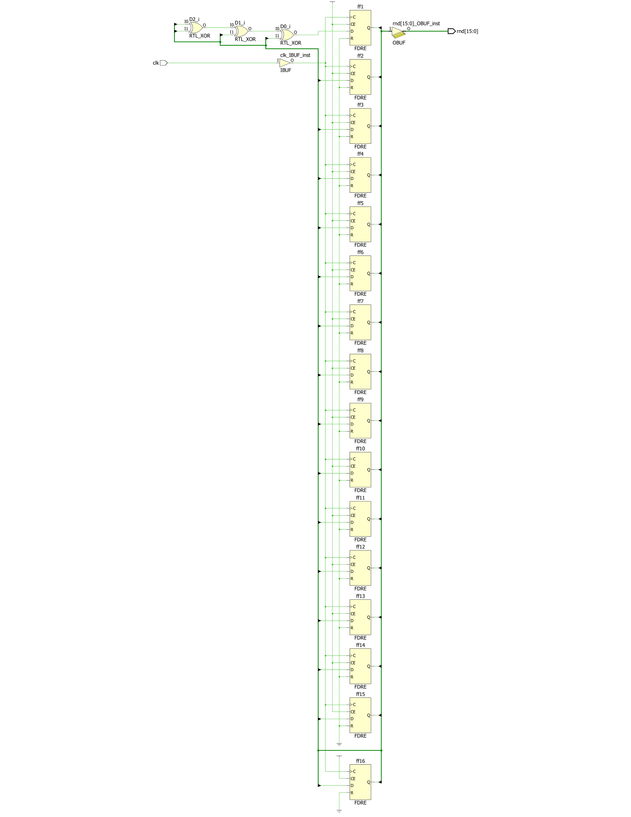

**Part Six: The Bee’s State Machine**

In order for the bees to keep being loaded or to start moving, I create a state machine for an individual bee that took several inputs from the overall game’s state machine. The first thing I did was create a state diagram that mapped out every possible scenario and result. The following is the state diagram I created:

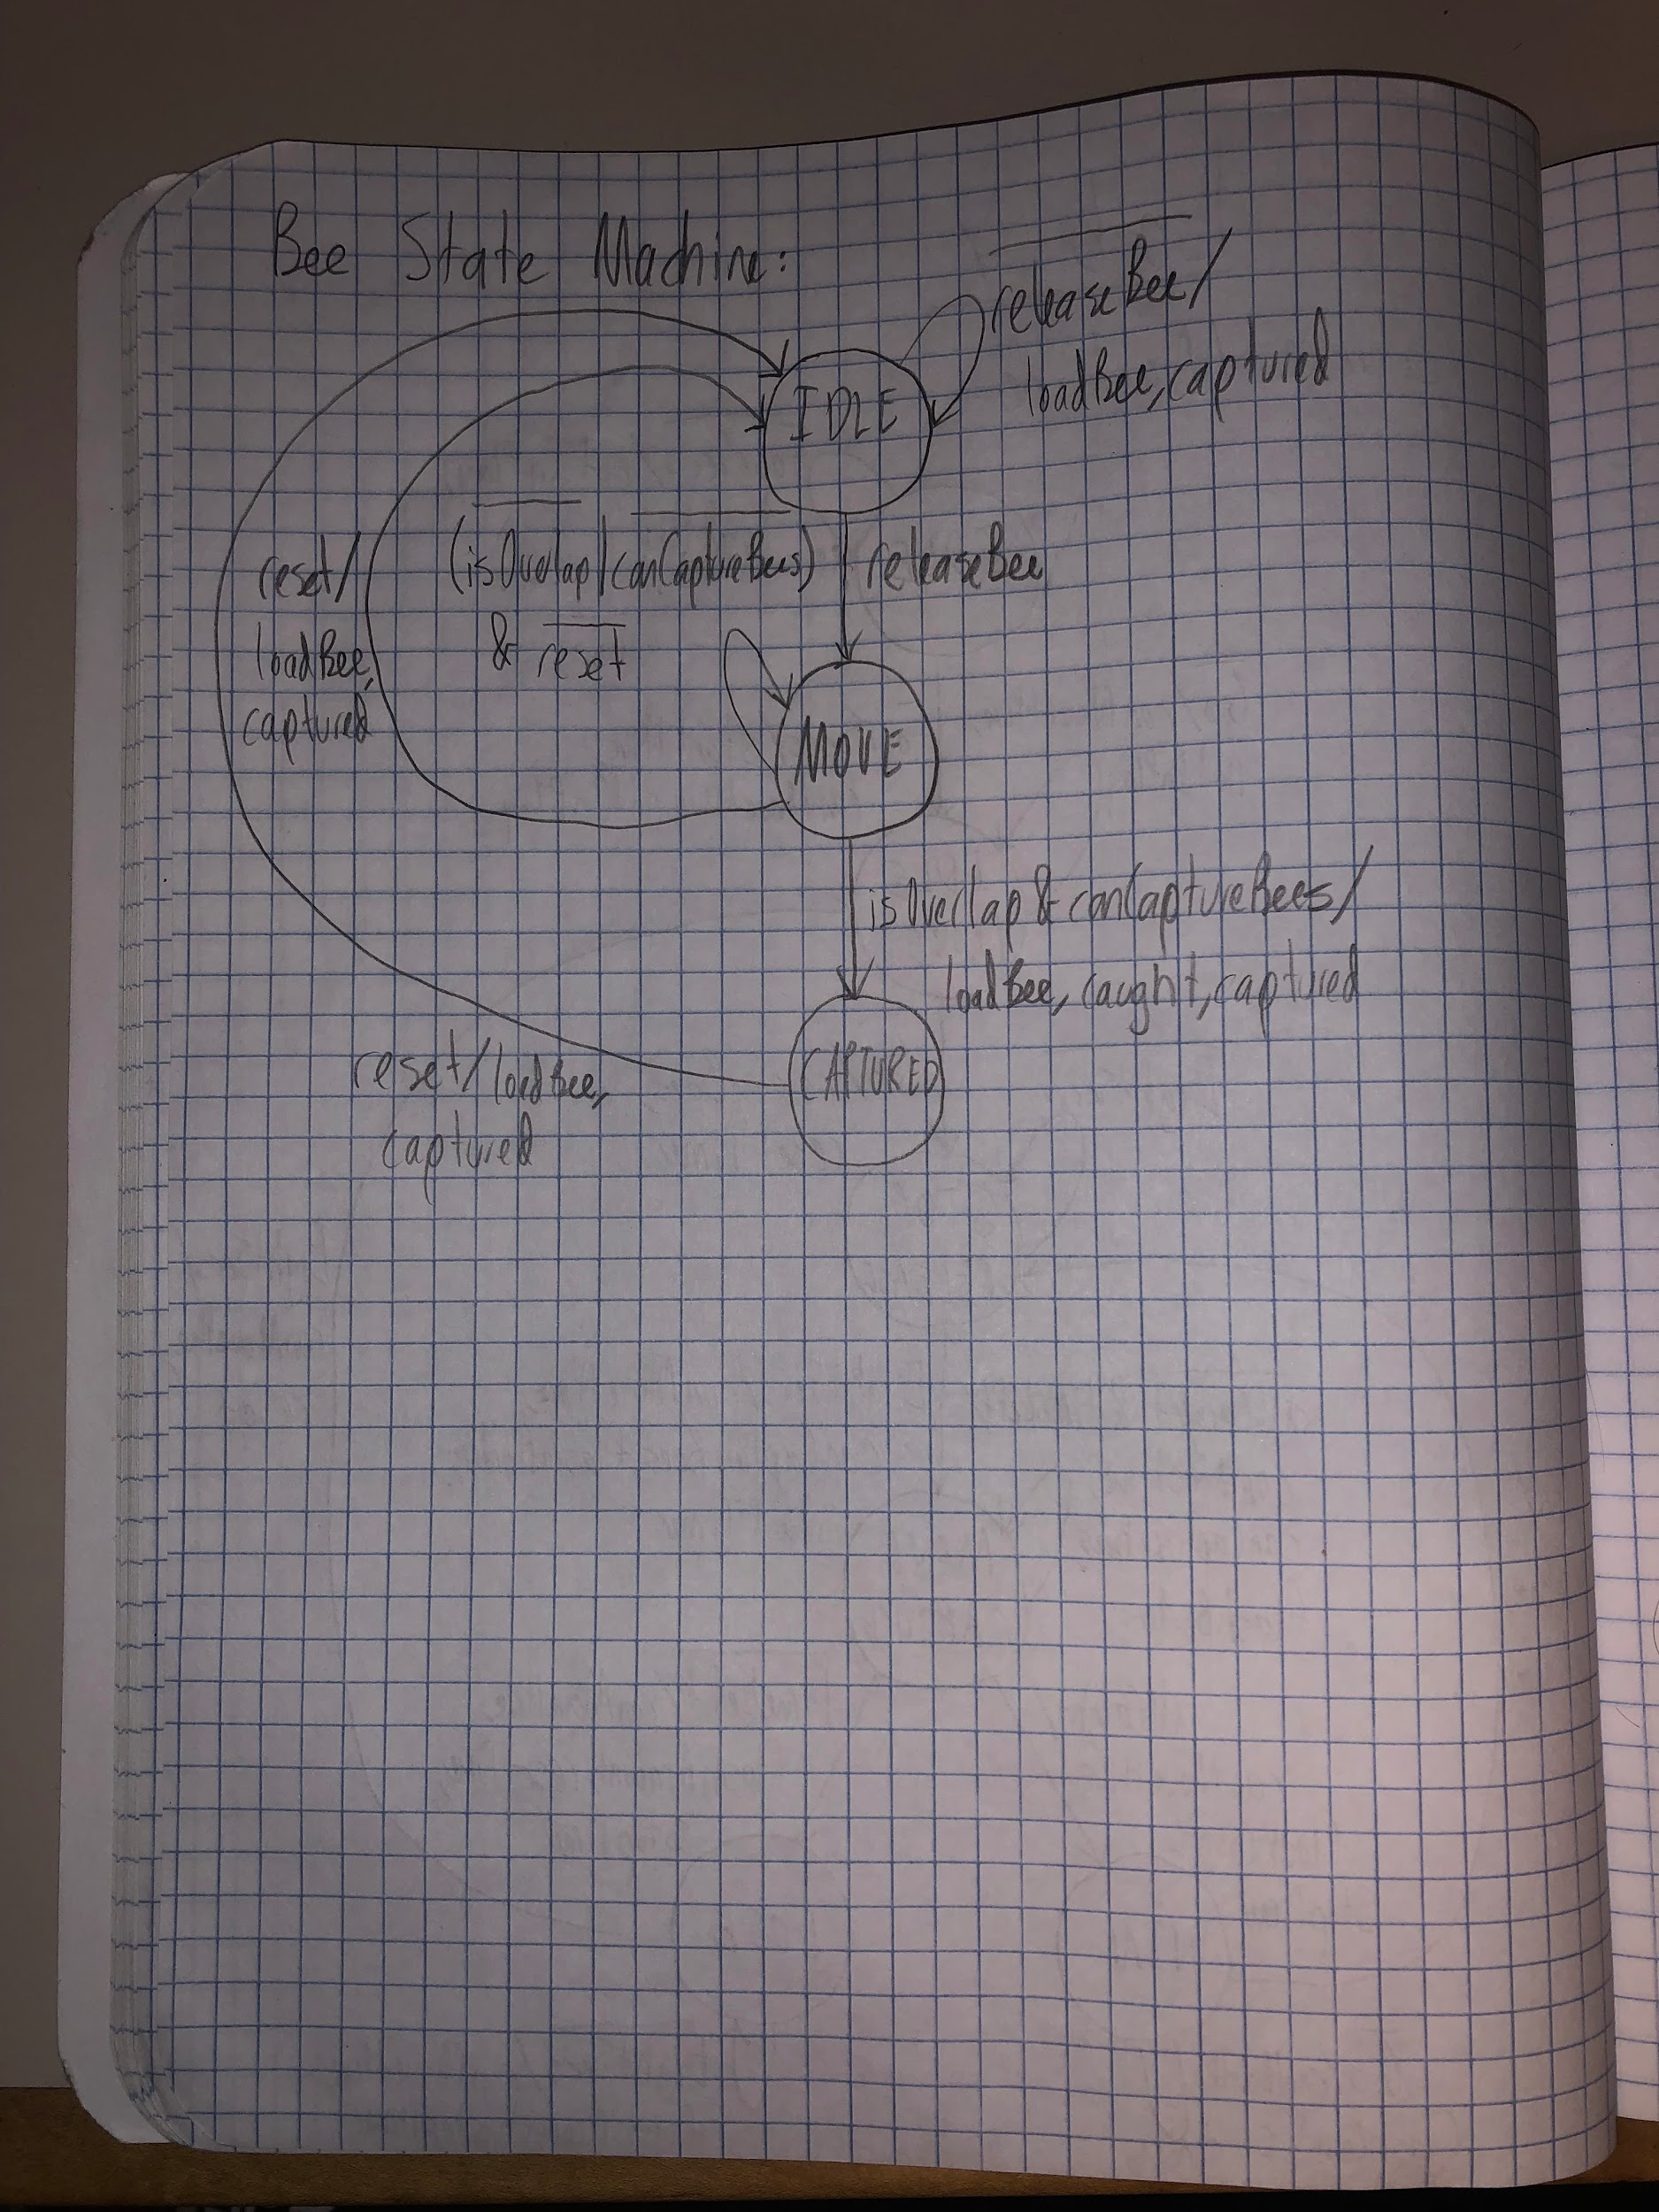

Initially, a single bee would be in state IDLE. While the bee was not released, the bee would stay in state IDLE, and keep being loaded into its position in the hive and be considered captured. When the bees were released, the bee transitioned to state MOVE, where the bee could start moving. The bee stayed in this state until it did not overlap with the hive when the hive could capture it, or until the system was reset. Then one of two things could have happened:

1. If the bee did overlap with the hive when the hive could capture it, the bee transitioned to state CAPTURED, and it would be loaded into the hive, caught and captured. The bee would then stay in that state until the system was reset, when it would transition back to state IDLE, load the bee into the hive, and be captured.
2. If the system was reset, the bee transitioned back to IDLE, loaded into the hive, and was captured.

The code and schematic for the state machine’s logic is shown below.

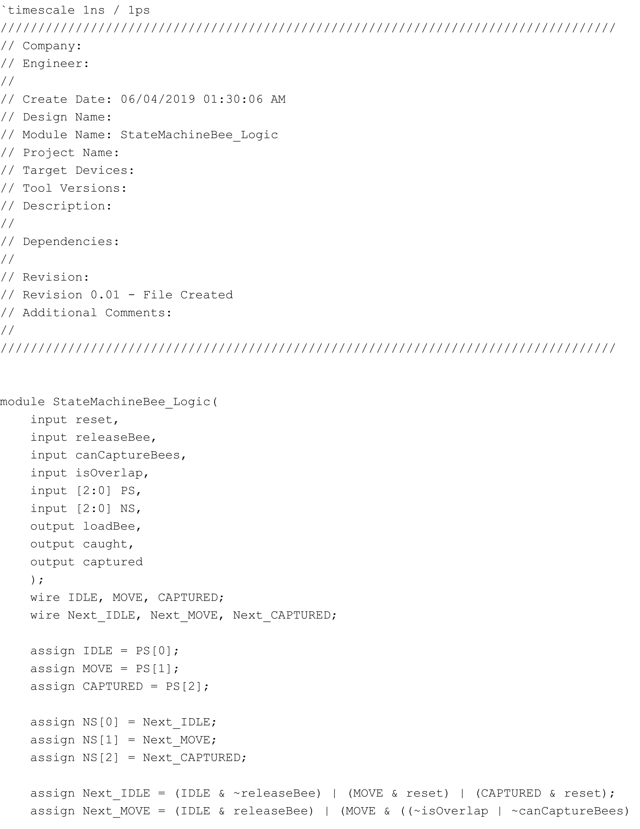

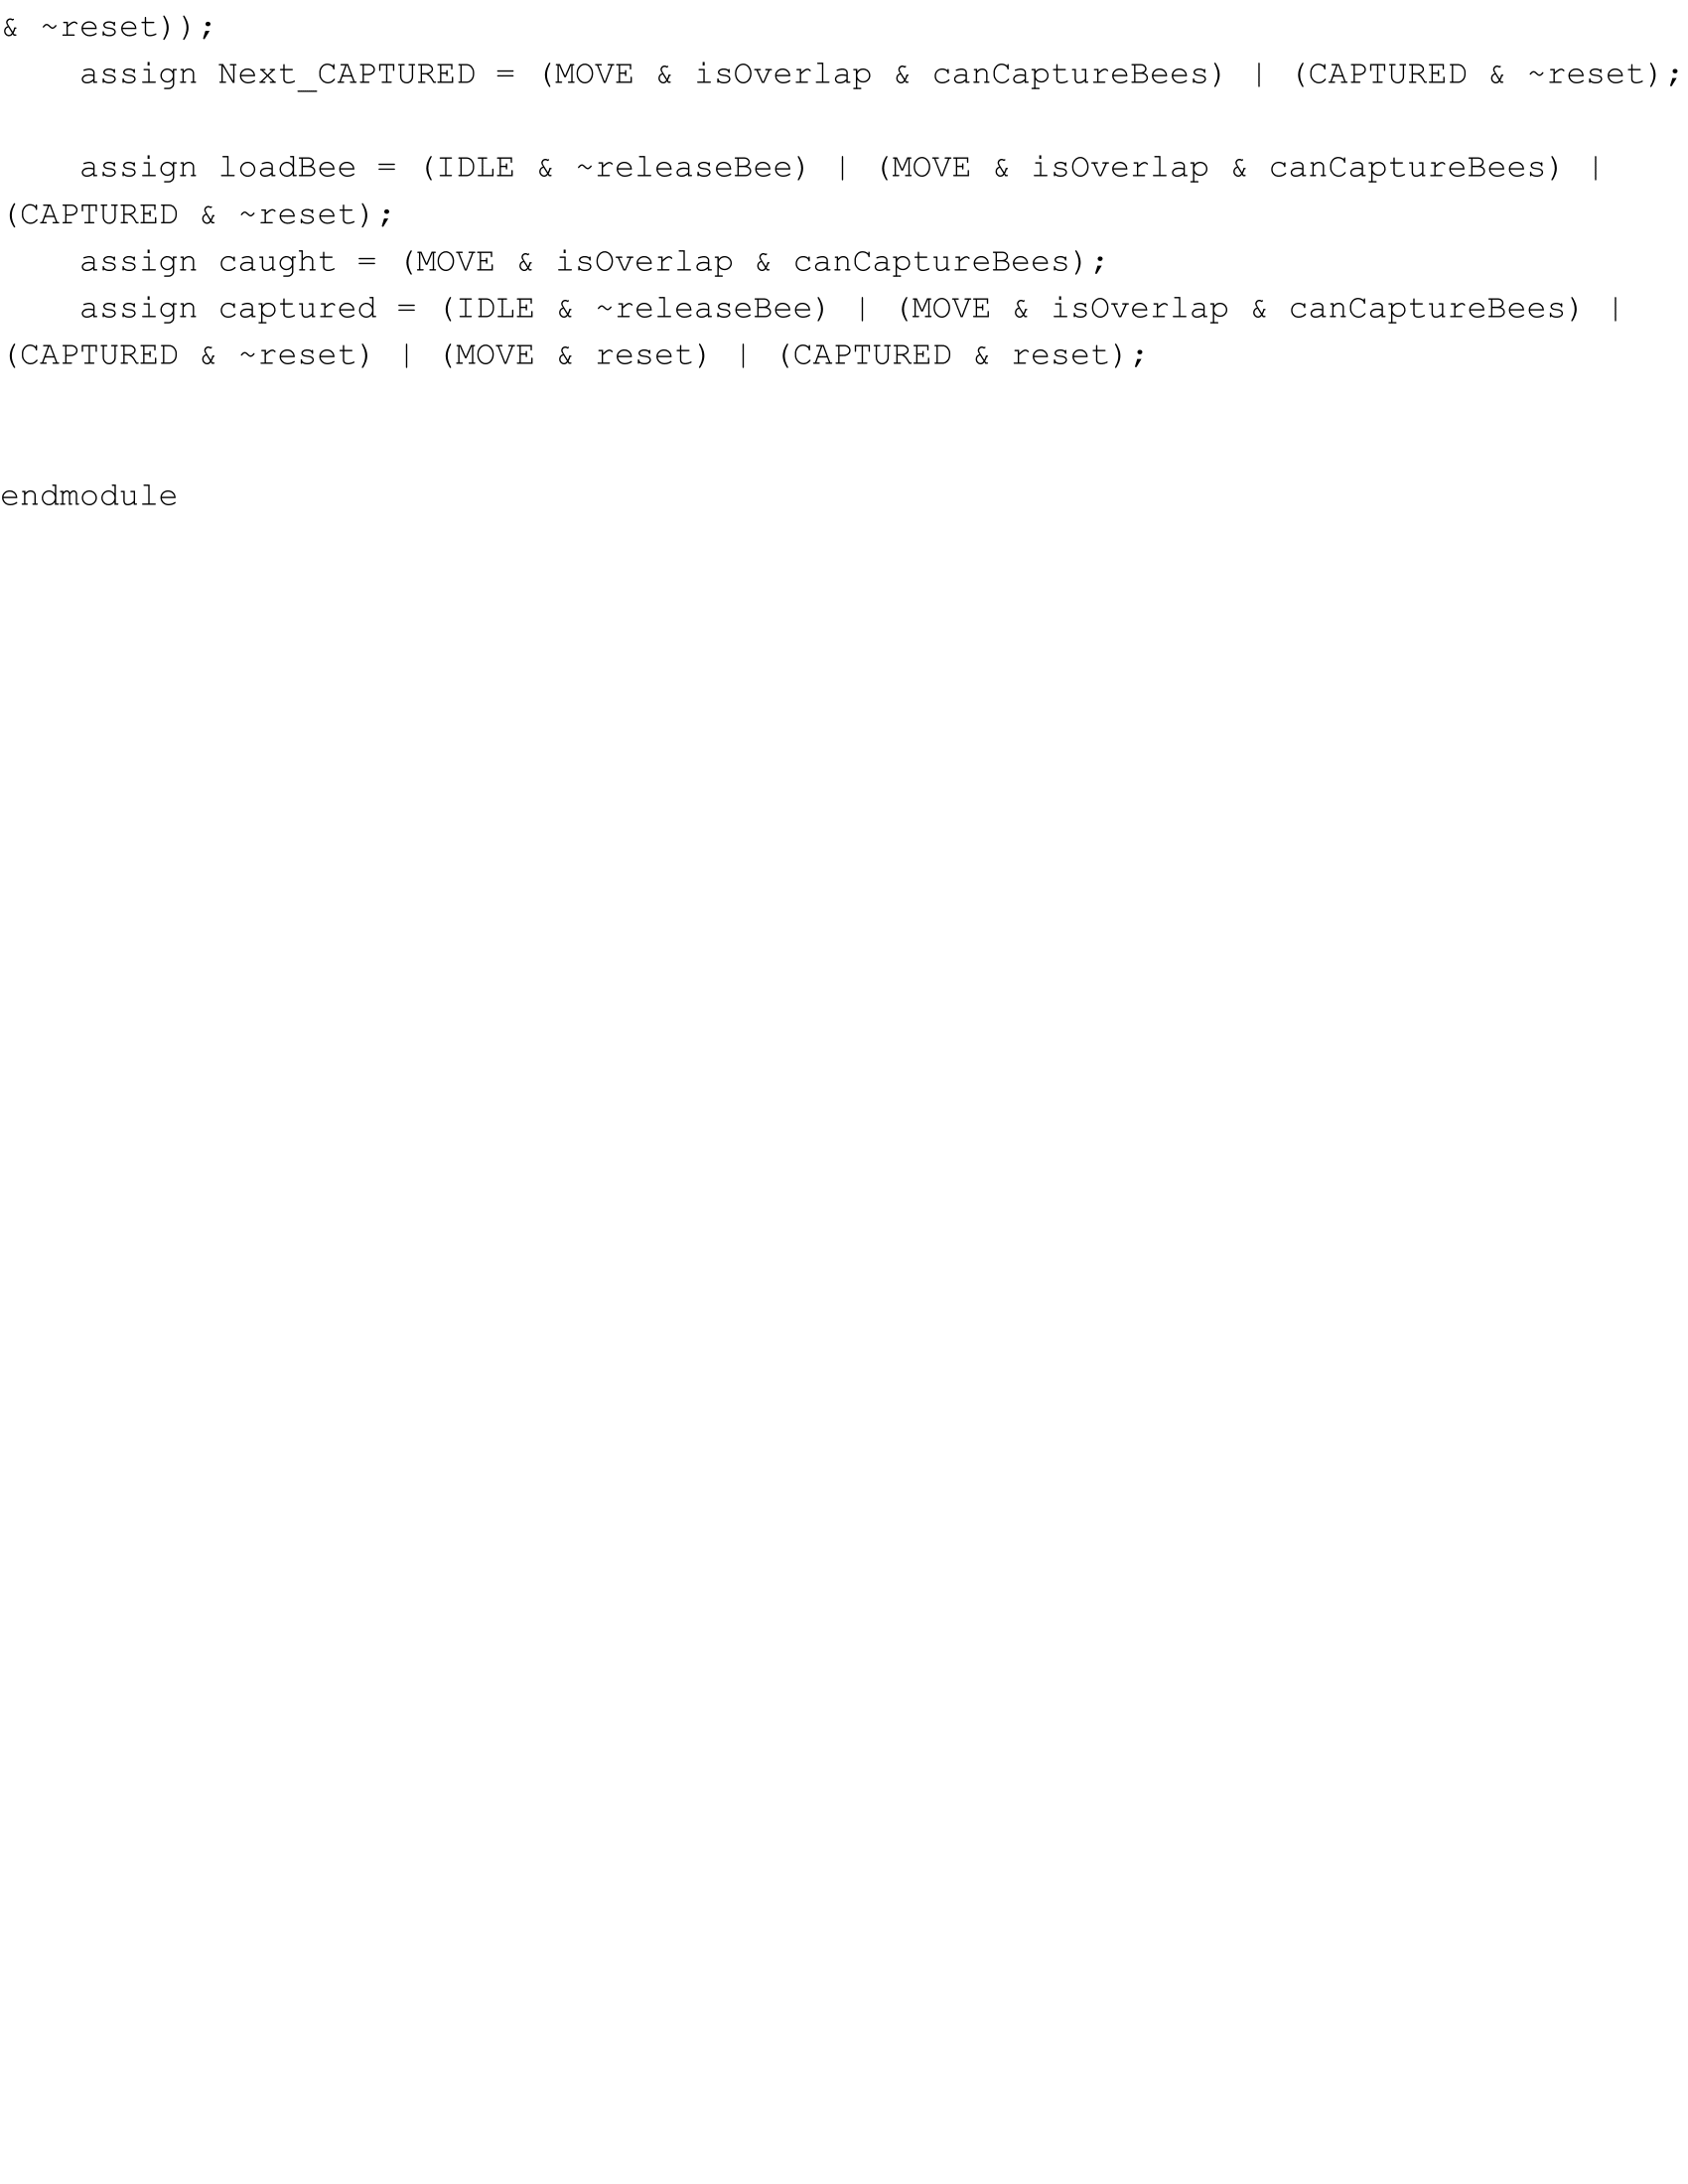

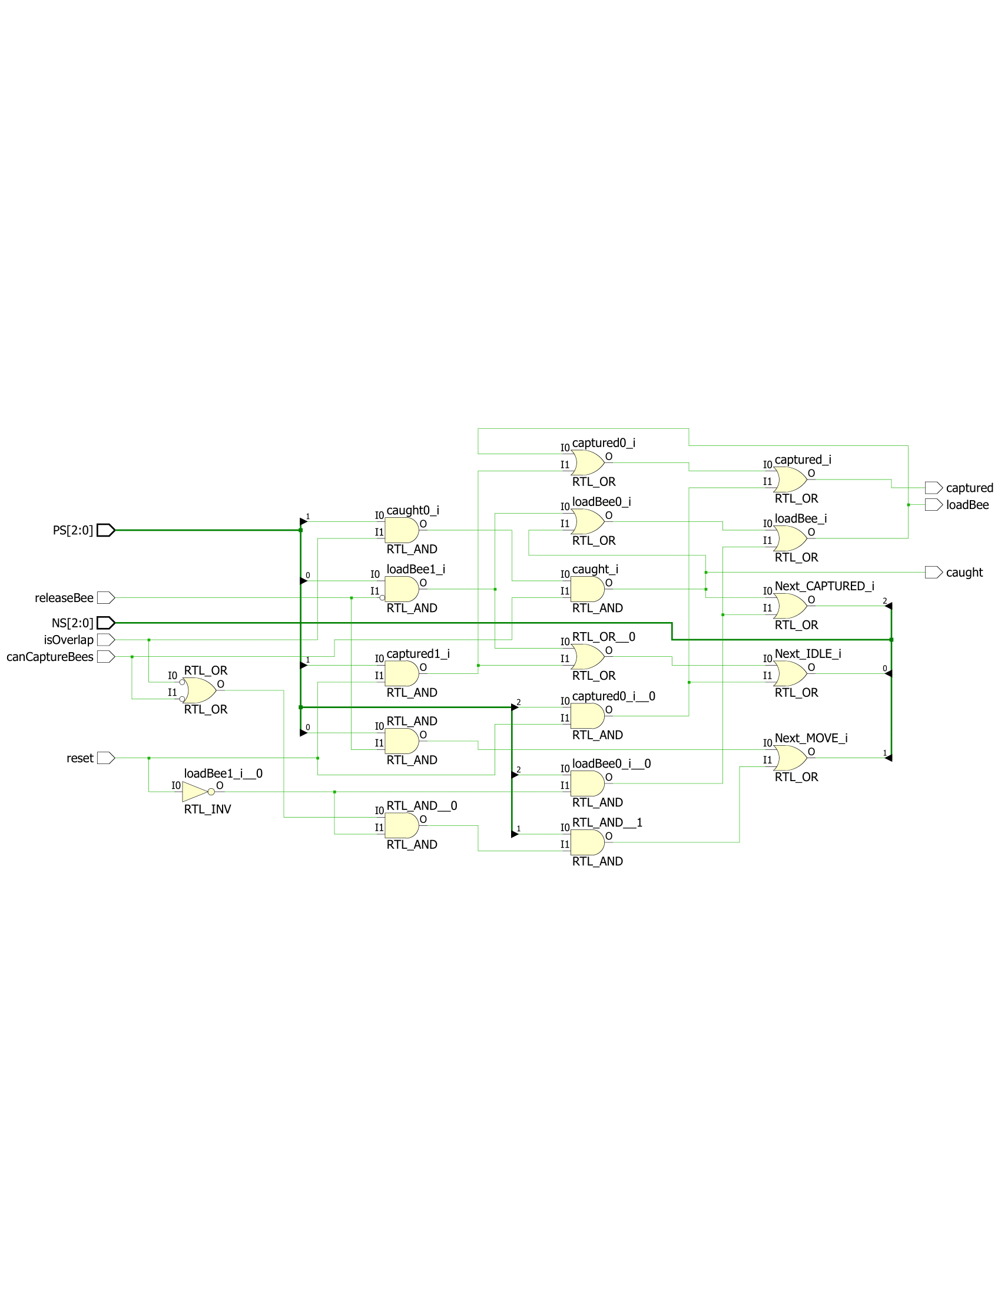

To facilitate the inputs and outputs of the state machine, I created a module that makes use of three flip-flops and one-hot encoding to ensure that only one state happens at a time. The code and schematic for it are the following:

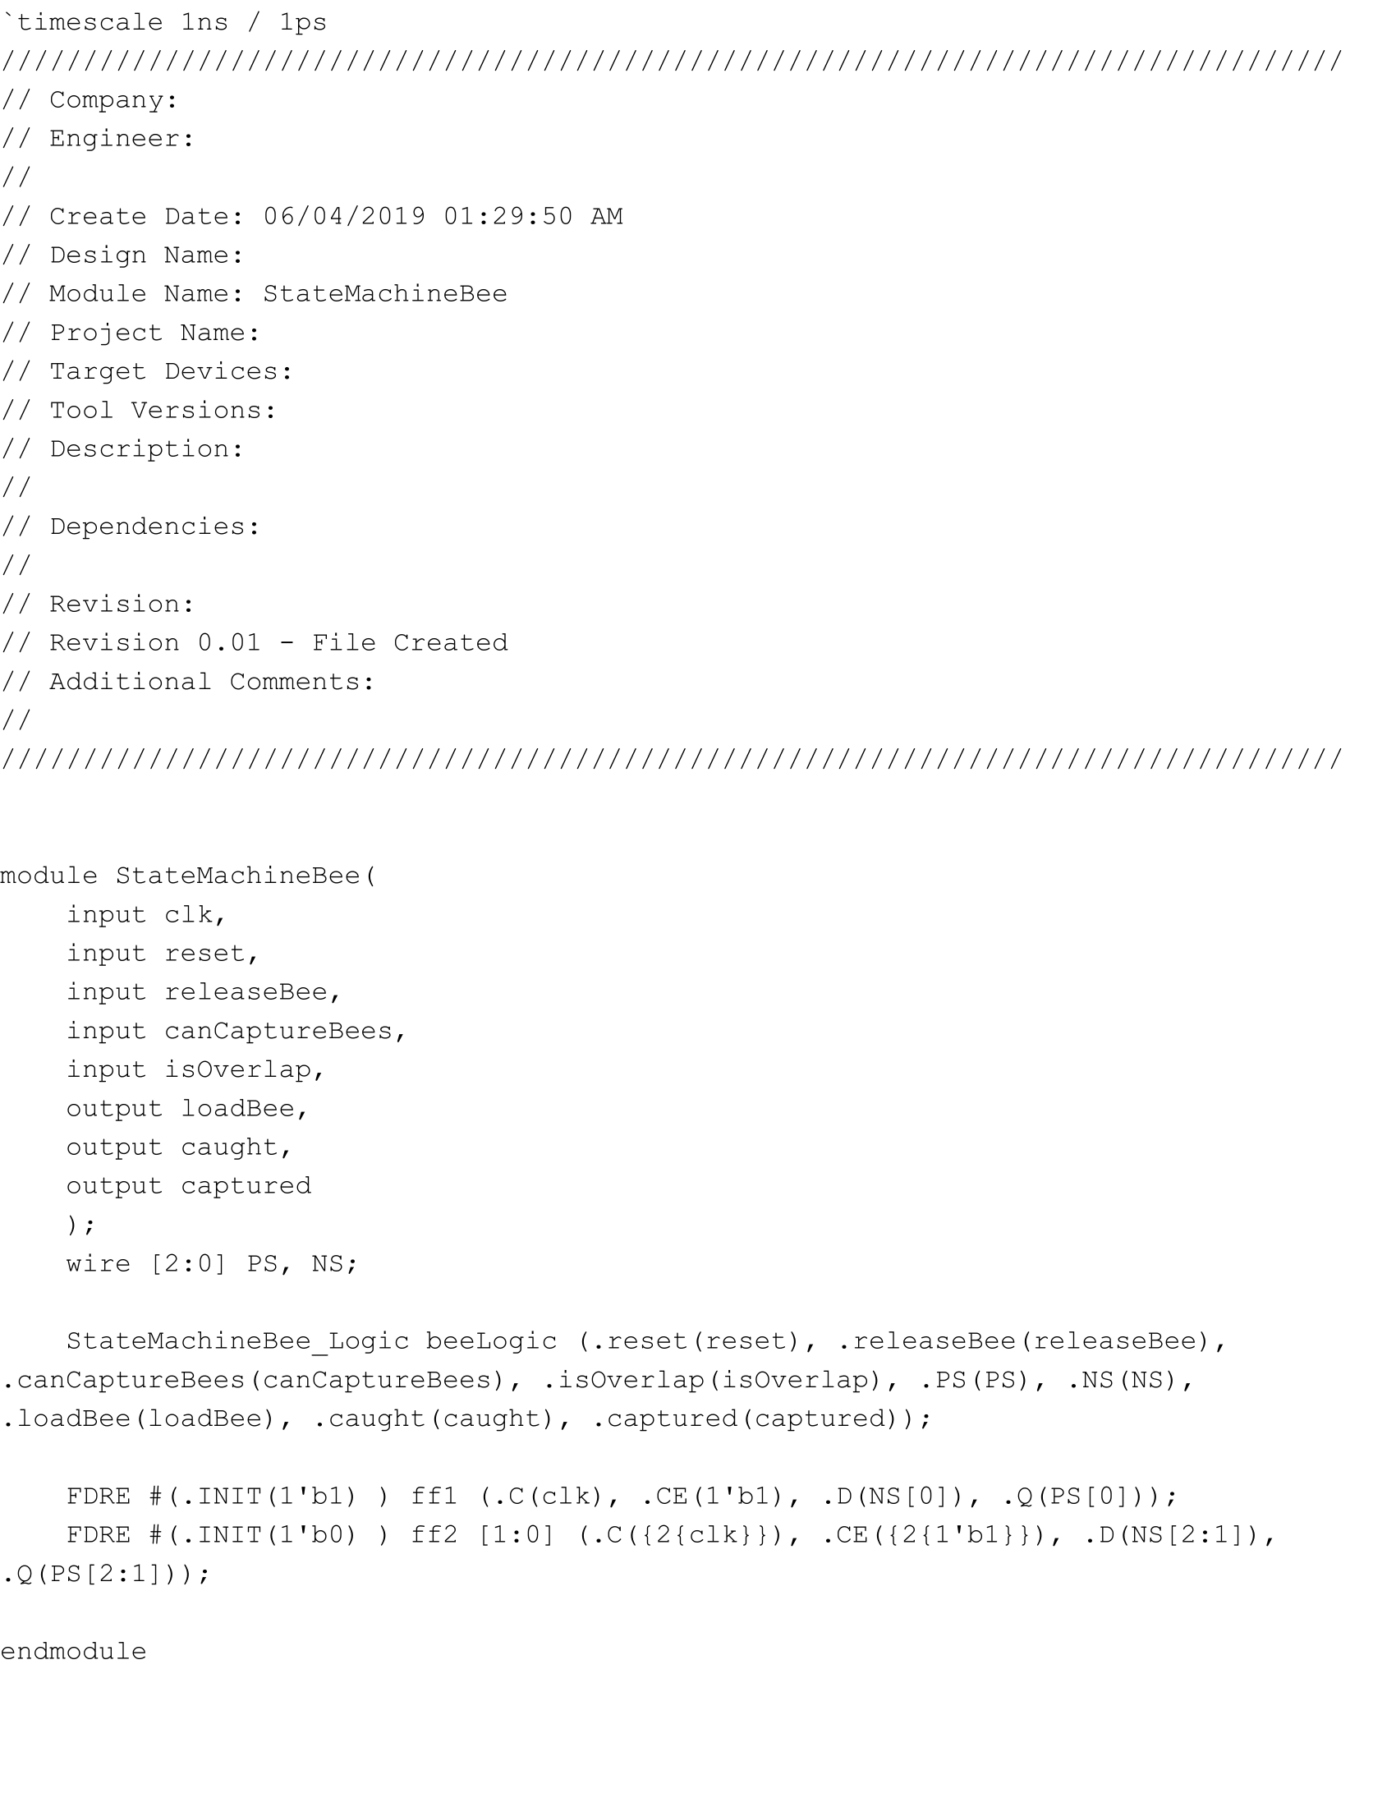







**Part Seven: A Single Bee**

The next part of the lab was to create a functioning bee that stayed in the hive until it was given the signal to start moving, and returned back to its original position if caught. I started with a single bee, which took in the hive’s x and y coordinates and its own starting x and y coordinates within the hive. Just like with the hive, I created an 8 x 8 square that began at its starting coordinates. Each bee also had its own state machine, which told the bee when it should be loaded into the hive if just starting or if it was caught, or begin moving around in a random diagonal direction depending on what the output of the two bits were from the LFSR. I implemented this by having four flip-flops that kept a direction high and kept incremented or decrementing the counters of its x and y coordinates accordingly or not at all if it was not allowed to move, or even loaded in its starting position if it had to return to the hive. The code and schematic for the bee are shown below:

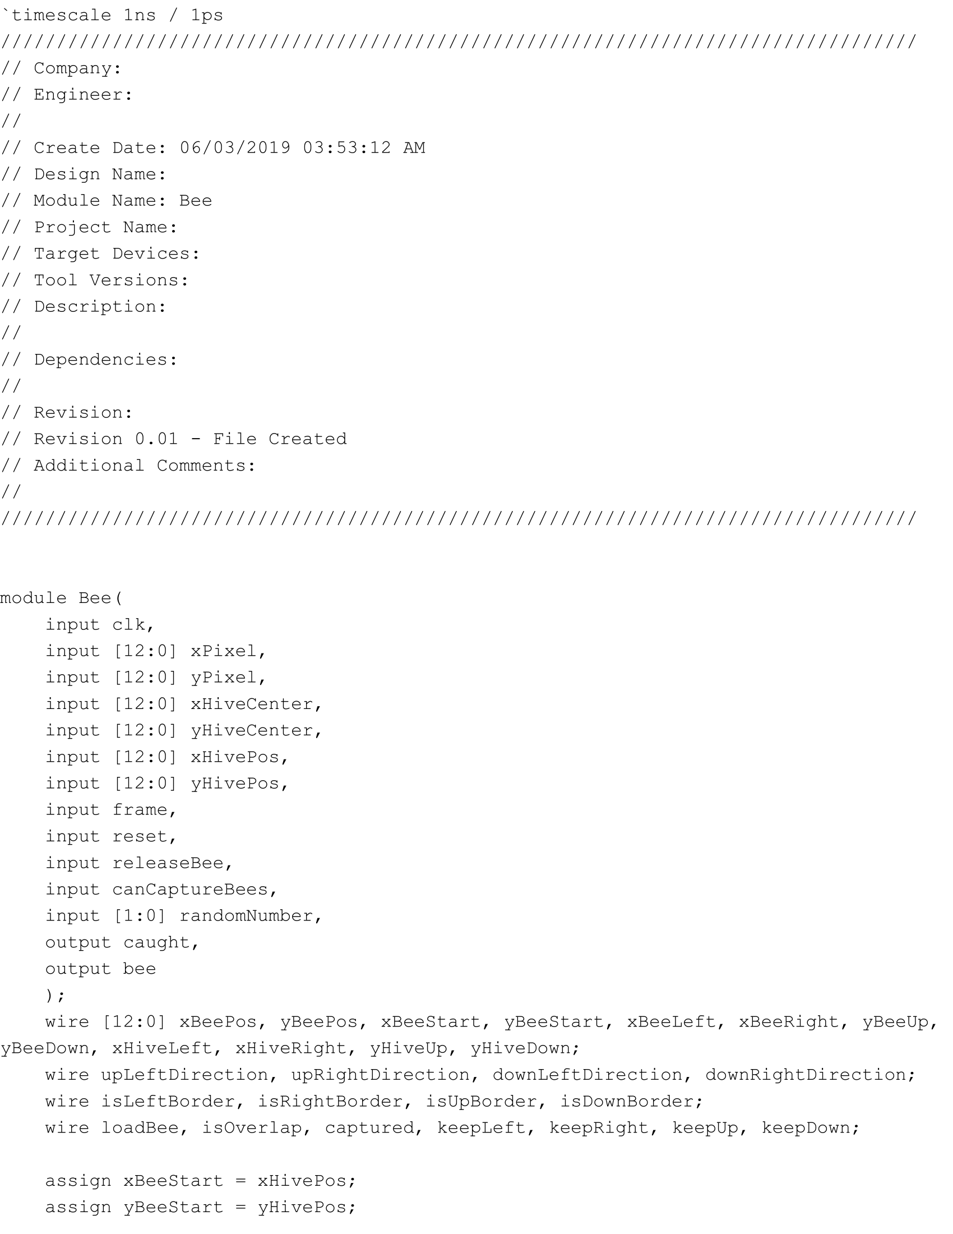

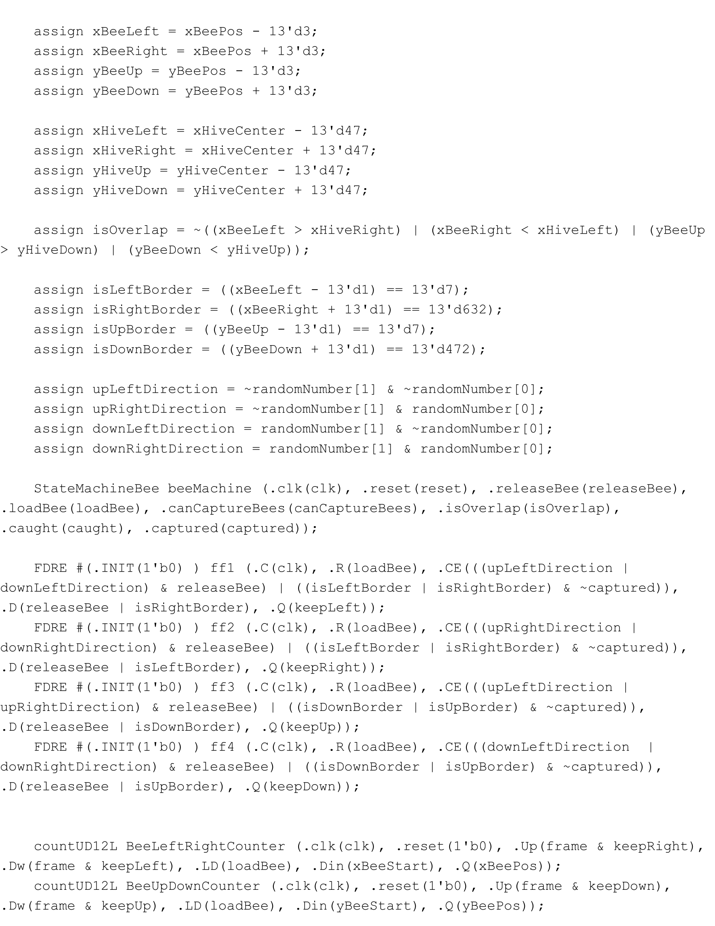

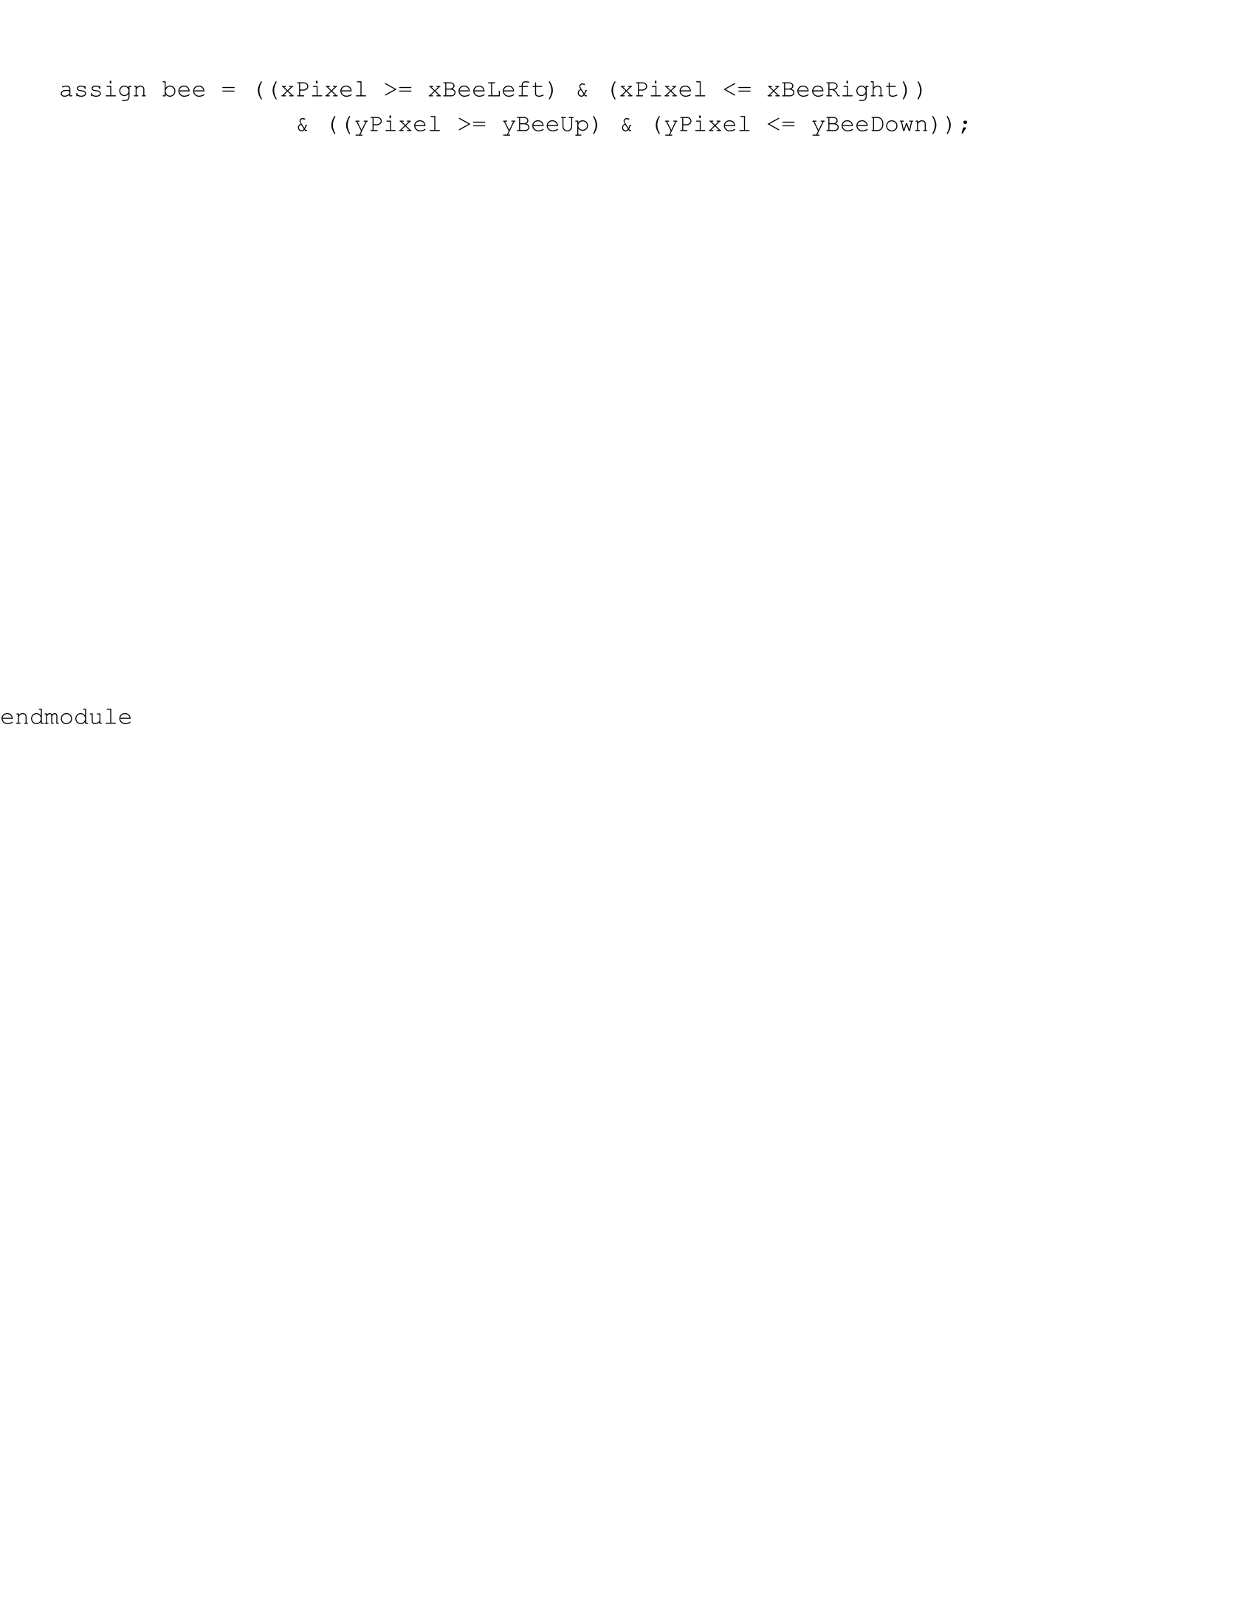

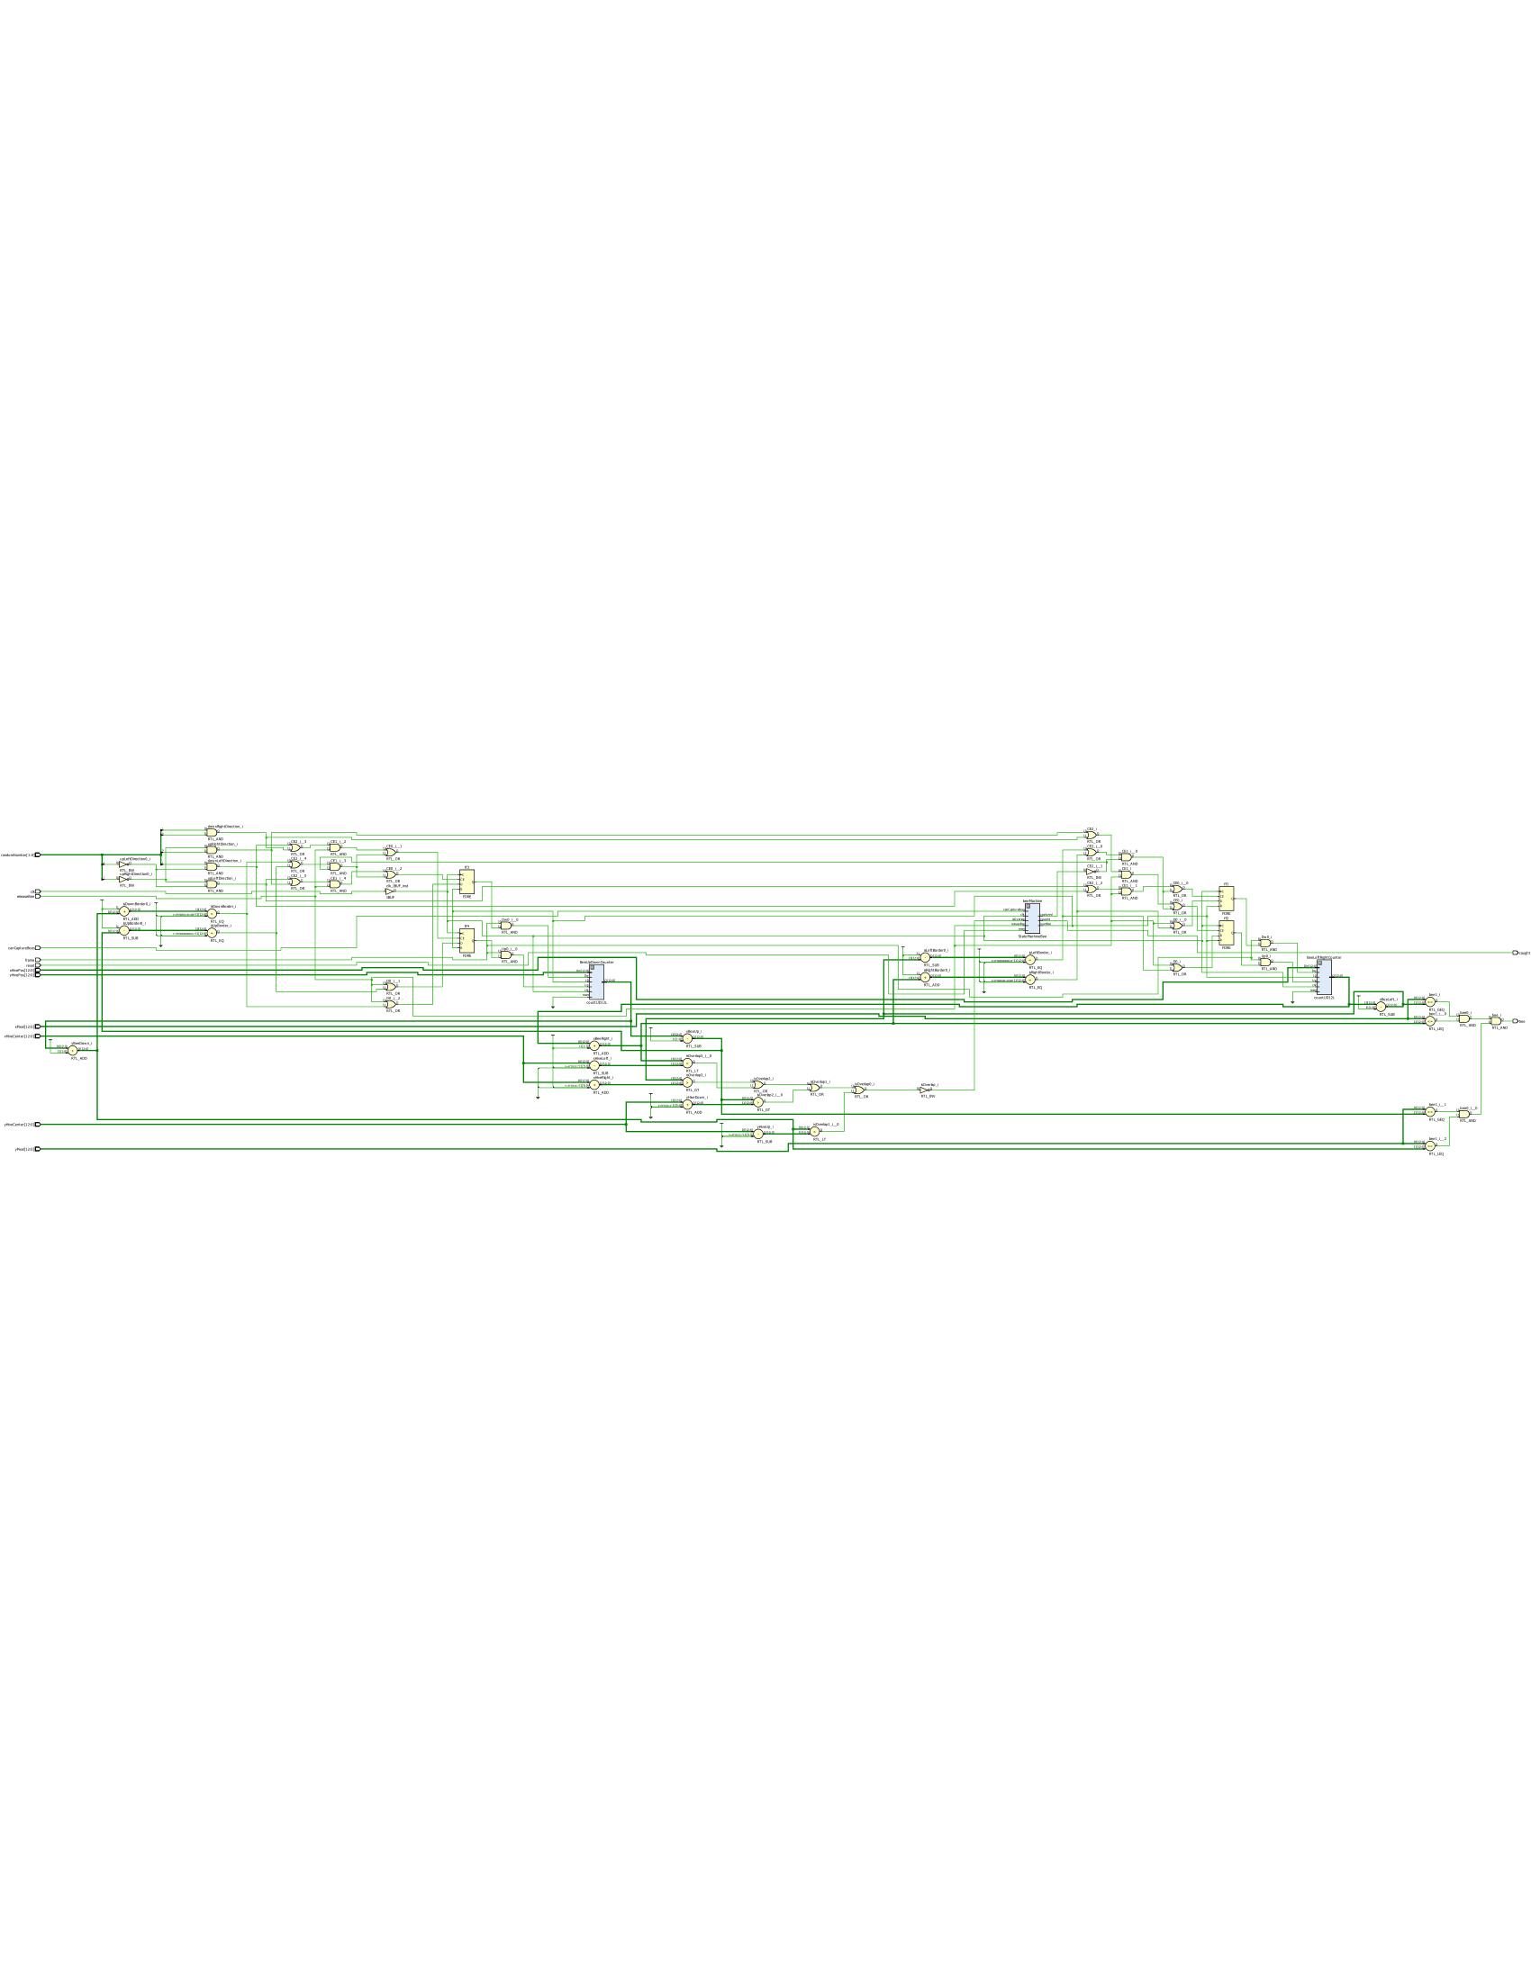

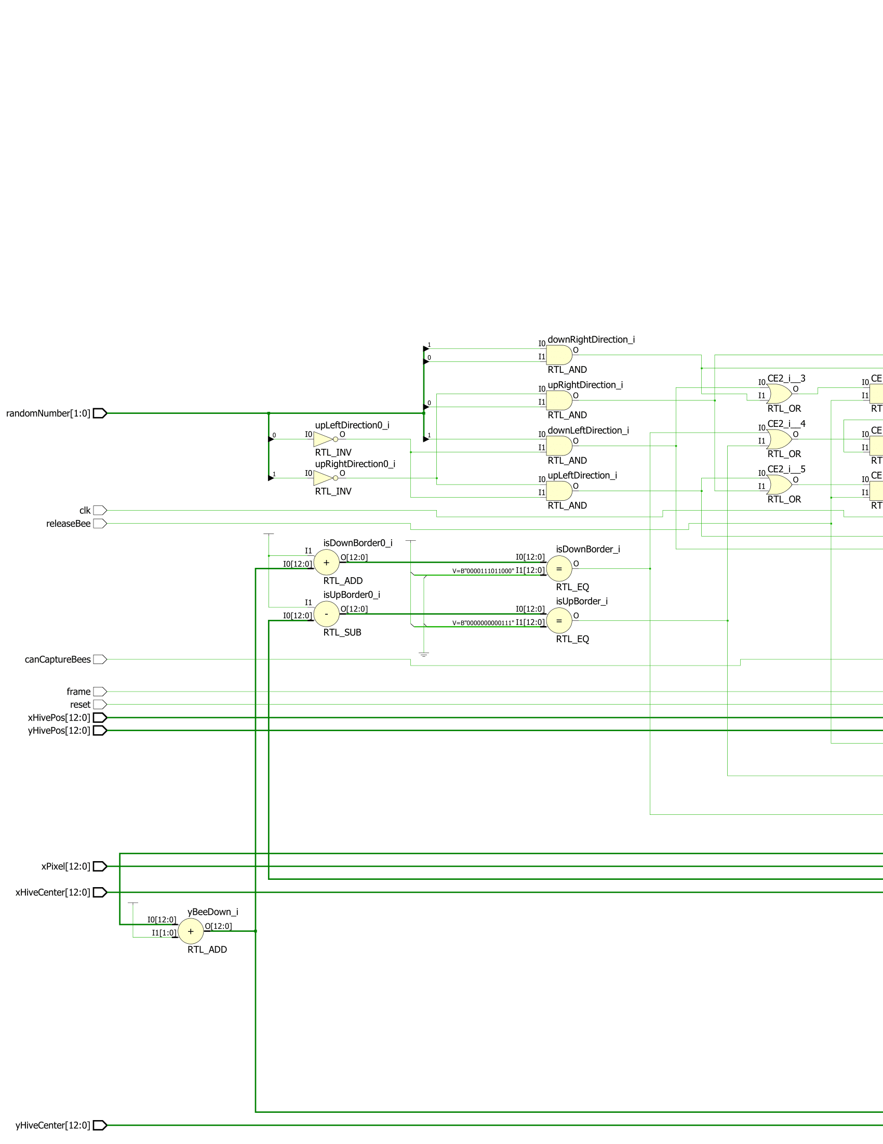

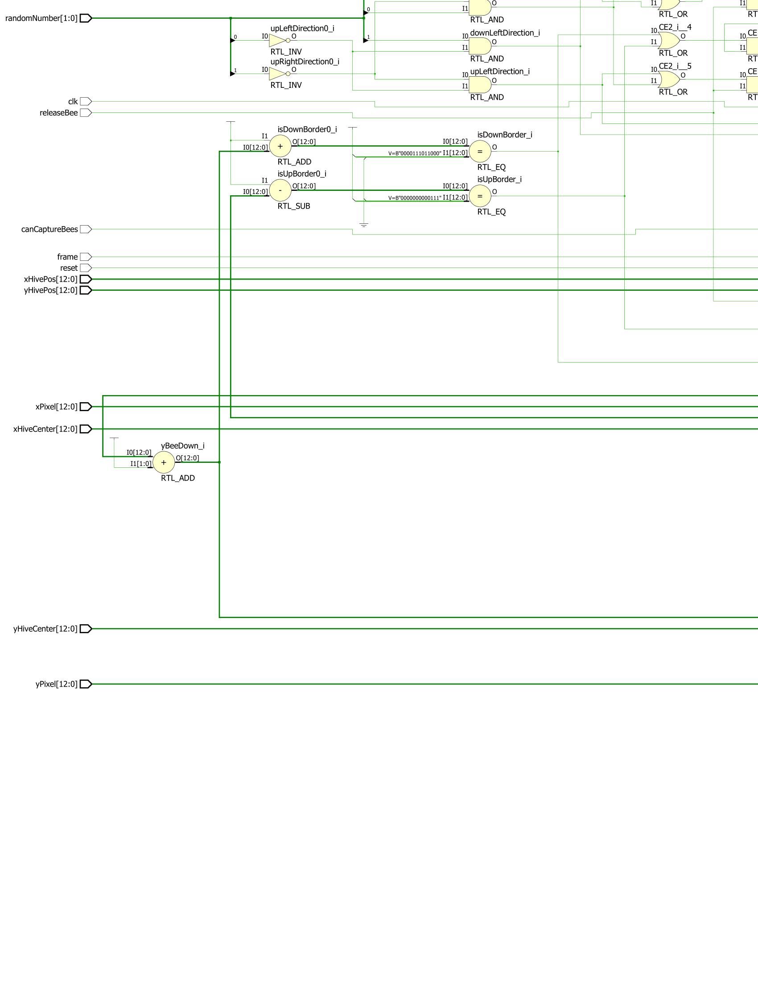

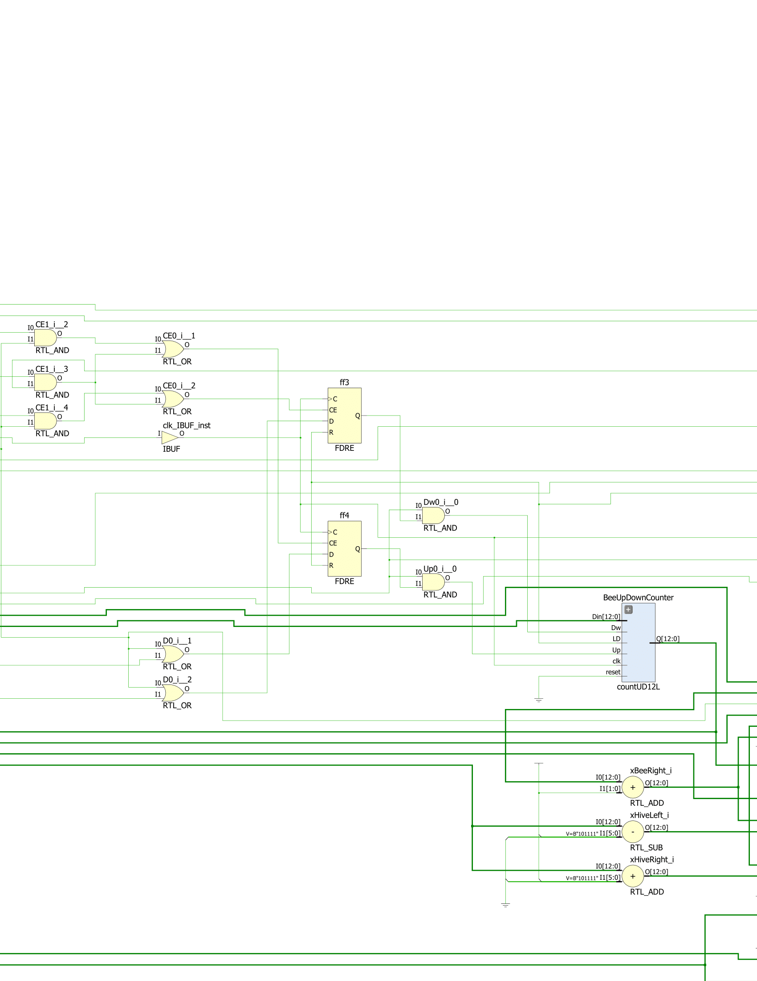

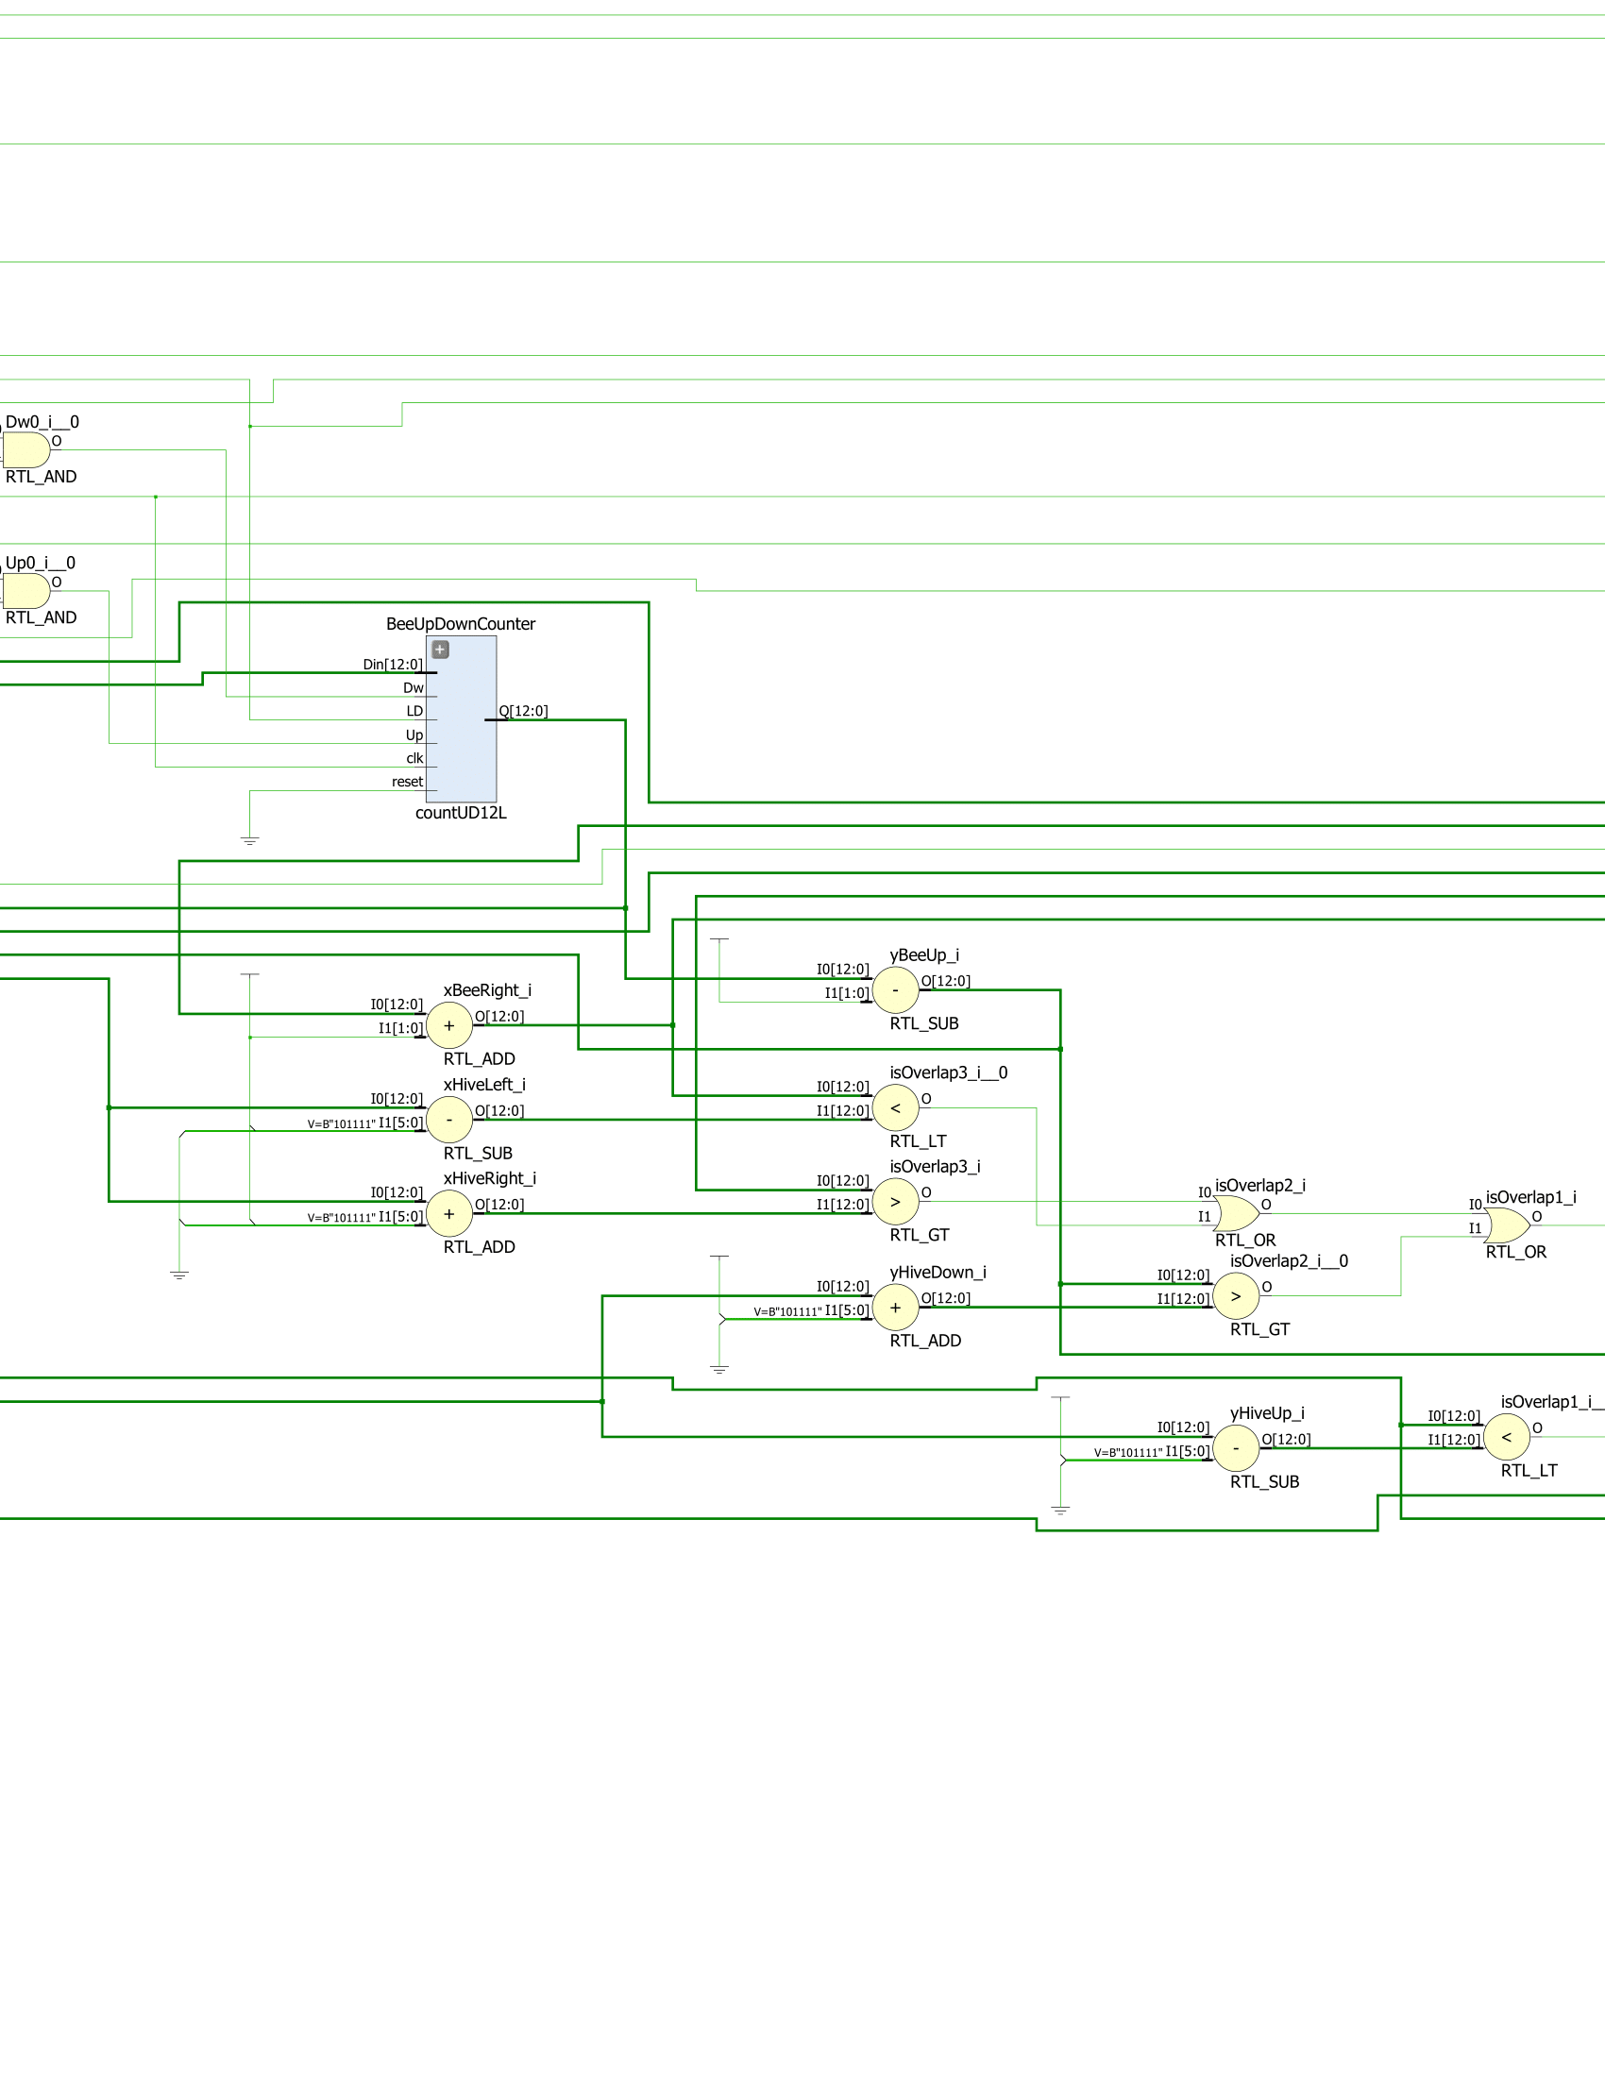

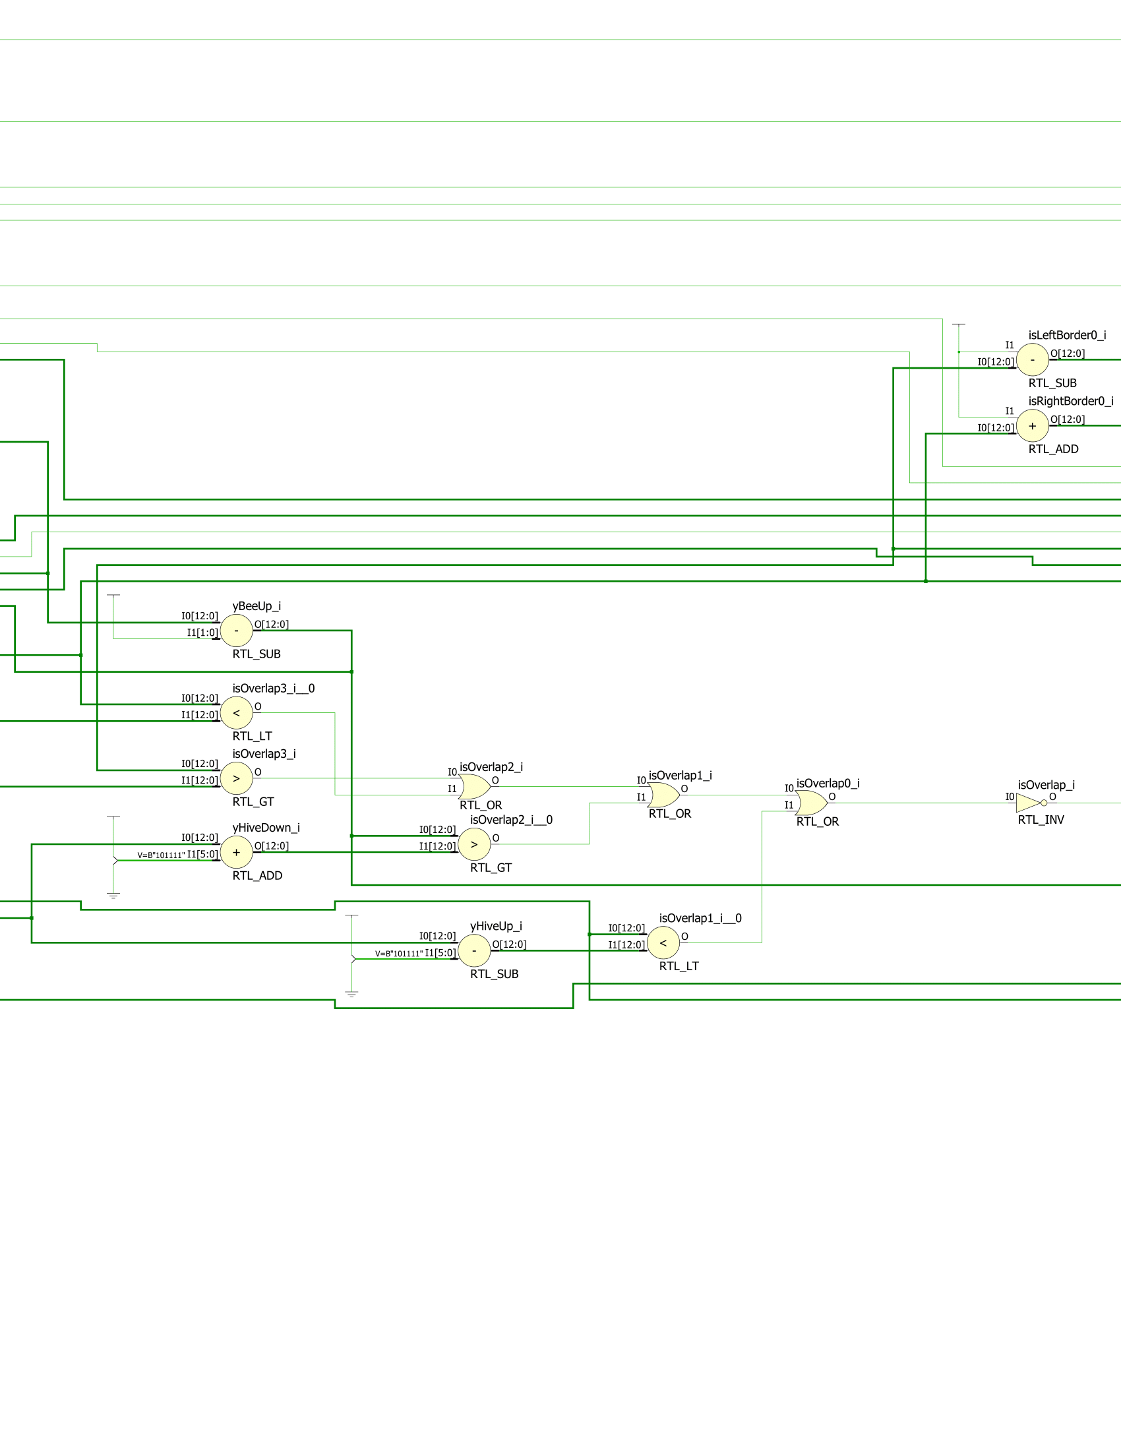

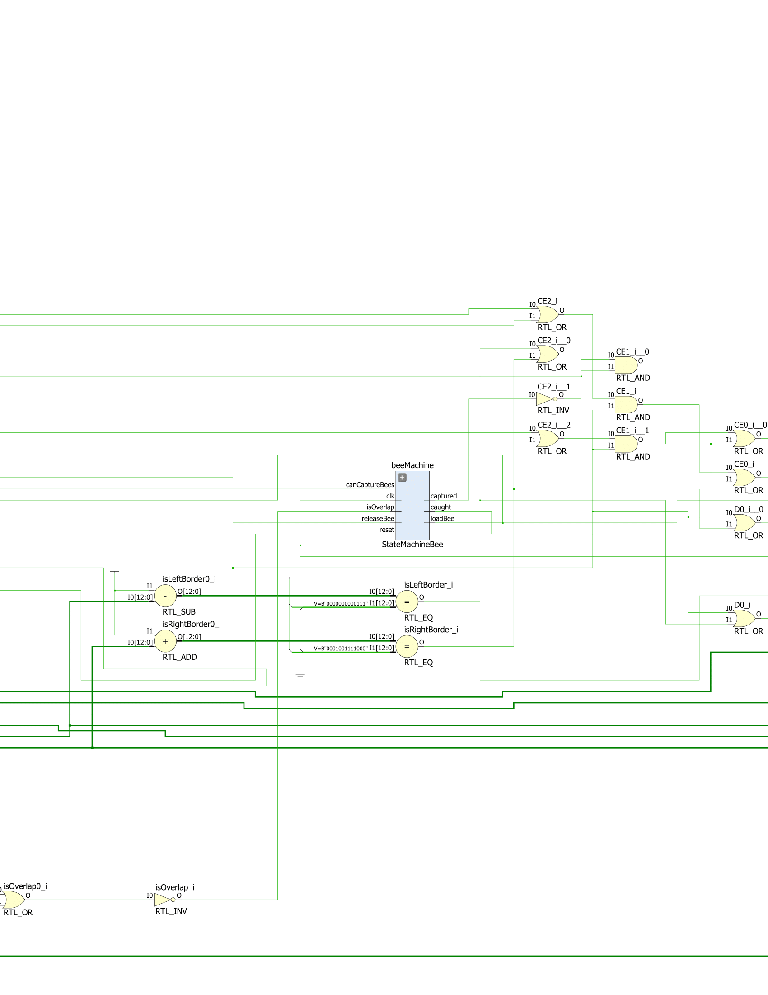

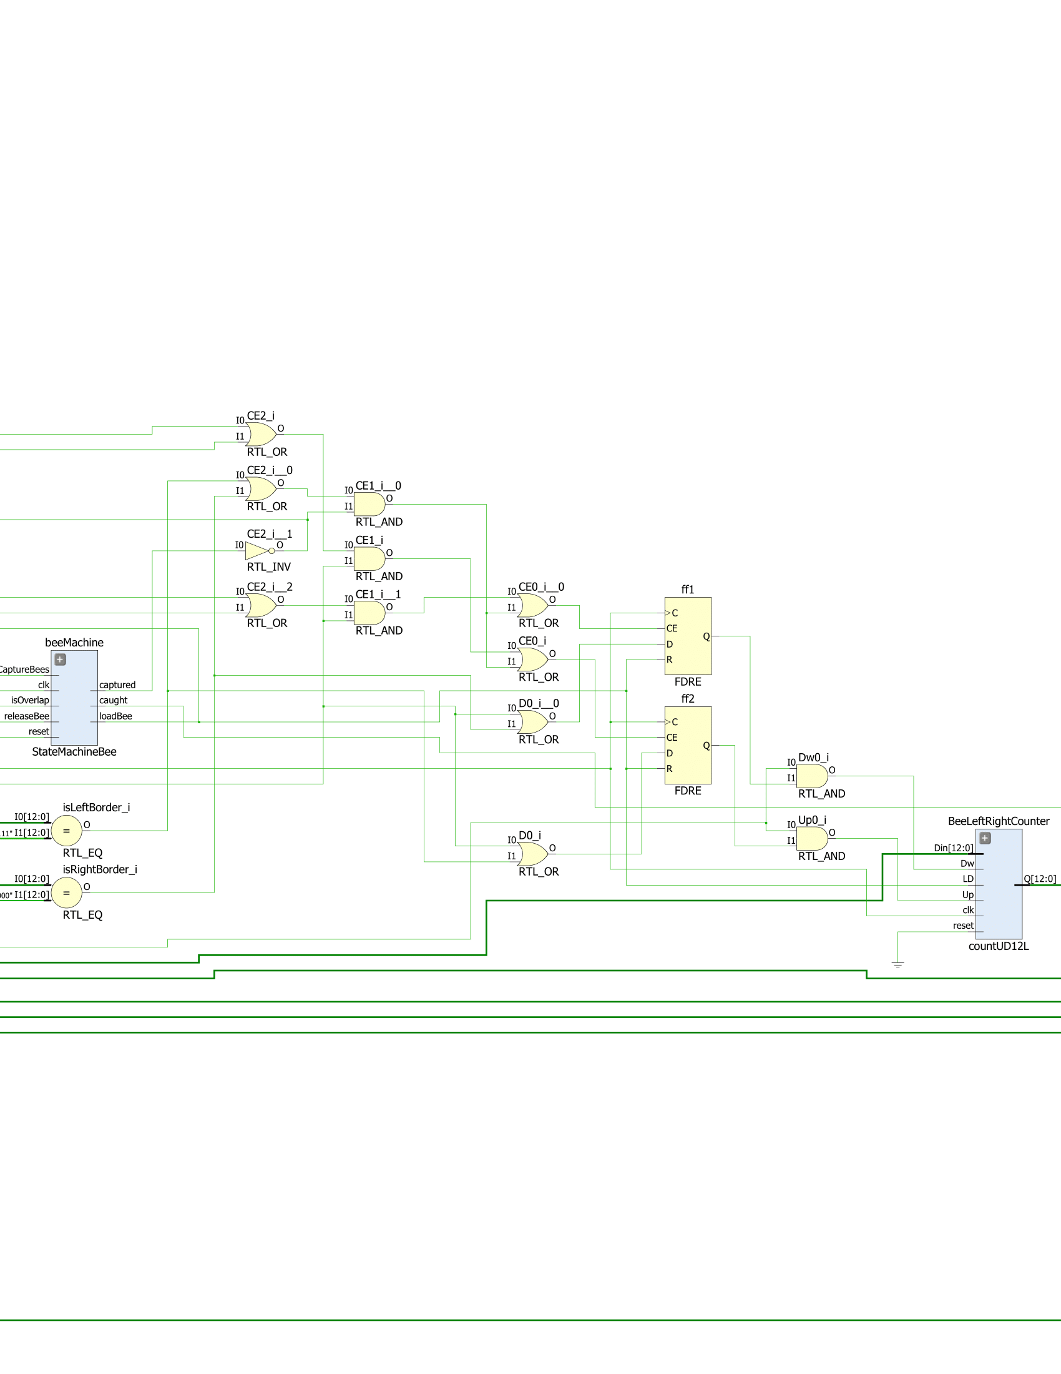

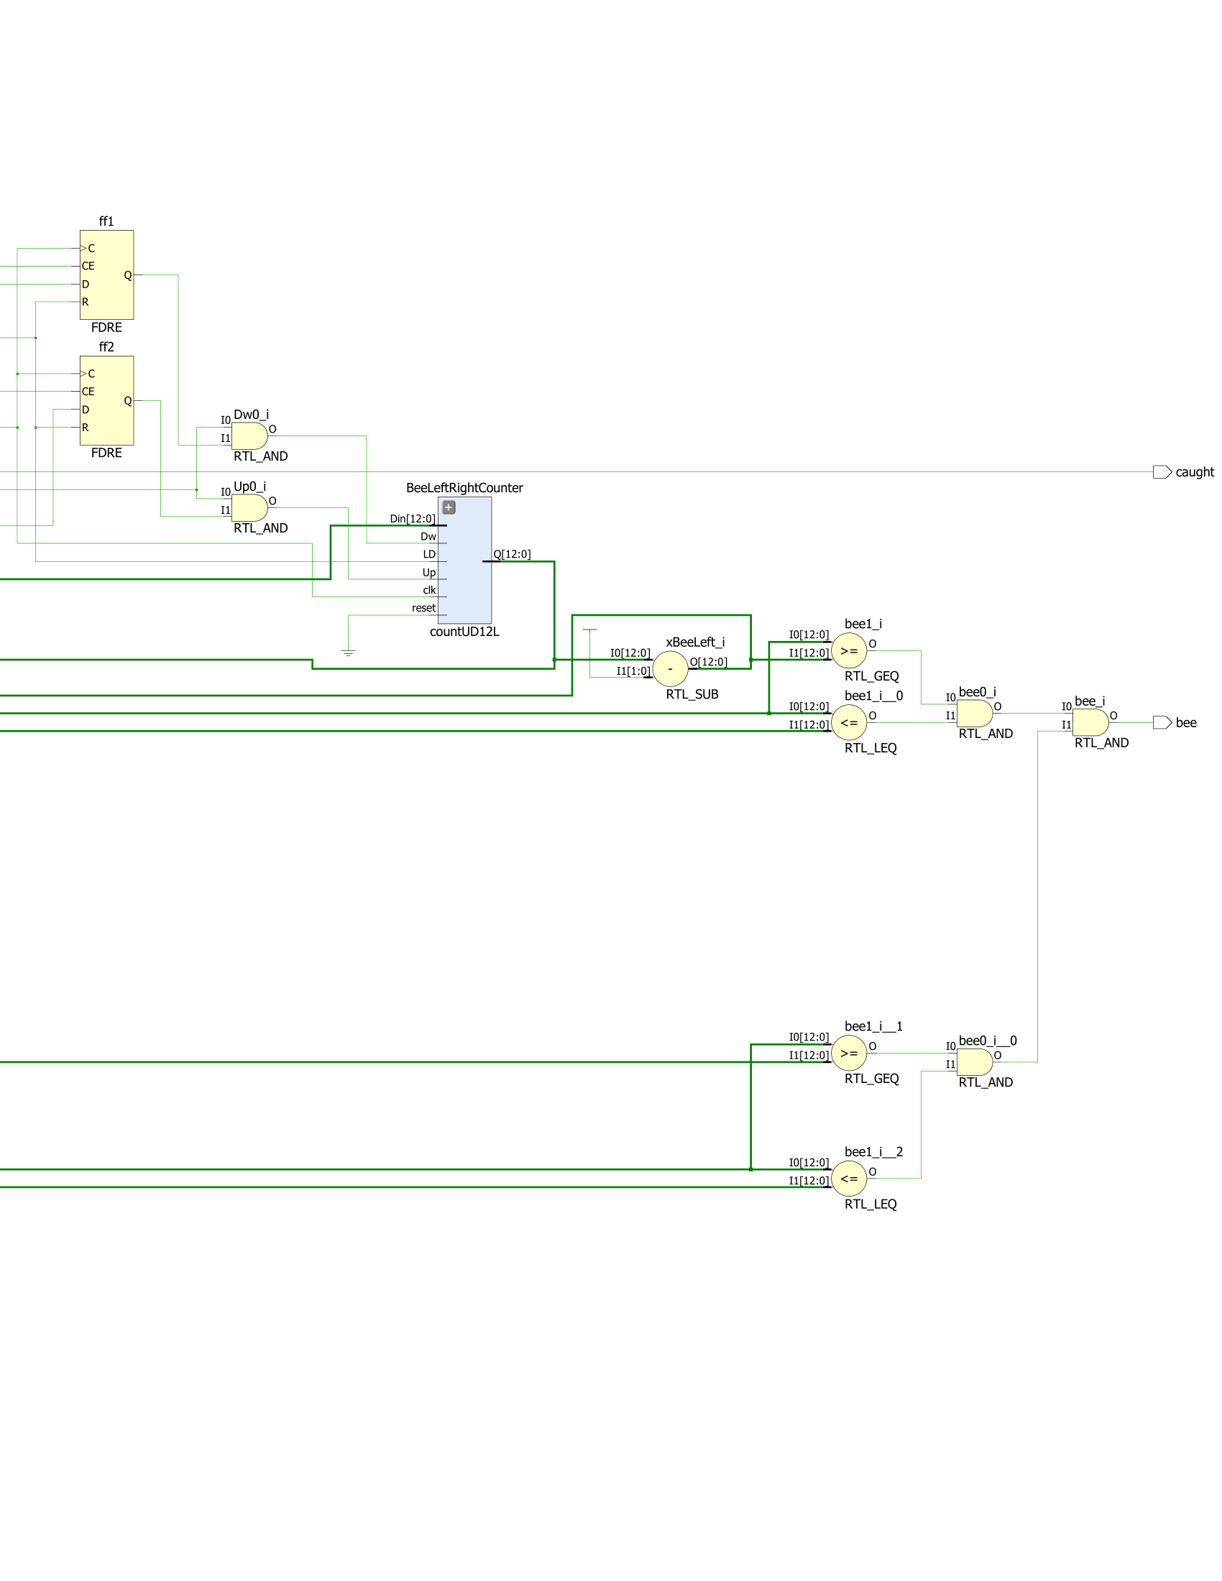

**Part Eight: 8 Individual Bees**

In order to have eight bees, I created a module that had eight instances of a bee, each with their own position and random direction. Each bee also outputted a value of 1 when it was caught, which was used to increment the amount of bees caught that would be displayed on the Basys3 board. The code and schematic for the module are the following:

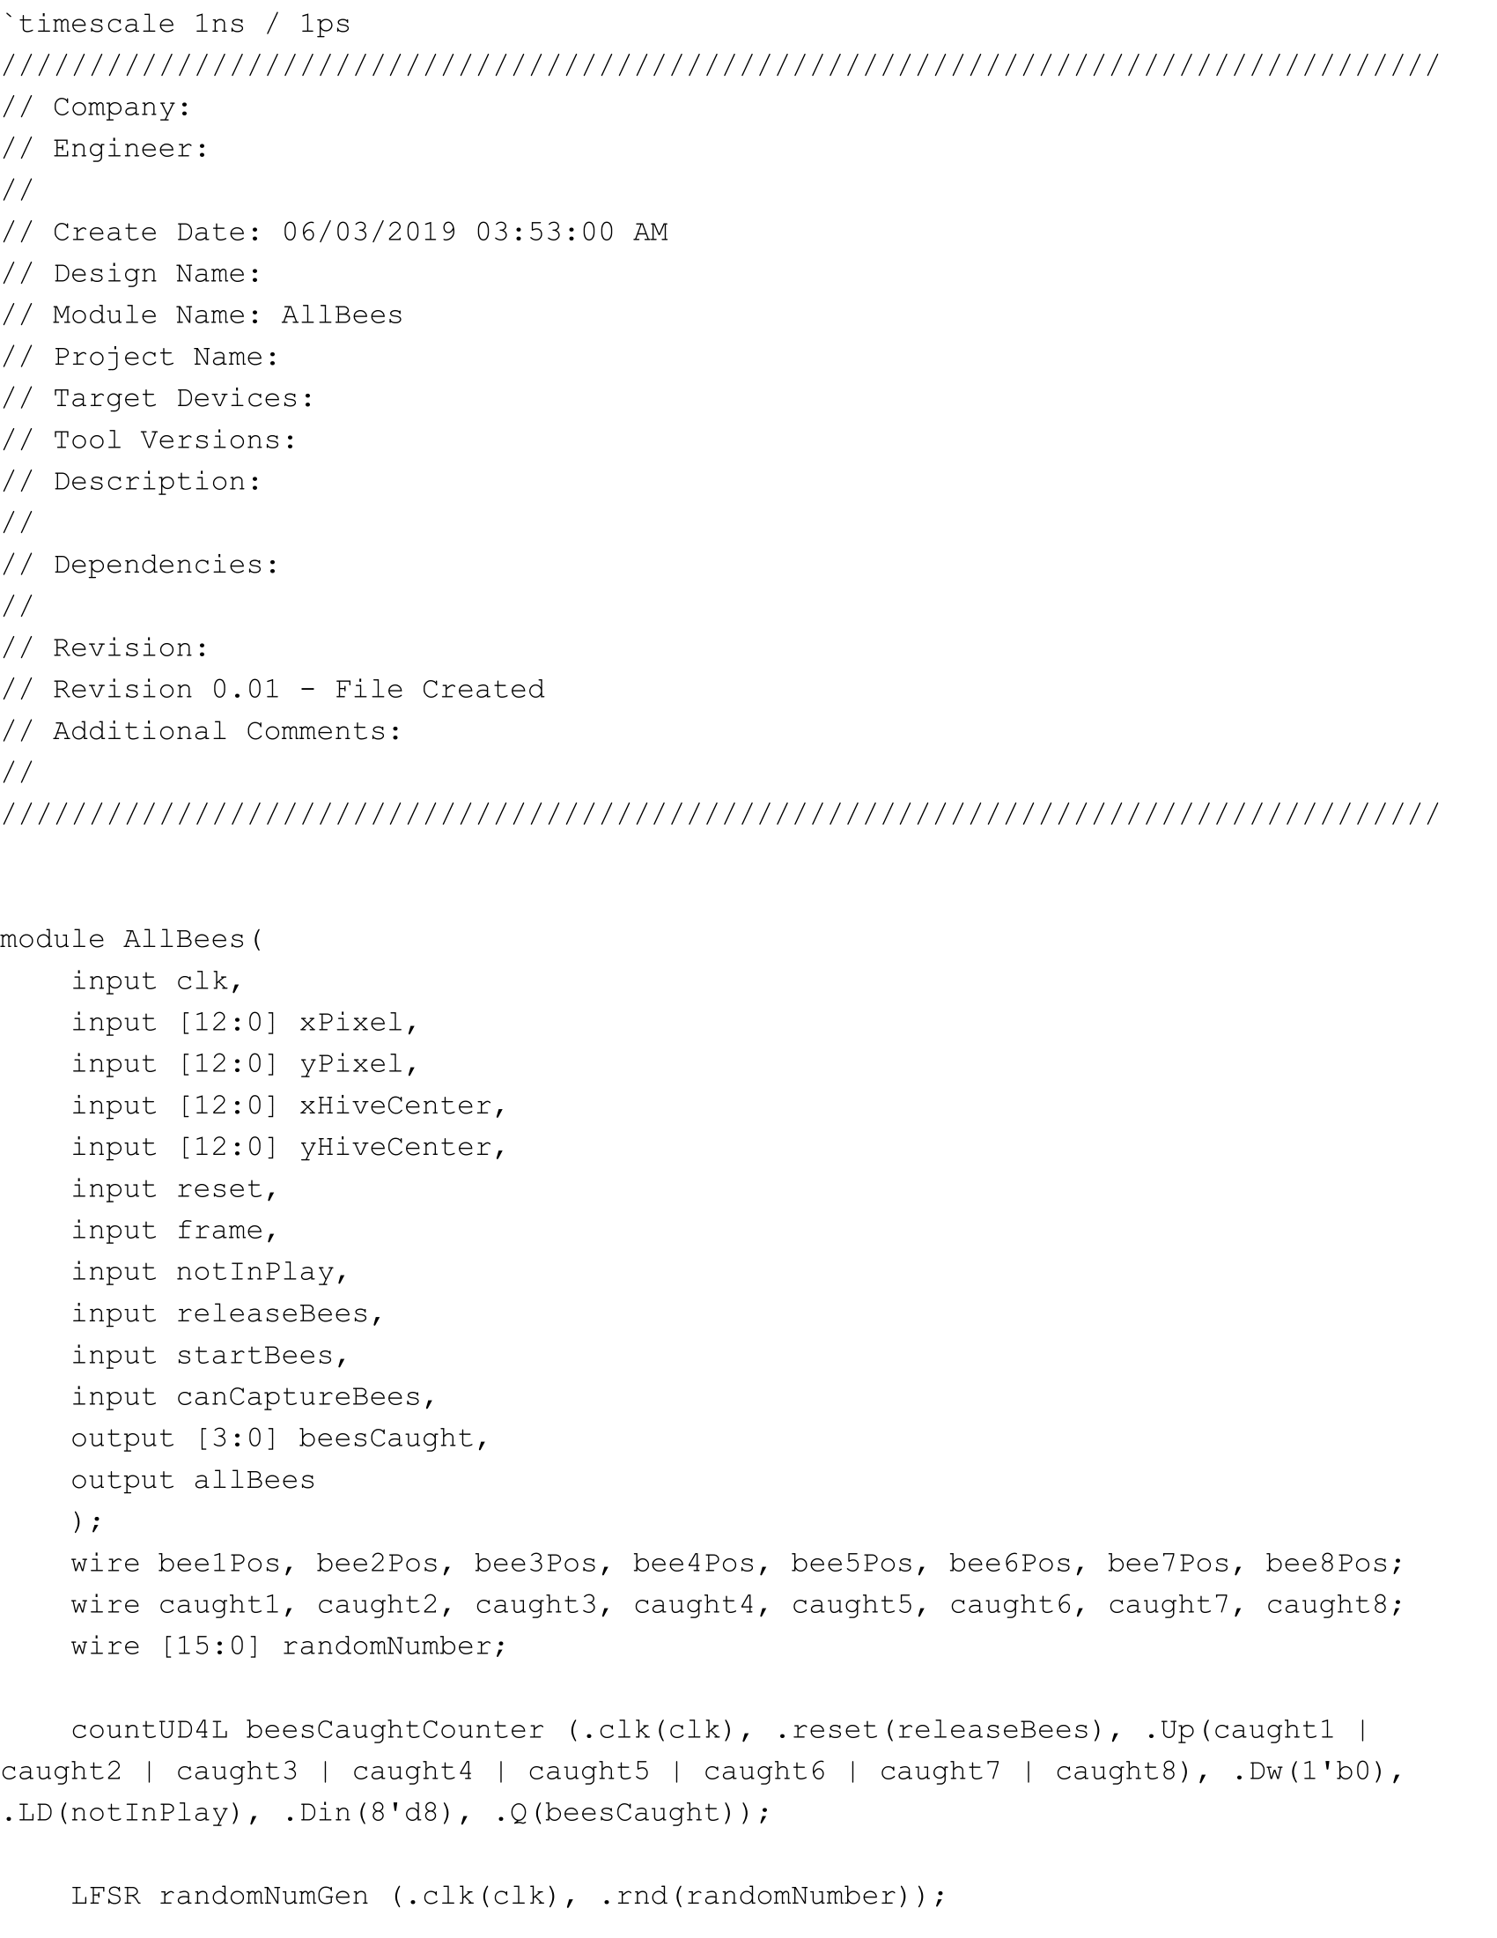

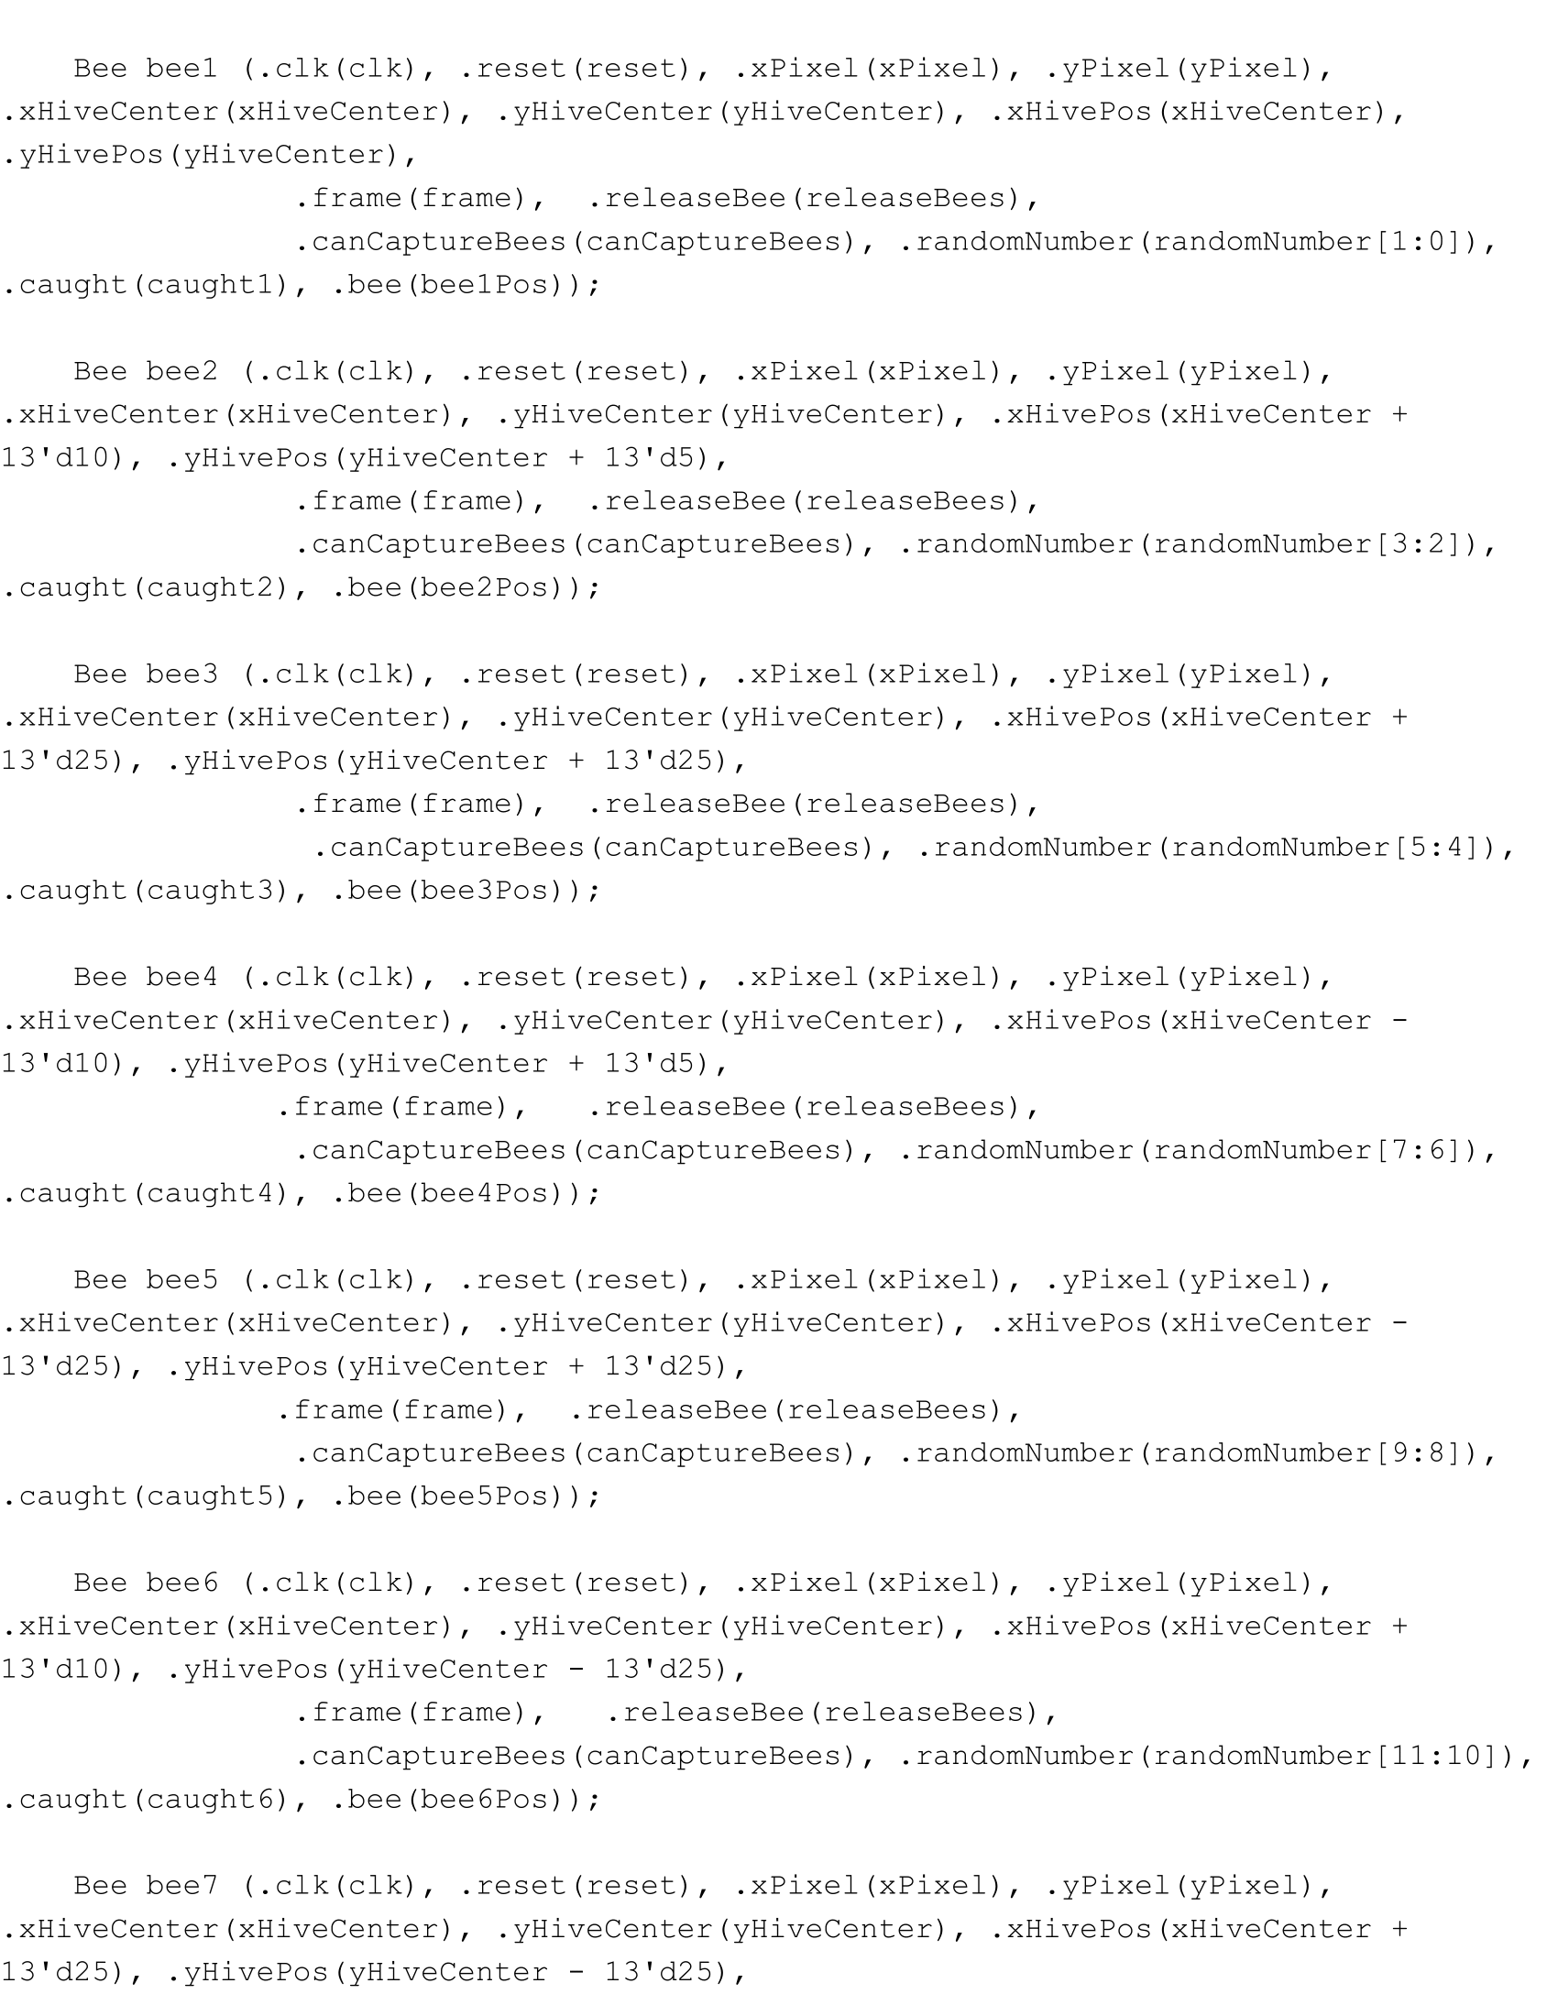

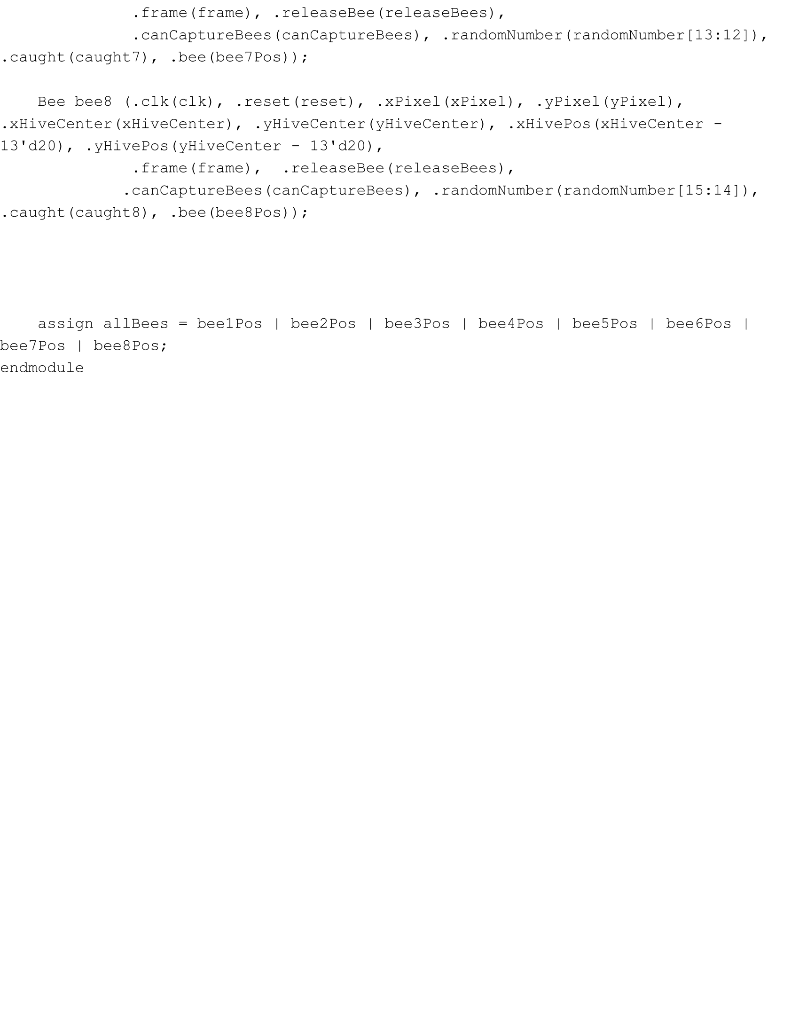

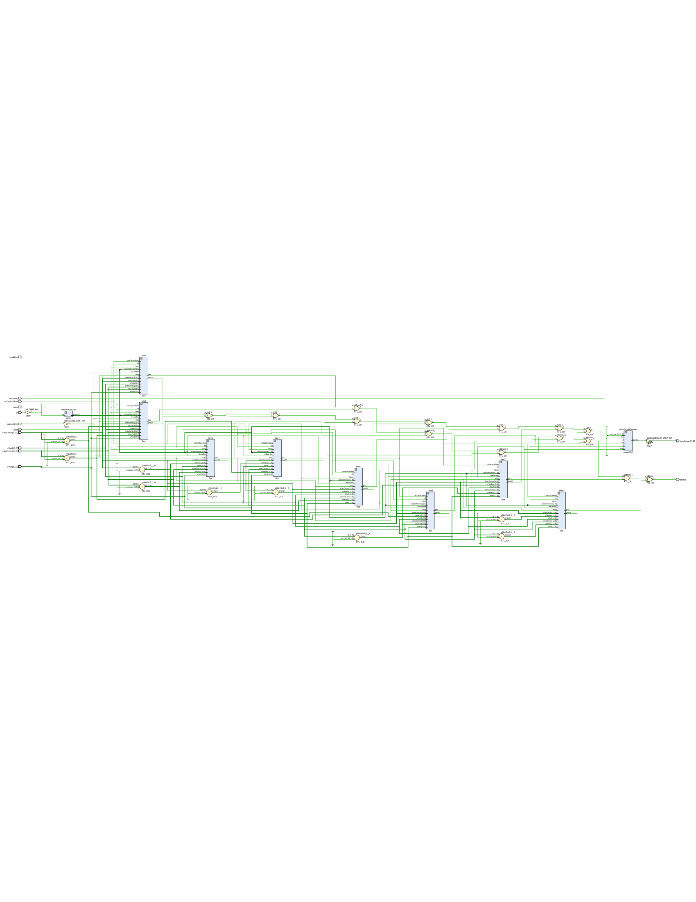

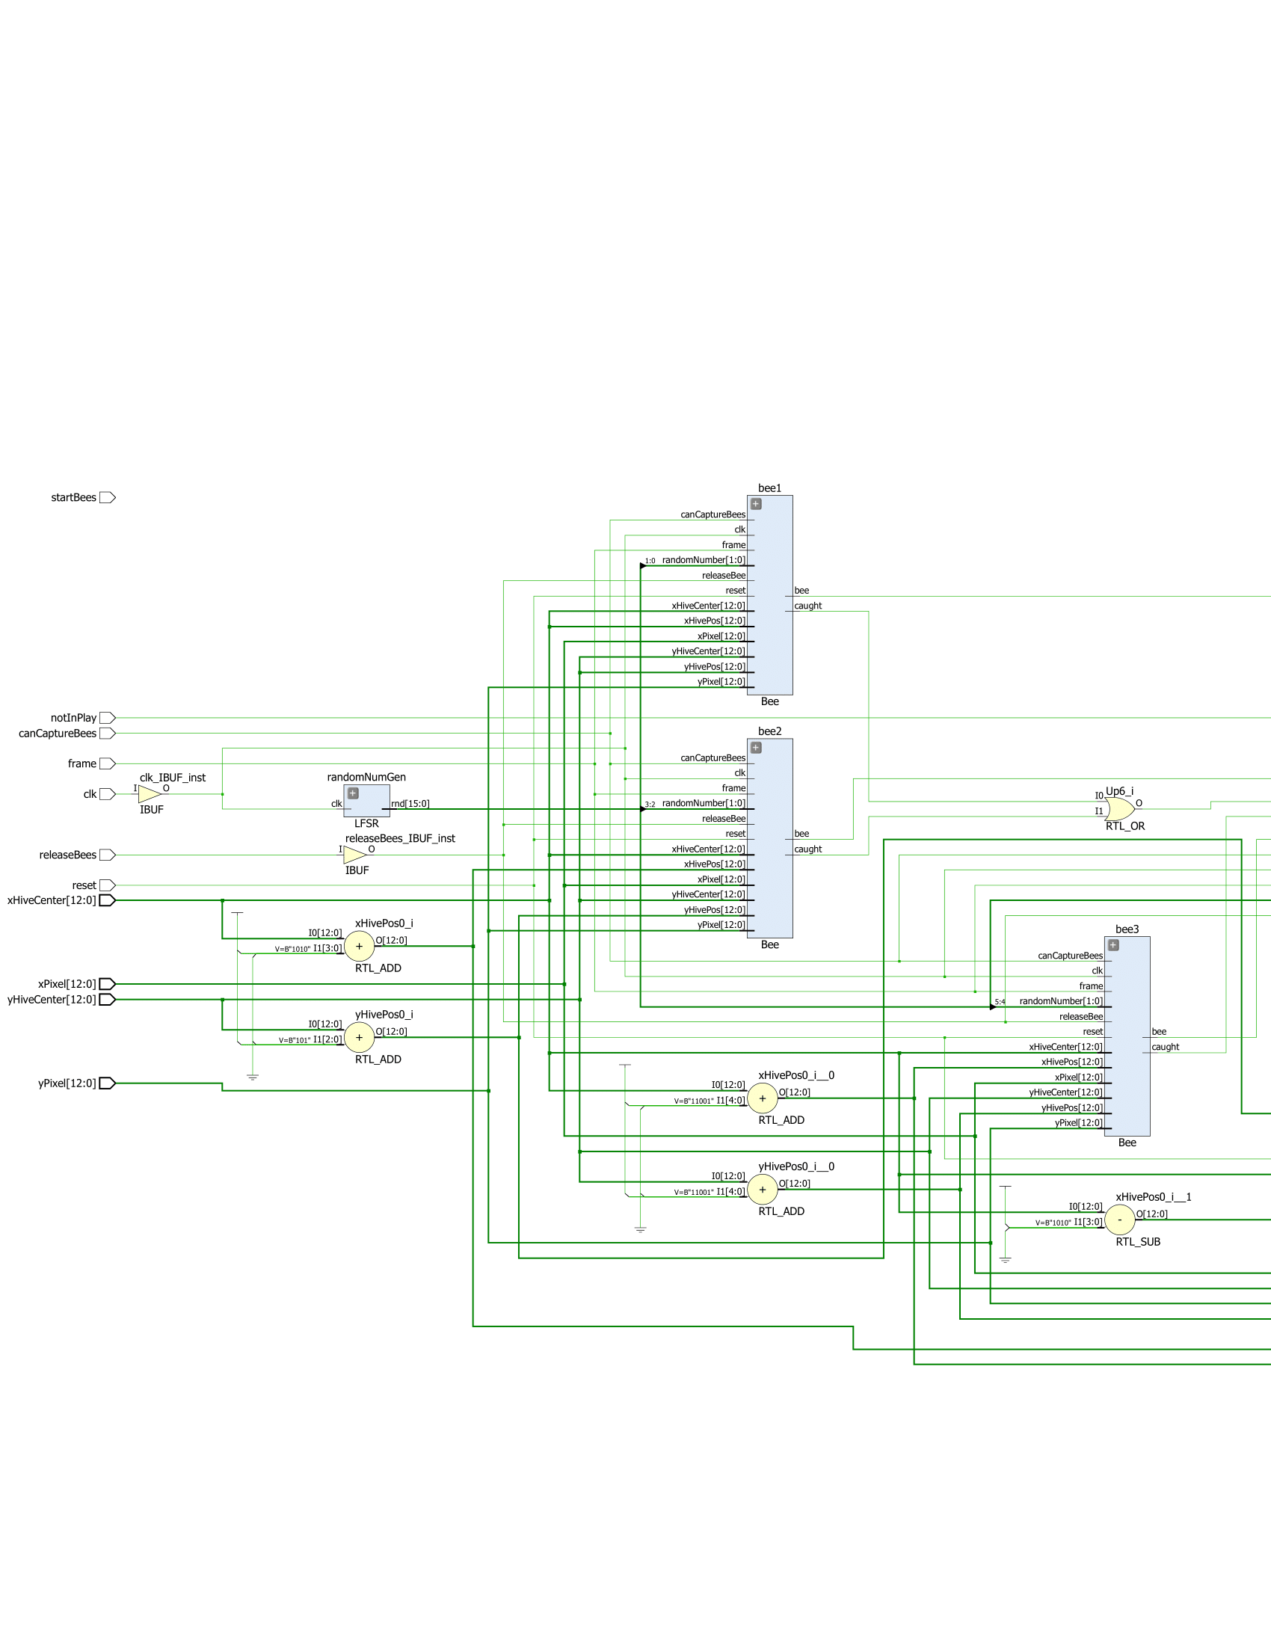

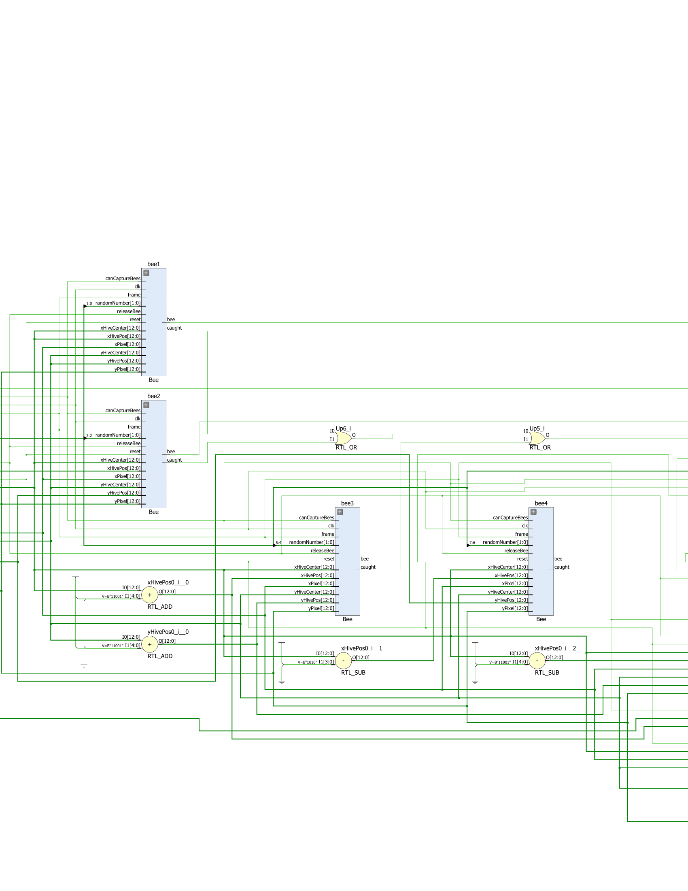

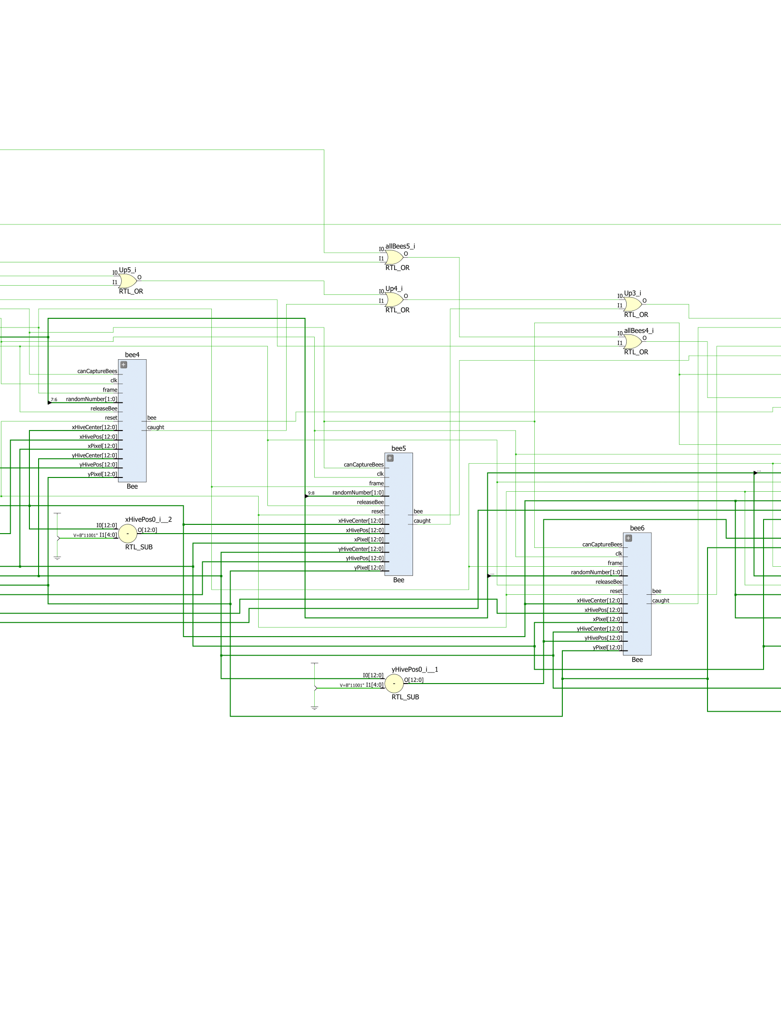

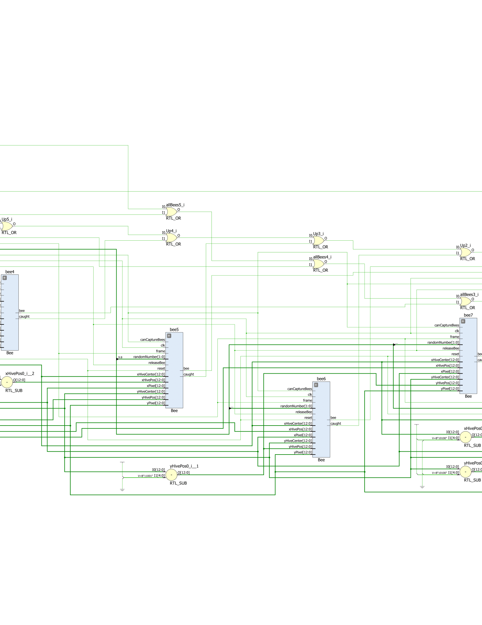

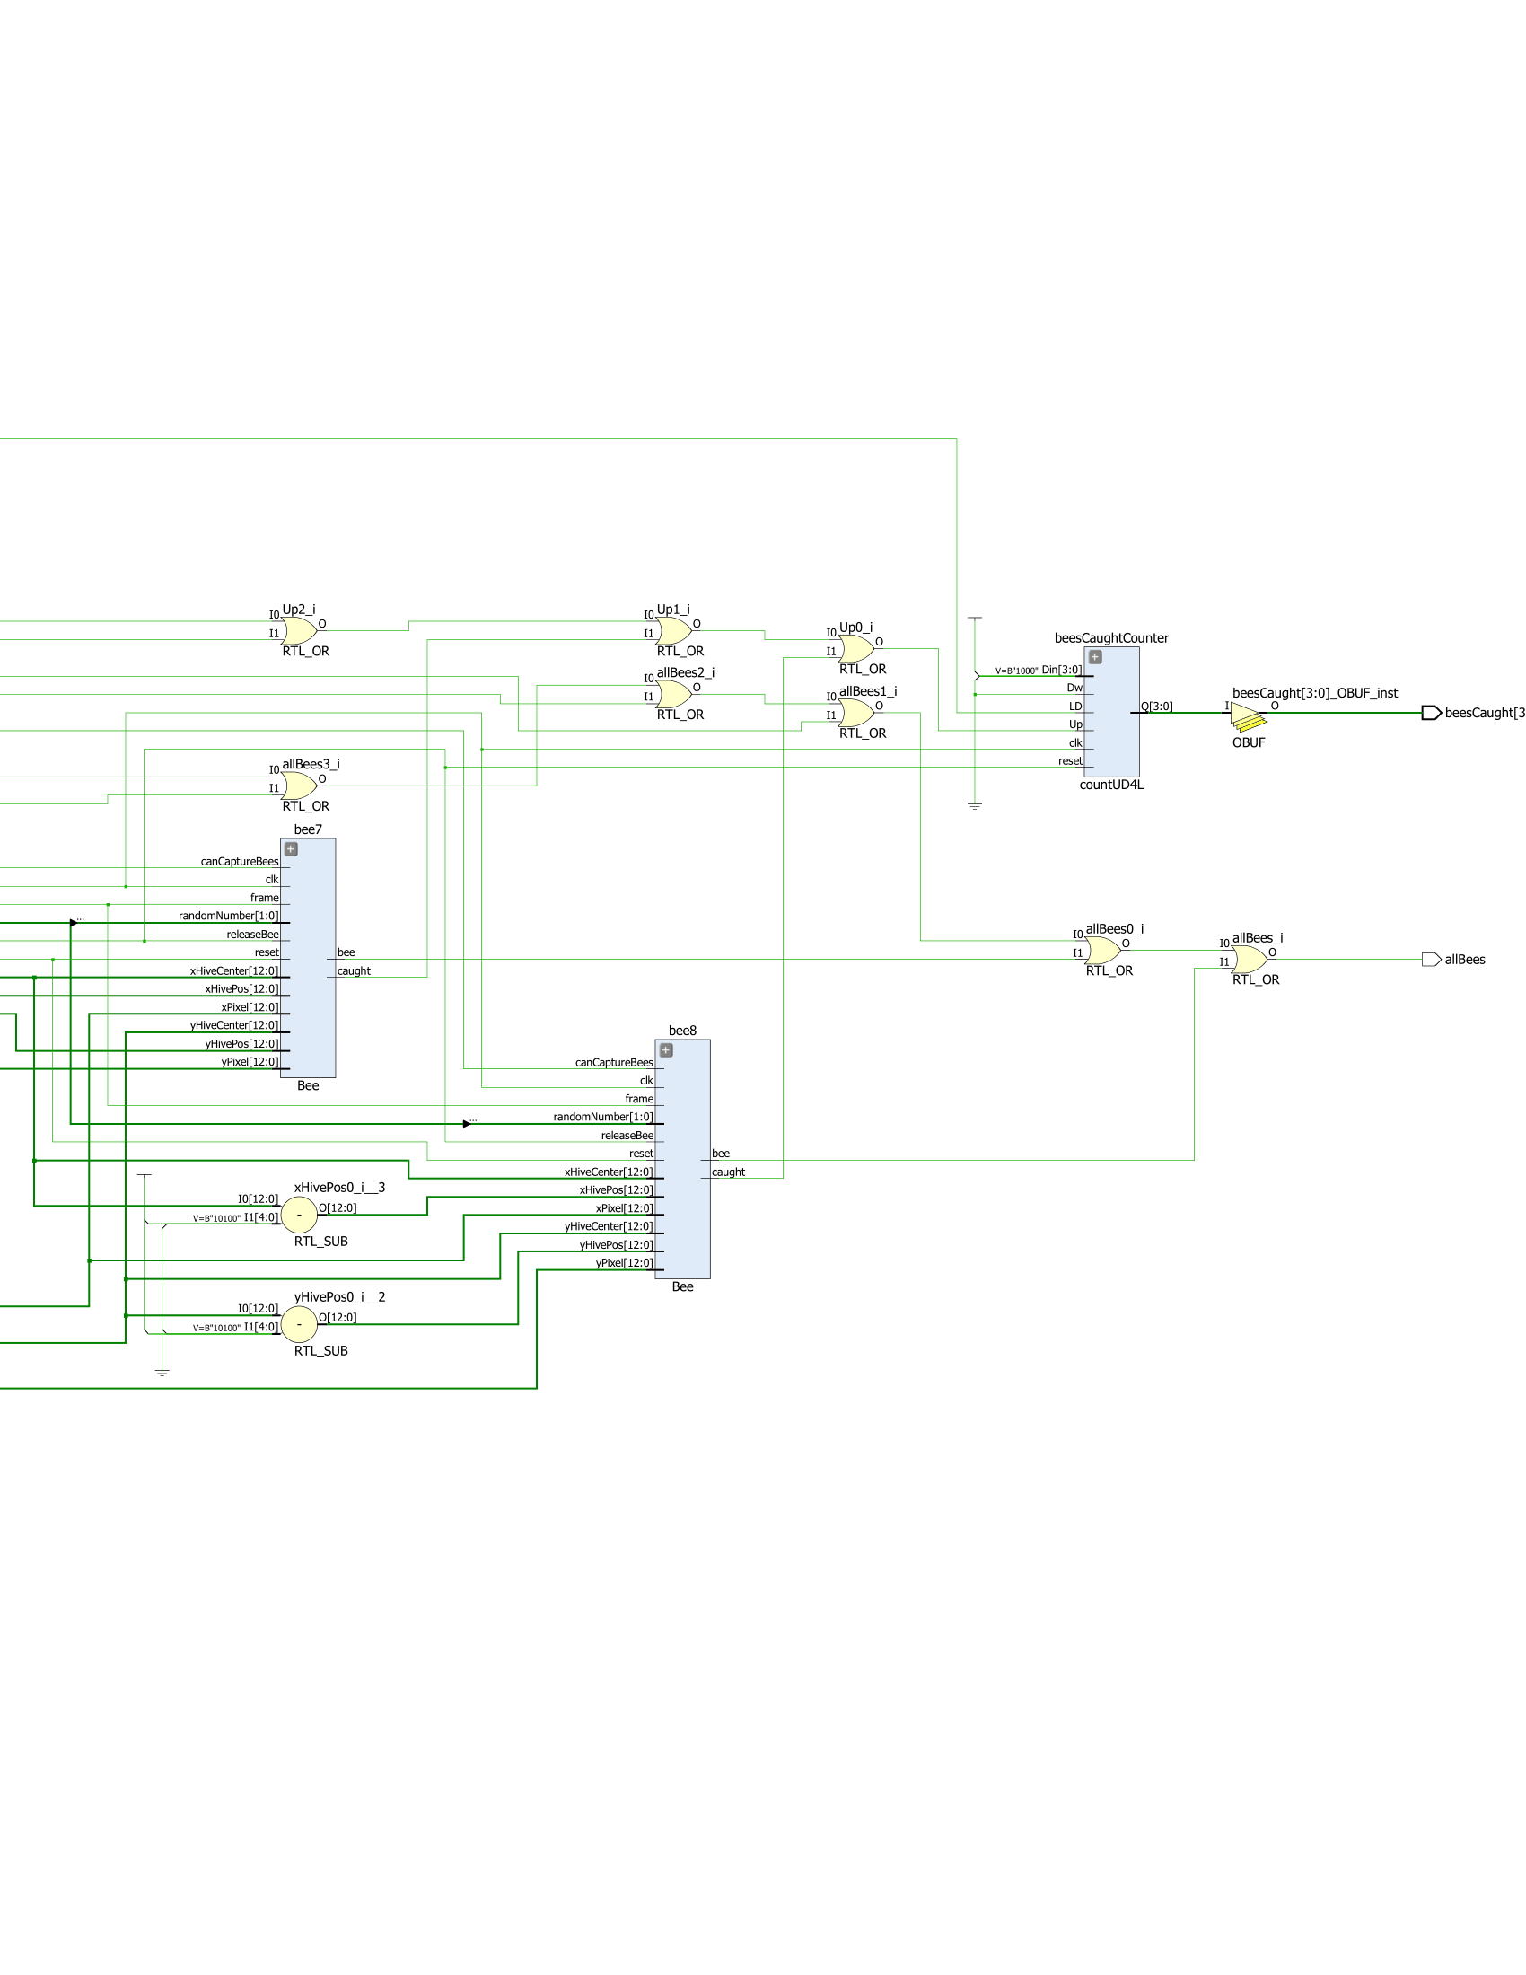

**Part Nine: The Top Level Module**

The final part of the lab was to put everything together into a single module that called everything else. The top level module called the VGA Controller, which kept track of every pixel on the screen and was used as an input to the hive and bees, as well to output Hsync and Vsync. Next, the outputs of vgaRed, vgaBlue, and vgaGreen depended on the positions of the hive and bee, as well the borders of the screen. I also have a time counter that kept track of when a quarter second, one second, four seconds, or eight seconds went by, which was used in the state machine. Also, another counter was used to load in time from the switches on the Basys3 board, and counted down when given the signal from the game’s state machine. The game’s state machine was used to facilitate the actions of the hive and bee, and gave them inputs accordingly. Finally, the result to be displayed on the board was given to the selector and hex7seg modules, which made use of the ring counter. The following is the code and schematic for the top level module:

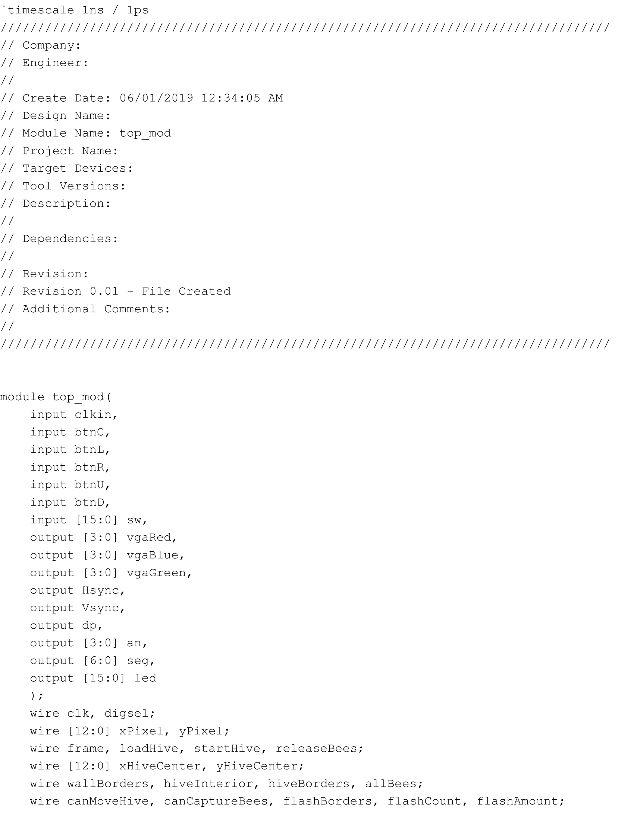

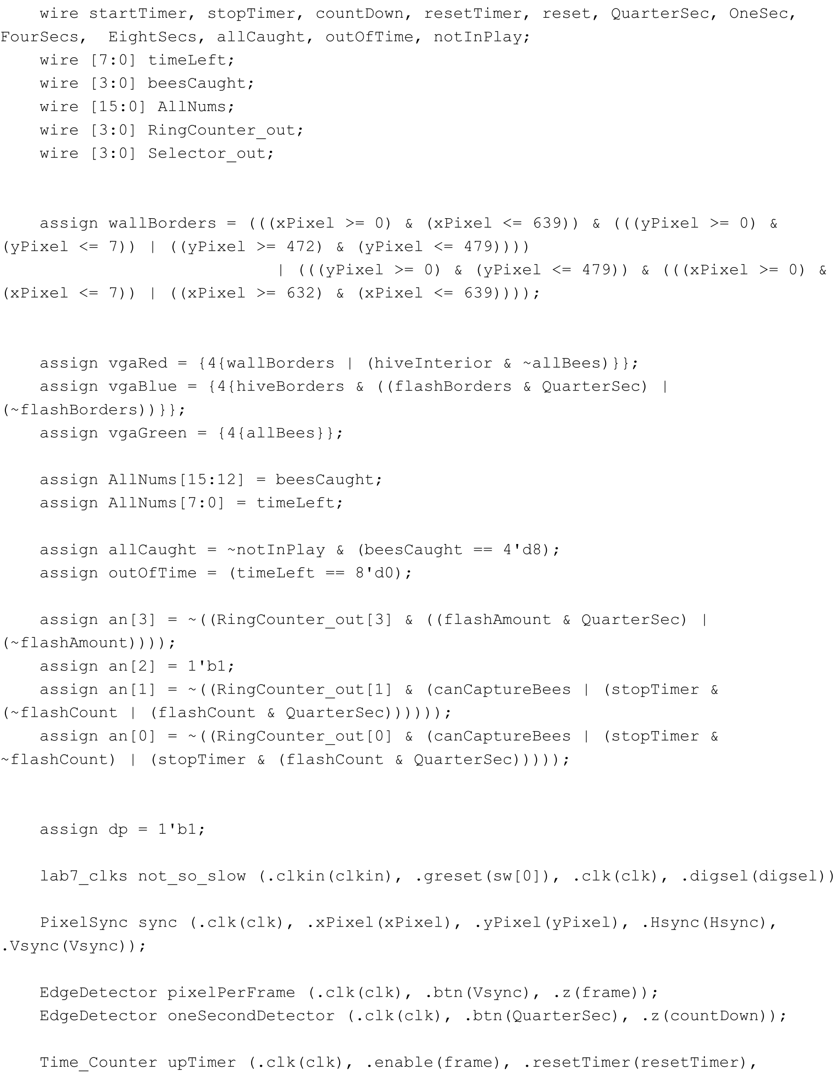

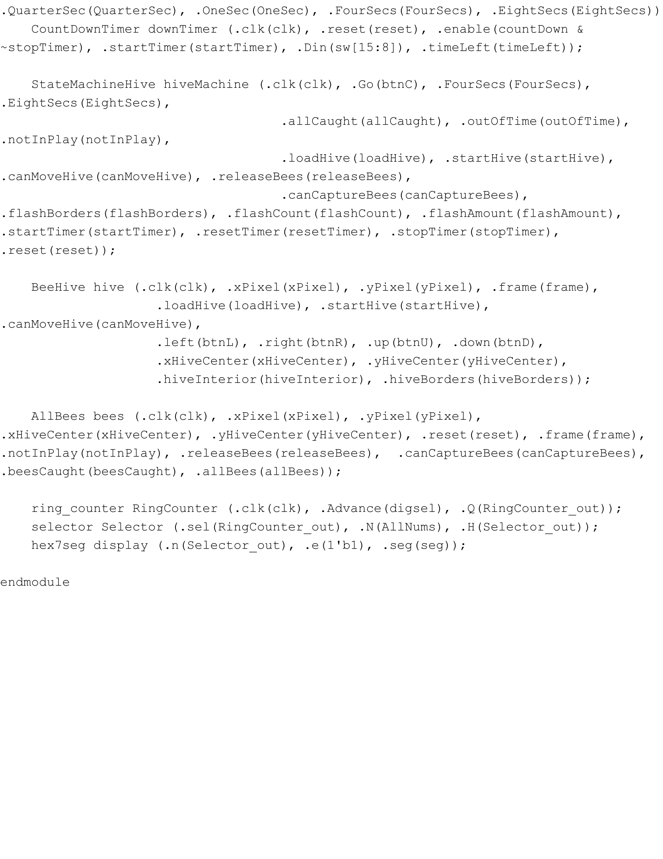

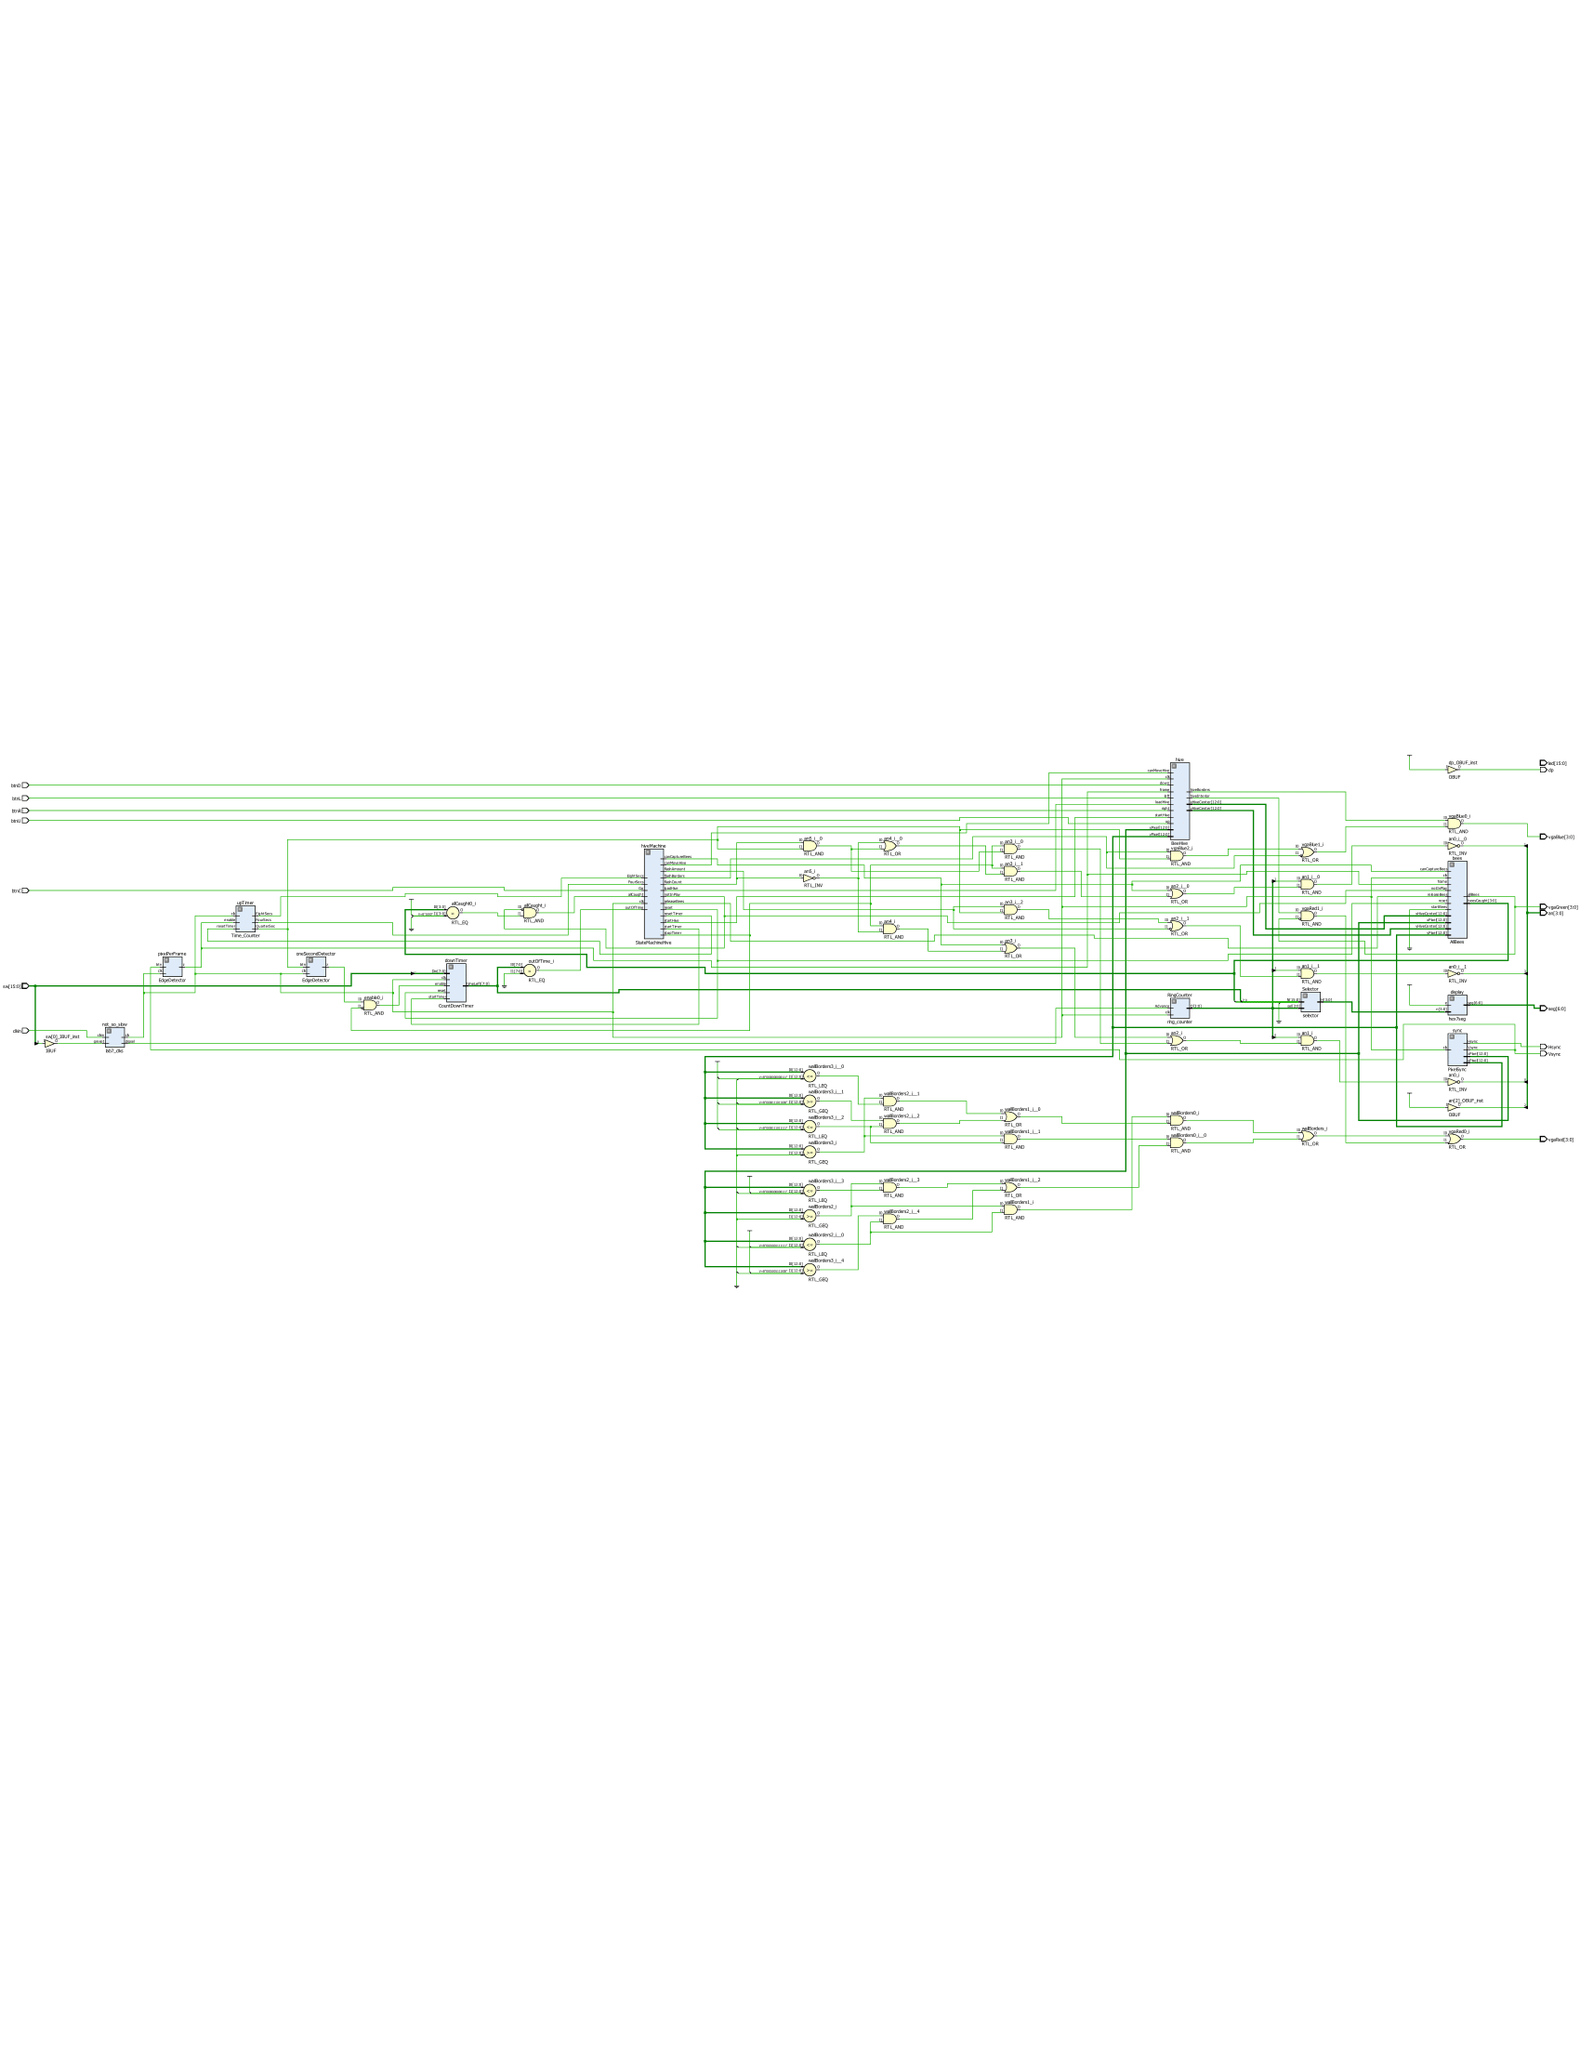

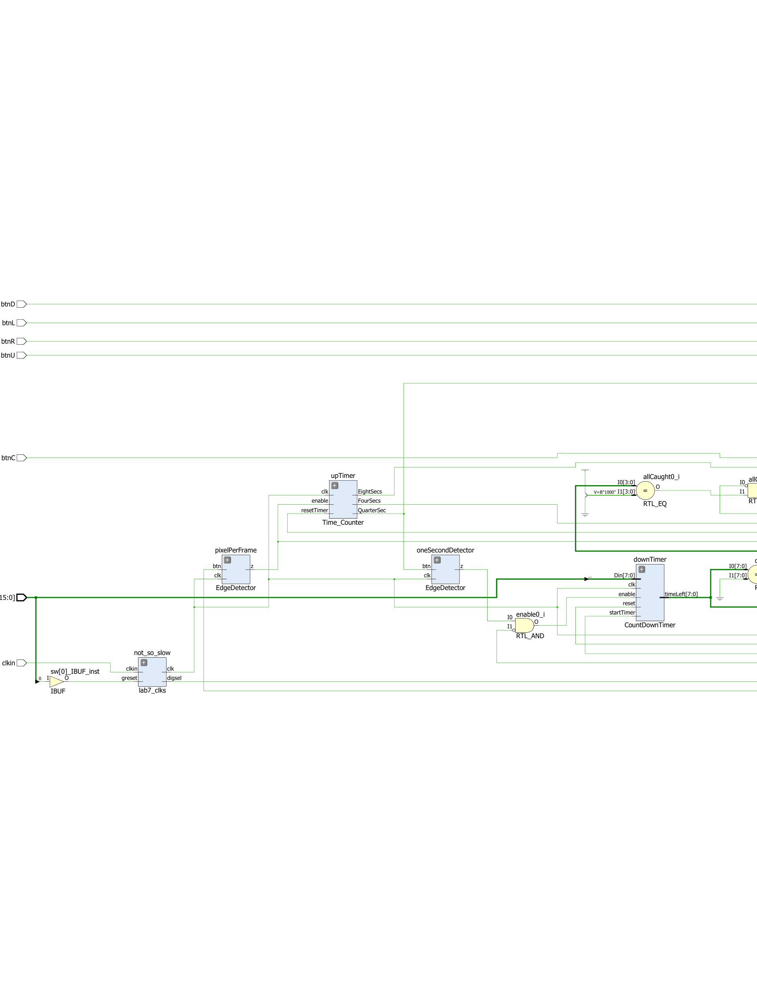

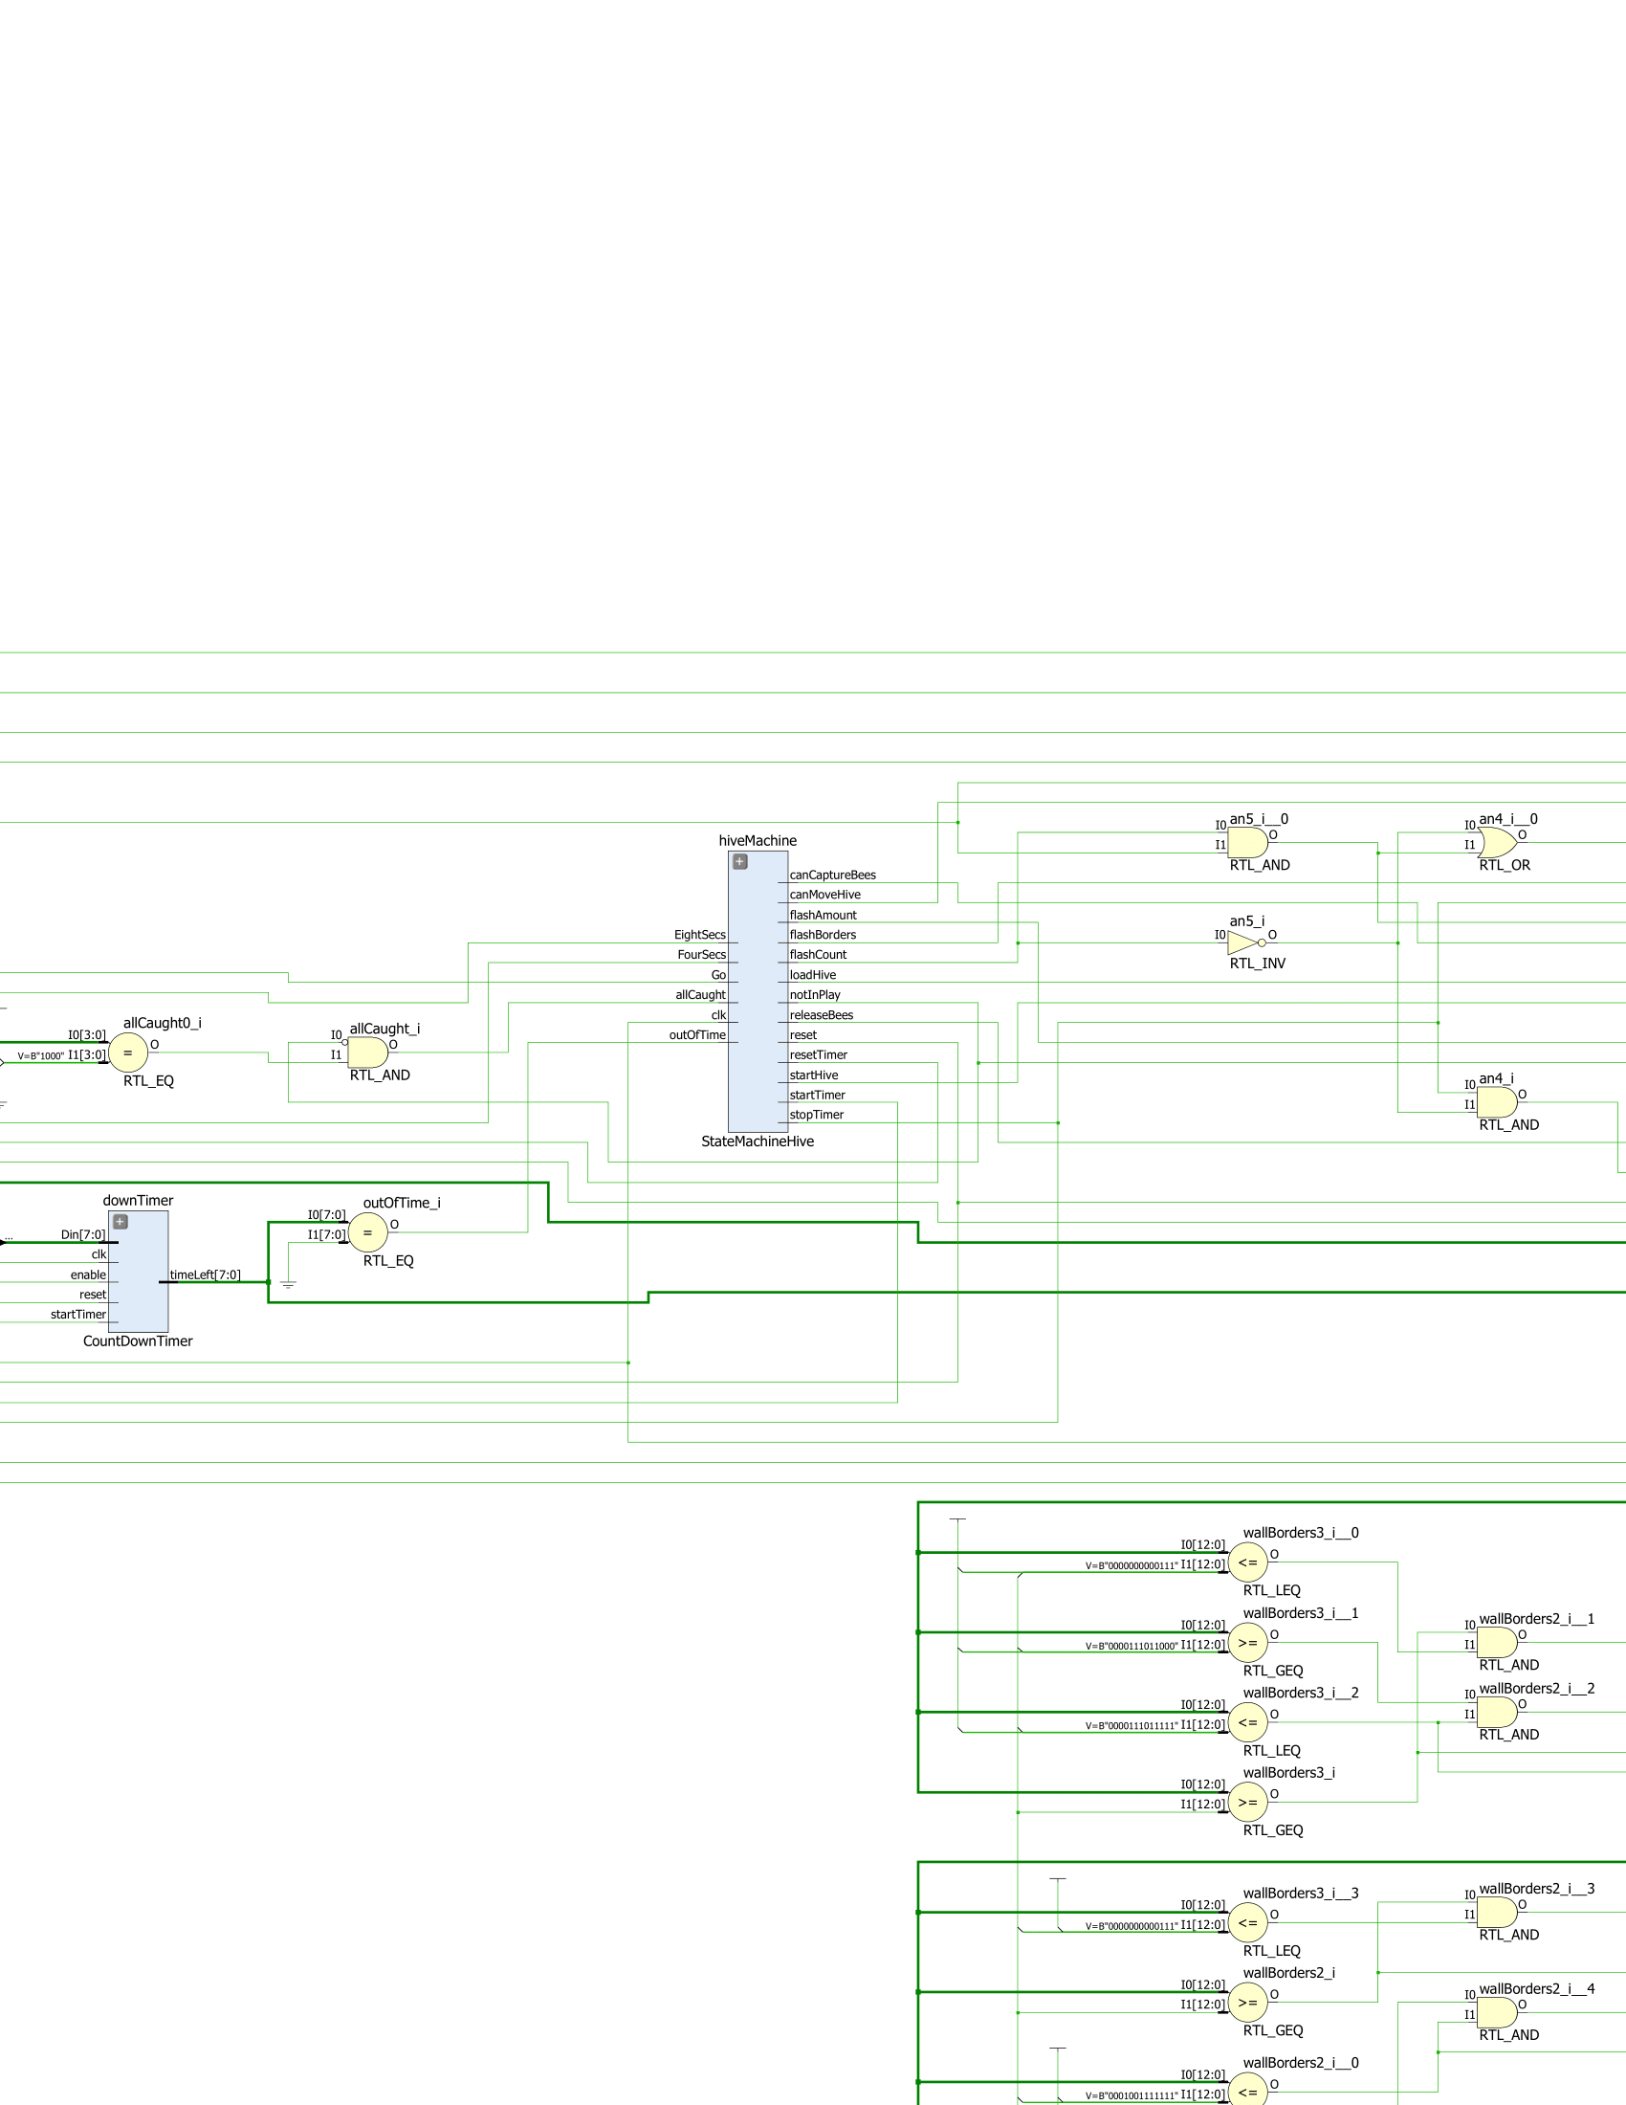

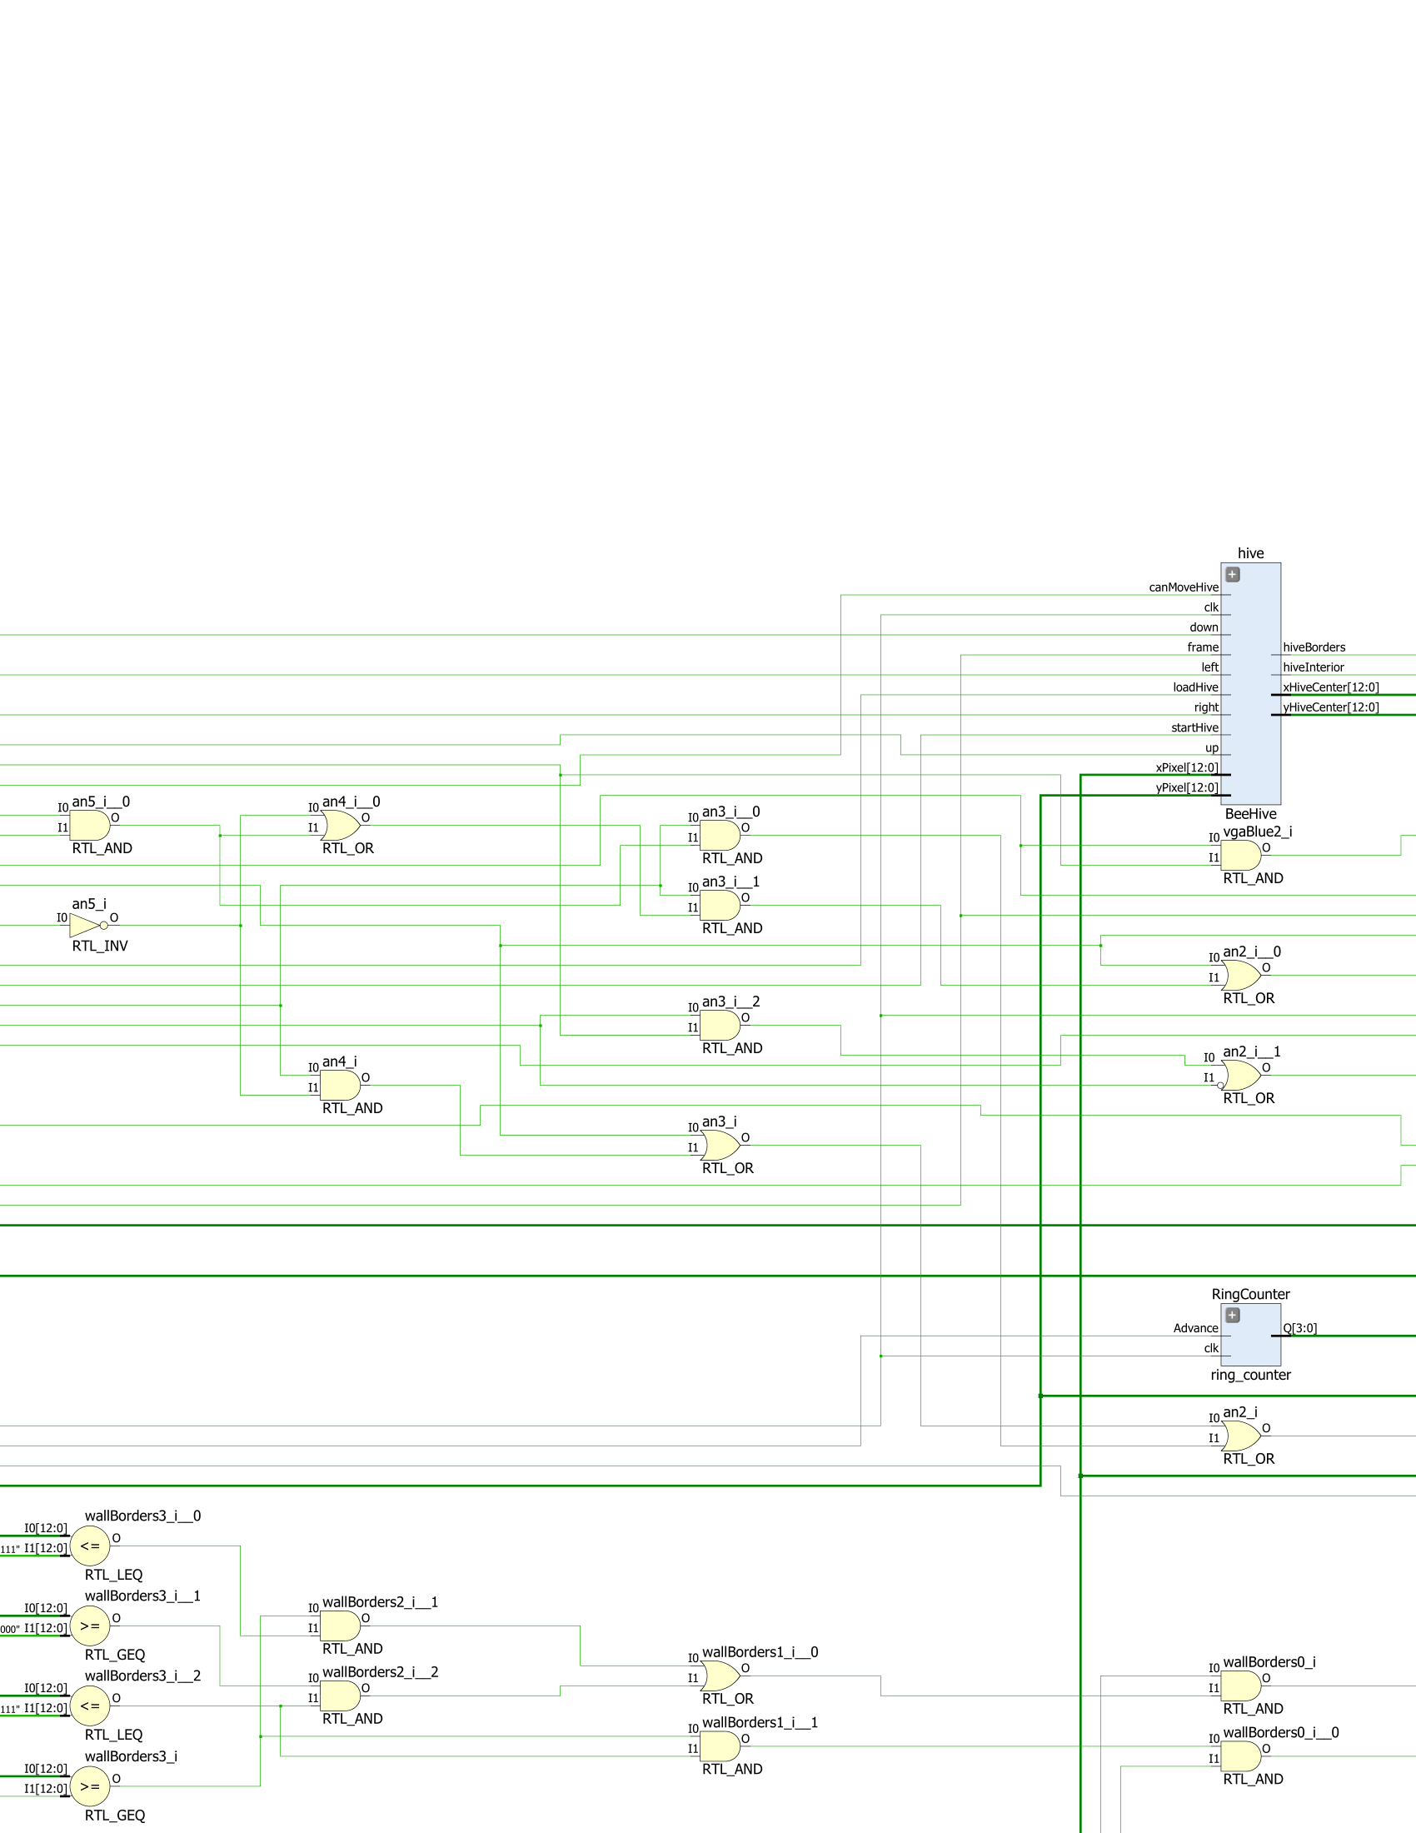

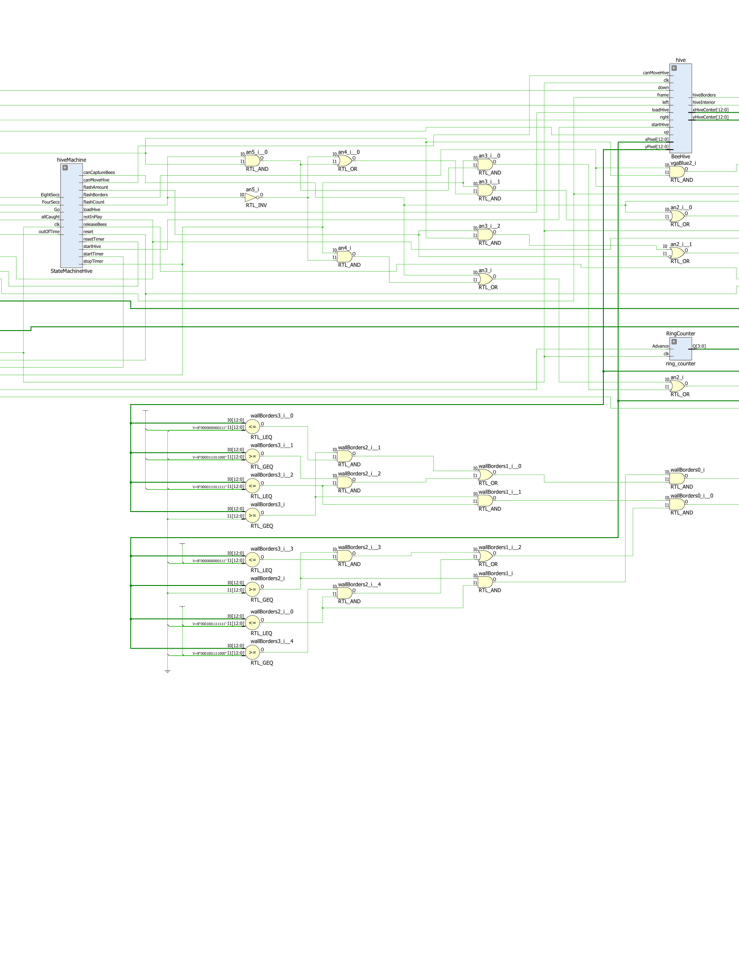

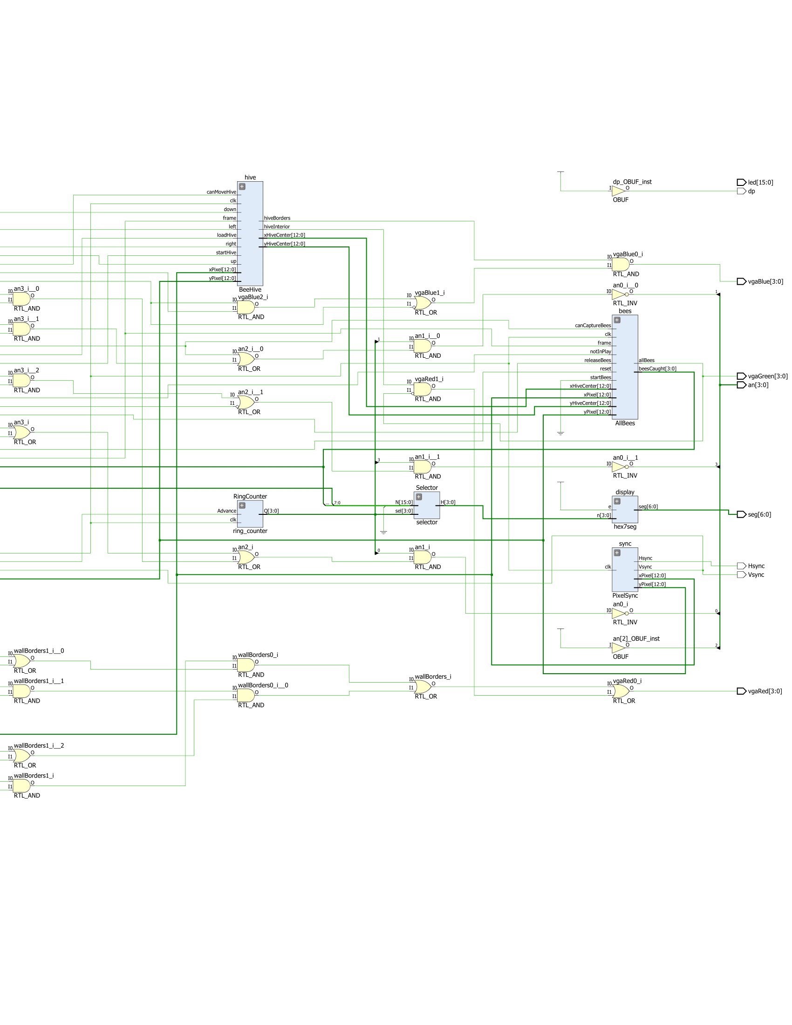

I then mapped all the outputs of the top level module to the Basys3 board, and verified that the game and display on the monitor were indeed working.

When looking at the Timing Report, the maximum clock frequency was at 100 MHz.

**Conclusion**

In conclusion, we successfully created a game of “Bee Keeper” that was able to be displayed on the monitor. We furthered our ability of implementing state machines into our designs in order to react to certain events, and output the correct actions, as well as how to use VGA to display images and actions. If I were doing this lab again, I would make better use of the simulator by testing my code as soon as I write it instead of testing it after creating multiple files with code that could be wrong.

**Appendix**





































































































